MULTITHREADING

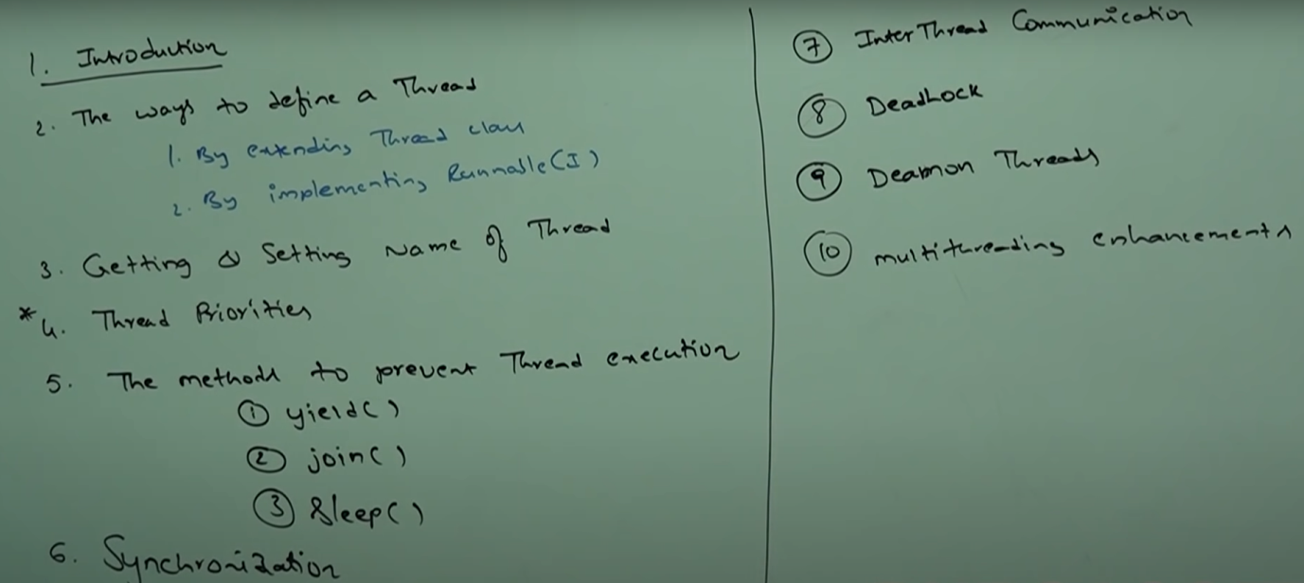

INTRODUCTION:

Executing several tasks simultaneously is a concept of Multitasking. There are 2 types of Multitasking. Main advantage/Objective is to reduce idle time of the processor/response time of the system and improve performance.

|  |  |
| --- | --- |
| Process based Multitasking | Thread Base Multitasking |
| Executing several tasks simultaneously where each task is separate independent process (program) is called Process based Multitasking. | Executing several tasks simultaneously where each task is separate independent part of the same program. Such type of multitasking is called Thread based Multitasking.  Each independent part is called a thread. |
| Best suitable at OS level not at programmatic level | Best suitable at programmatic level |
| Ex: While Writing a code in Editor we can Listening to music file from same system at same time we can download a file from Net. All these tasks will be executed simultaneously an independent of each other. Hence it is process based multitasking. |  |

Application areas of multithreading:

1. Develop multimedia graphics
2. To develop animations
3. To develop video games
4. To develop web servers and application servers (Ex **GMAIL**. For each request, a thread will be assigned. ) The default thread for TOMCAT server is 60.

Where it is used: Given a keyword, give the names of all the files / print the file names in Console who has these given keywords in them.

Thread – A flow of execution. For each thread a separate independent job / task is there. Every Java Program will contain one thread by default – MAIN thread. There will be many threads inside by Main thread is just one.

Defining a thread:

We can define a thread in two ways:

1. By extending Thread Class
2. By implementing Runnable Interface

BY EXTENDING THREAD CLASS: Override run method

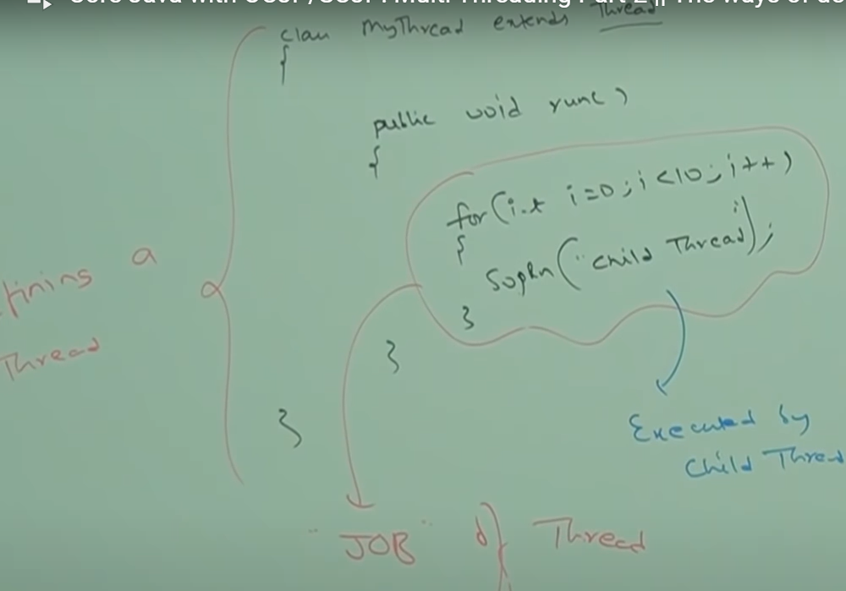

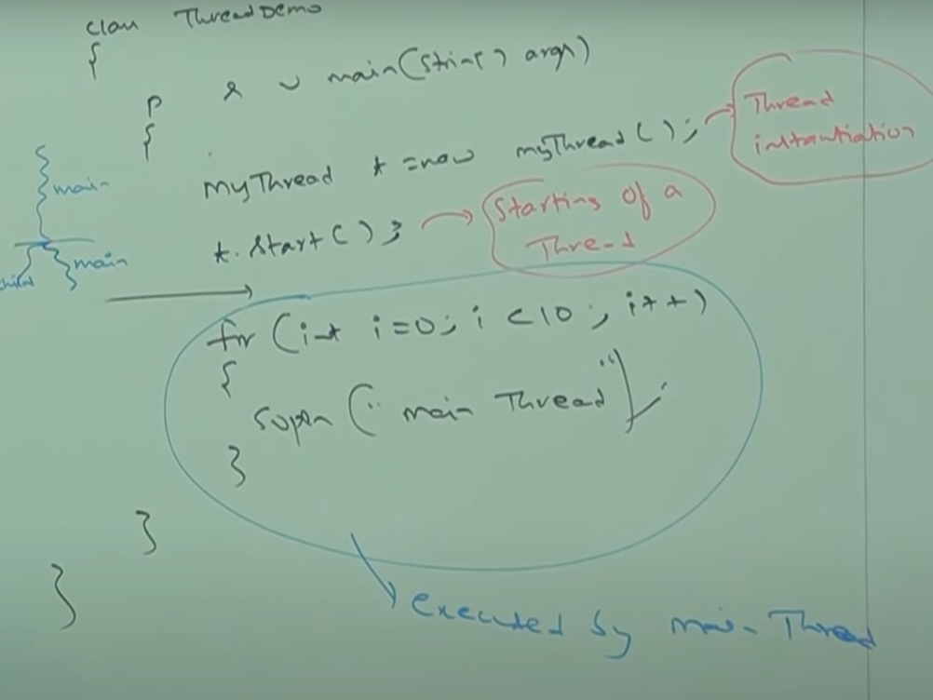

Thread instantiation starting of thread done by **MAIN** thread. The code in the main method will be executed by the main thread only. The Only job/task of the new thread is present in the run method. Main thread is responsible to execute the main method.

THREAD SCHEULER:

1. It is a part of JVM.
2. It is responsible to schedule threads i.e. if ,multiple thread are waiting to get chance of execution, then in which order threads will be executed will be decide by thread scheduler.
3. We cannot expect exact algorithm followed by thread scheduler. It is varied from JVM to JVM. Hence we can’t expect threads execution order and exact output. Hence, whenever situation comes to Multithreading, there is no guarantee for exact output, but we can provide several possible outputs.

Following are various possible outputs for the above program.

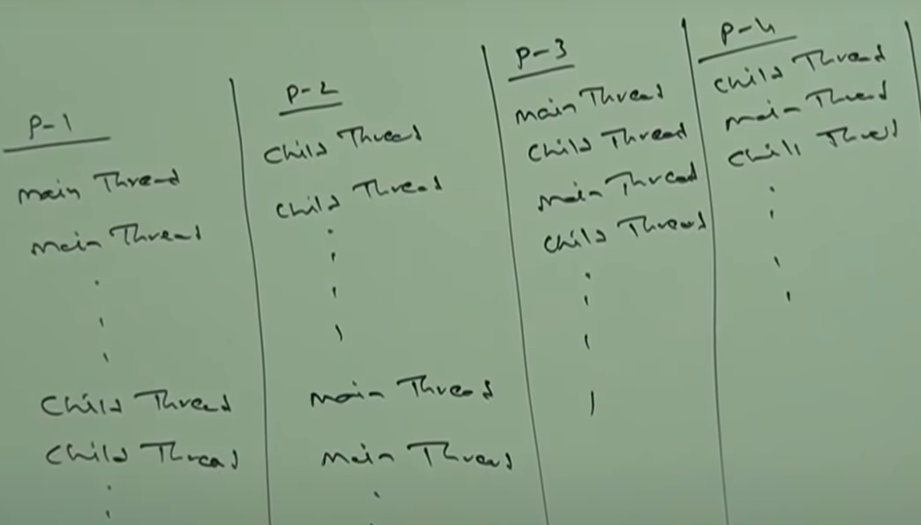

CASE: 2 – Difference between **thread.start()** & **thread.run()**

Thread is started by calling start method which will be present in parent class (Thread Class). This will in turn call the run method over-ridded in the Custom Class. What if we directly call run method from main method instead of start in above program.

thread.start -- > A new thread will be created which will be responsible to perform the task implemented in the run method.

Thread.run --> It will behave as a normal method call. A new thread will not be created when used this instead of thread.start. So the code implemented in the run method will be executed by the MAIN thread only.

Hence, in the above program if we replace thread.start with thread.run then the output will be same at all runs. (Child thread .. 10 times followed by Main thread …10 times since one thread is present.)

CASE -3: IMPORTANCE of THREAD CLASS START METHOD: (Start method – **Heart of Multithreading**)

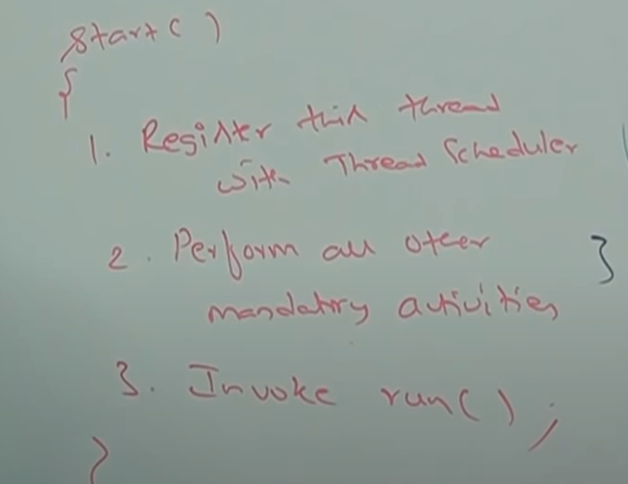

CASE – 4: Overloading of Run method:

Overloading of run method is always possible but thread class start method can invoke no-argument run method. The other overloaded method, we have to call explicitly like a normal method call.

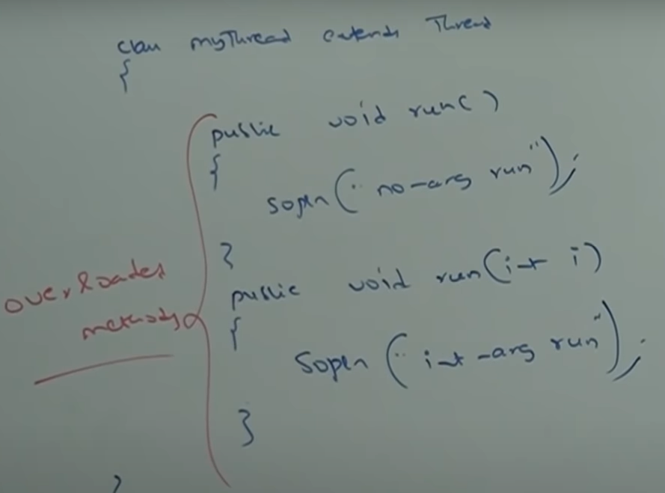

CASE – 5: If we are not overriding run method, then THREAD class run method will be executed which has empty implementation. Hence, we will not get any output. But the code will be compiled and there will be no errors.

Note: it is highly recommended to override run method otherwise do not go for multithreading Concept.

CASE – 6: Overriding start method:

It is not recommended to override start method. Otherwise do not go for Multithreading concept. Overriding start may not call the Thread Initializer and other modification that needs to be done.

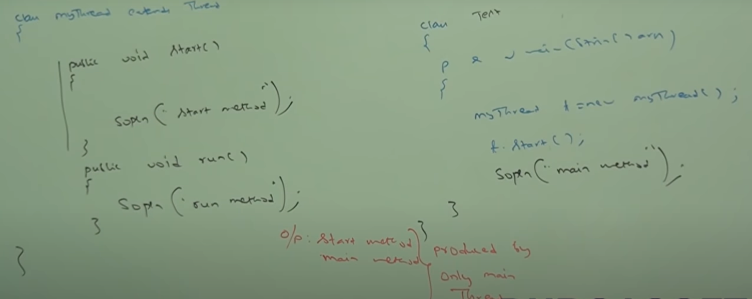

Start method here is executed as a normal method call by the main thread.

CASE: 7 -- Using super.start()

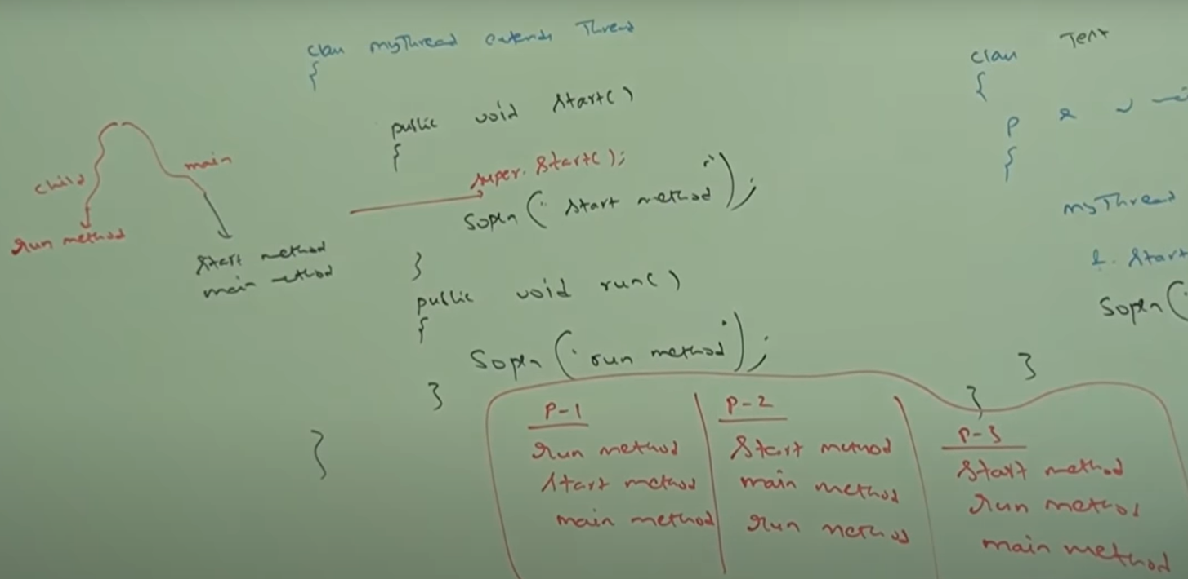

CASE: 8 – Life Cycle

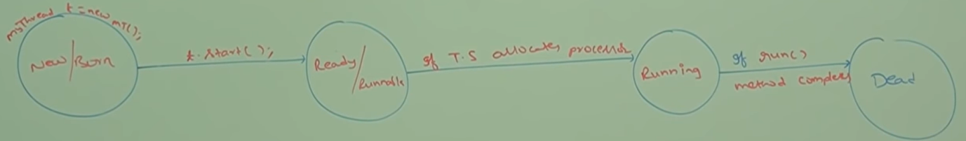

CASE: 9 – After starting a thread, if we trying to restart the same thread then we will get run time exception saying IllegalThreadState Exception.

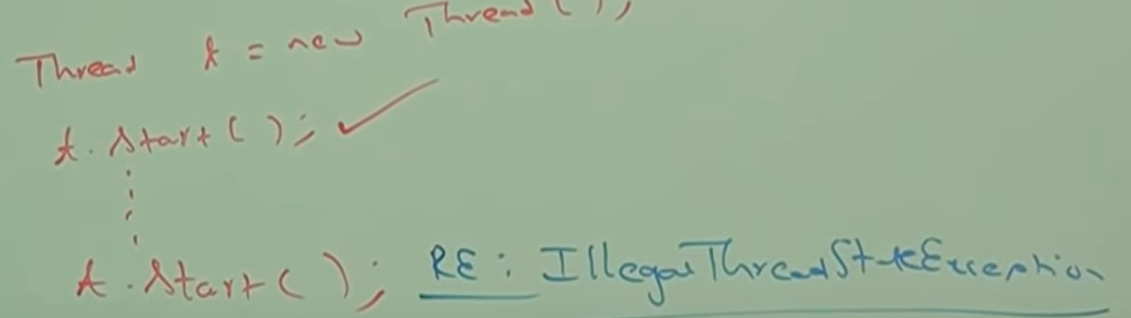

BY IMPLEMTING RUNNABLE INTERFACE: Override run method

We can define a thread by implementing RUNNABLE interface.

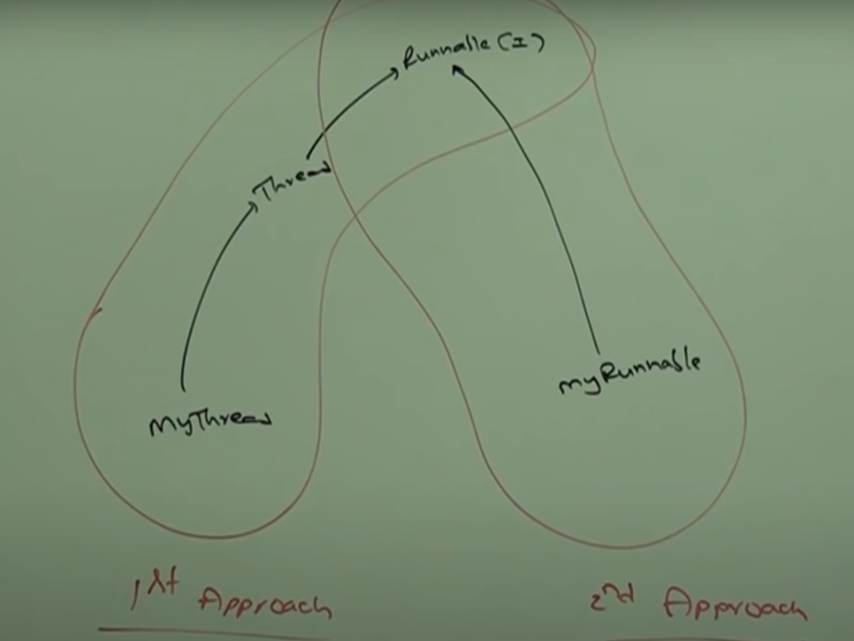

Runnable interface present in **java.lang** package and it contains only one method -- > run method.

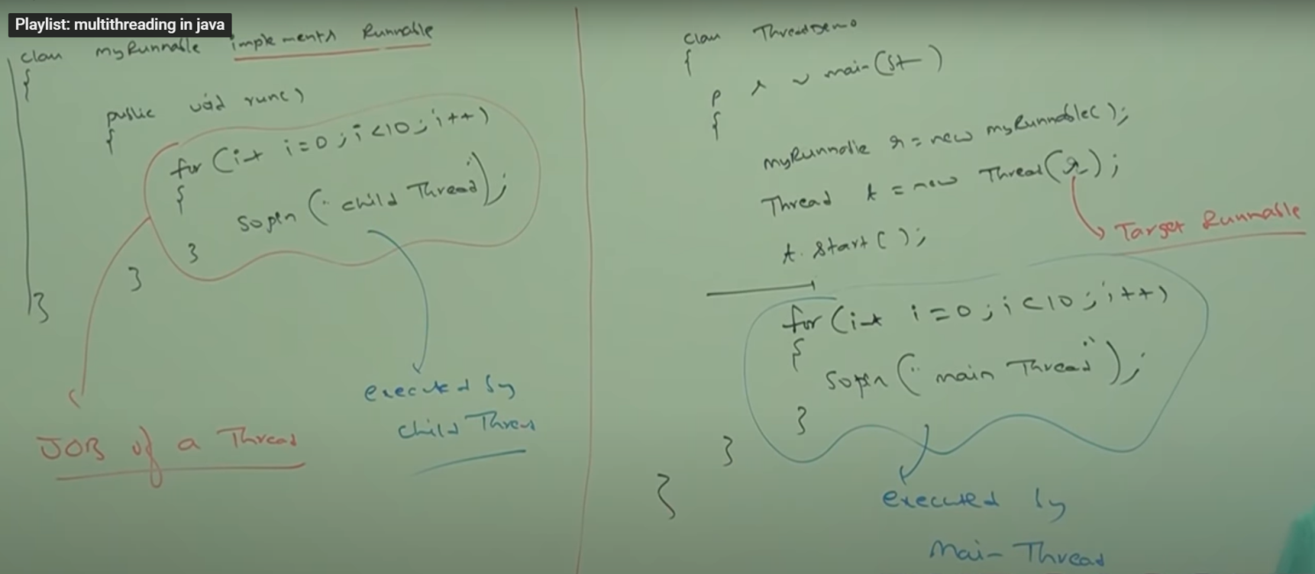

After t.start() method, there will be 2 threads.

Target Runnable: We will get mixed output and we can’t tell exact output. MyRunnable has just one method which is run. It cannot start the thread. So, we have to create Thread class object and start the thread. If we call t.start without passing the target Runnable to thread class, it will call the run method of Thread class which has empty implementation. So, in order to call the run method of MyRunnable class, we pass the target runnable.

Note: If we create a THREAD class object and call run method, it will not create a new thread but instead the run method is called as a normal method.

CASE STUDY:

|  |  |
| --- | --- |
| MyRunnable r = new MyRunnable();  Thread t1 = new Thread();  Thread t2 = new Thread(r); | |
| t1.start(); | A new thread will be created which is responsible for execution of Thread class run method, which has empty implementation. |
| t1.run(); | No new thread will be created and Thread class run method will be executed just like a normal method call. |
| t2.start(); | A new thread will be created which is responsible for execution of MyRunnable class run method. |
| t2.run(); | No new thread will be created and MyRunnable run method will be executed just like a normal method call. |
| r.start(); | We will get compile time error saying, MyRunnable class does not have start capability. |
| r.run(); | No new thread will be created and MyRunnable run method will be executed just like a normal method call. |

Which approach is best to define a thread?

Among the two ways of defining a thread, implements runnable approach is recommended. In the first approach, our class always extend Thread class, there is no chance of extending any other class. Hence, we are missing inheritance benefits. But in the second approach while implementing Runnable interface, we can extend any other class. Hence we won’t miss any inheritance benefits. Because of above reason, implementing Runnable interface approach than extending thread class.

**THREAD CLASS CONSTRUCTORS:**

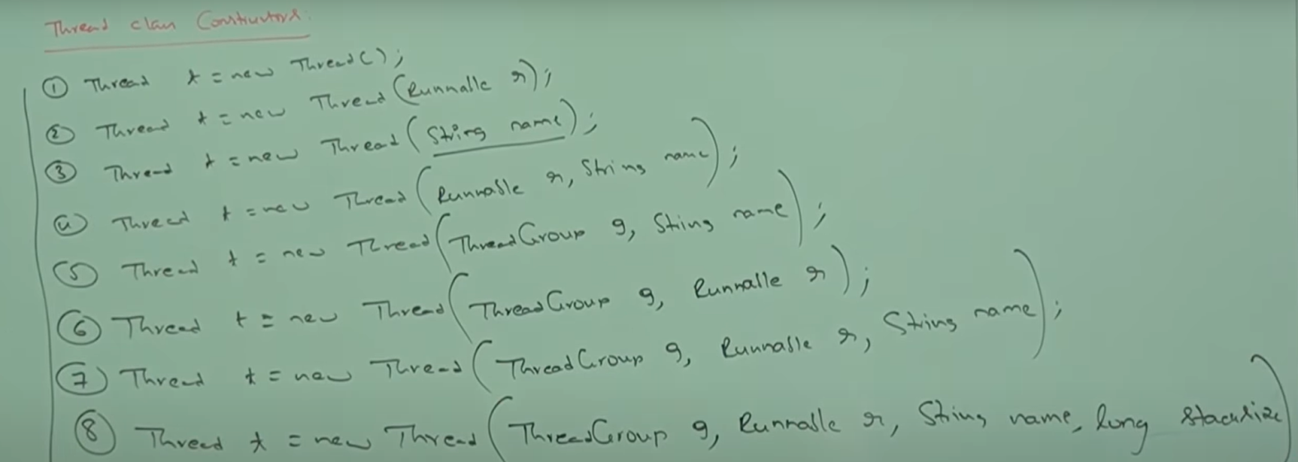

Thread Group: Every thread belongs to some group. Based on some functionality we can group threads in some group.

StackSize: For every Thread JVM will create a runtime stack.

APPROACH 3: Durga’s Approach (Not recommended to use)

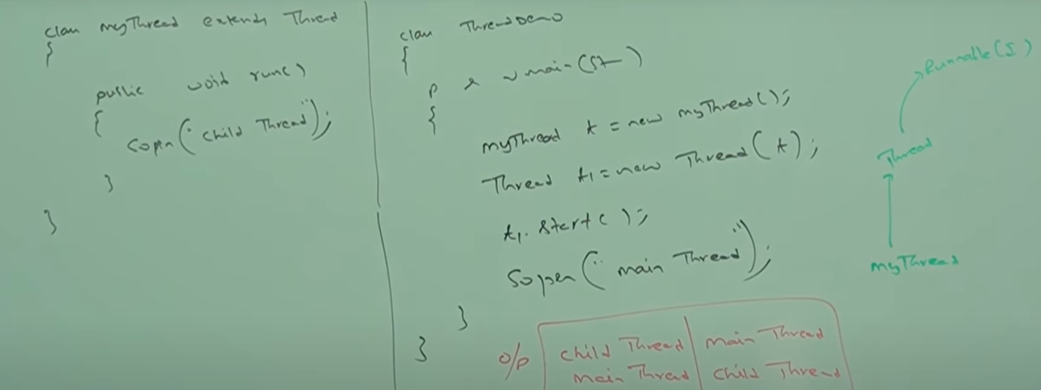

GETTING and SETTING name of a THREAD:

Every thread in java has some name. It may be default name generated by JVM or Customized name provided by programmer. We can get and set name of thread by using following two method of thread class.



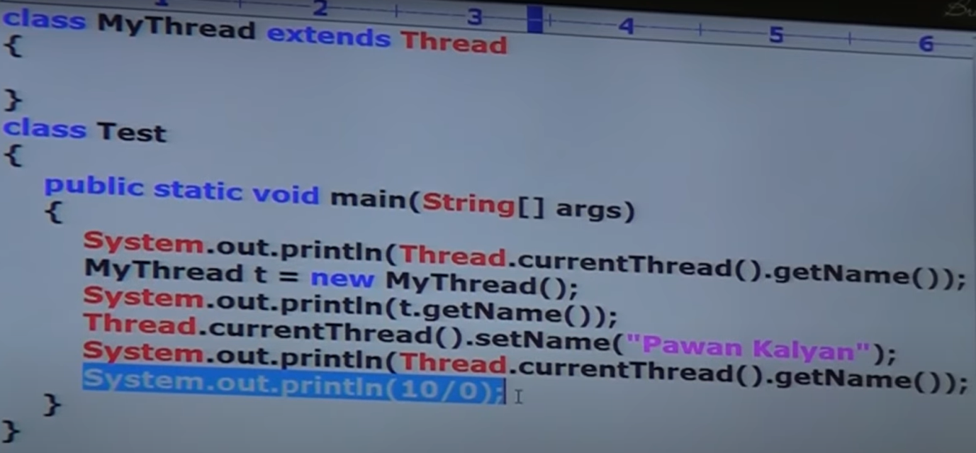

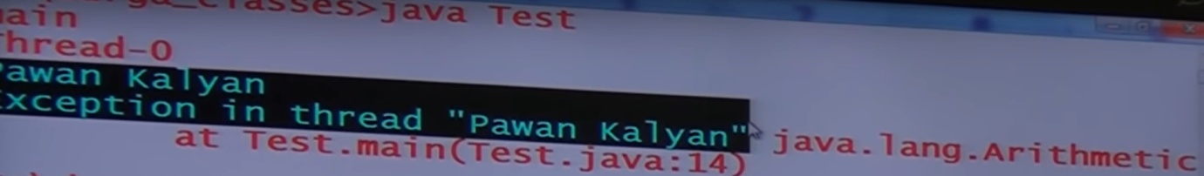

By default, JVM gives the name as thread-number (ex: thread-0).

We can get current executing thread object by using **thread.currentThread()** method. It is a static method present in Thread class.

THREAD PRIORITIES:

Every thread in Java has some priority. It may be default priority generated by JVM or customized priority provided by the programmer.

The Valid range of thread priorities is 1 to 10 where 1 is min priority and 10 is max priority.

Thread class defnies the following constants to represent some standard priorities.

THREAD.MIN_PRIORITY --------- > 1

THREAD.NORMAL_PRIORITY ----------- > 5

THREAD.MAX_PRIORITY ------------- > 10

Thread Scheduler will use priorities while allocating processor. The thread which is having highest priority will get a chance first.

If two threads have the same priority then we can’t expect the exact execution order. It depends on Thread Scheduler.

Thread class defines following methods to define priorities of a thread. Allowed values range is 1 to 10 for priority else we get an Illegal Argument Exception.

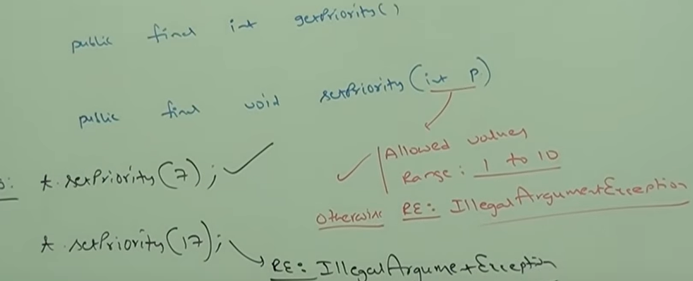

DEFAULT PRIORITY:

The default priority only for the main thread is 5. But for all remaining threads, **default priority** will be inherited from parent to child i.e. whatever priority the **parent thread** has the same priority will be there for the child thread.

Parent thread is the one which will create the child thread. For ex: In main method, we create the thread class object. This will be executed my main thread. So, main thread will be the parent here.

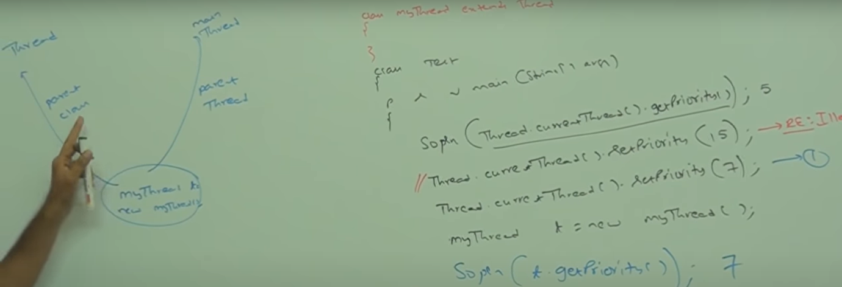

If we comment line 1, child thread priority will be 5.

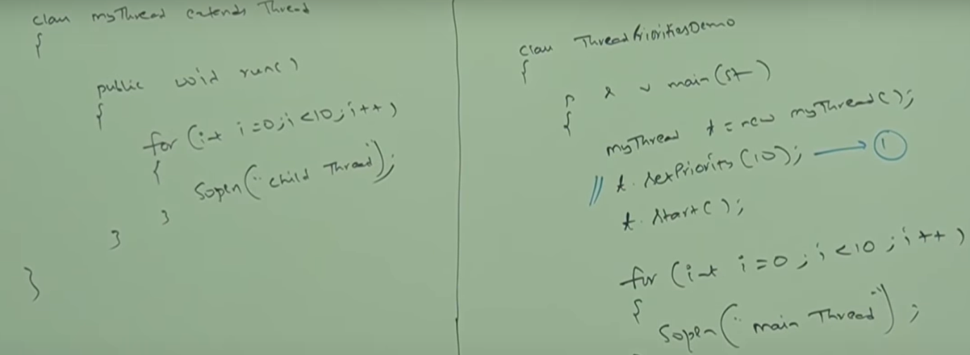

If we are commenting line 1, then both the main and child thread have the same priority 5 and hence, we can’t expect execution order and exact output.

If we not commenting line1, then main thread has priority 5 and child had 10. Hence, child thread will get a chance first followed by main thread. In this case output is Child Thread….. 10 times followed by Main thread ….. 10 times.

Some platforms won’t provide support for thread priorities. The problem is with the OS.

PRESENTING THREAD EXECUTION:

We can prevent a thread execution by using the following methods:

1. yield() 2) join() 3) sleep()

YEILD METHOD:

**Main Point: It causes to pass the current executing thread to give the chance for waiting threads of same priority**. If there is no waiting thread or all waiting threads have low priority then same thread can continue its execution.

If multiple threads are waiting with same priority, then which waiting thread will get the chance, we can’t expect. It depends on the thread scheduler.

The thread which is yielded, when it will get a chance once again, it depends on thread scheduler. So we can’t expect exactly. Ex: if tx thread is yielded, it will get added to the list of waiting thread and the control get passed say to thread t1. Now we cannot say exactly when tx will get a chance again to execute/run.

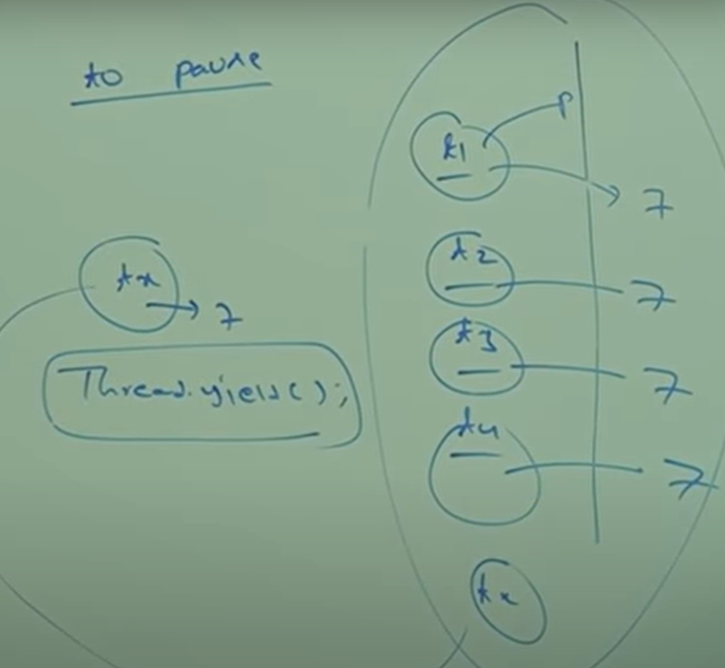

Long batsman, if more processing or more execution is there, in middle it is recommended to call yield methods.

PROPTYPE of YEILD METHOD:

**Public static native void yield();**

Native methods are the one which are not implemented in Java.

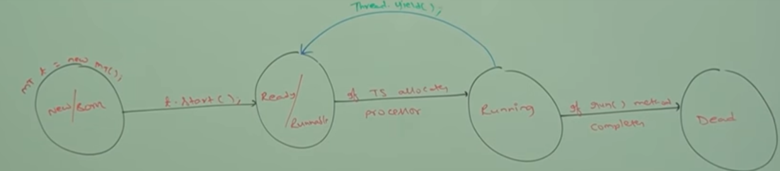

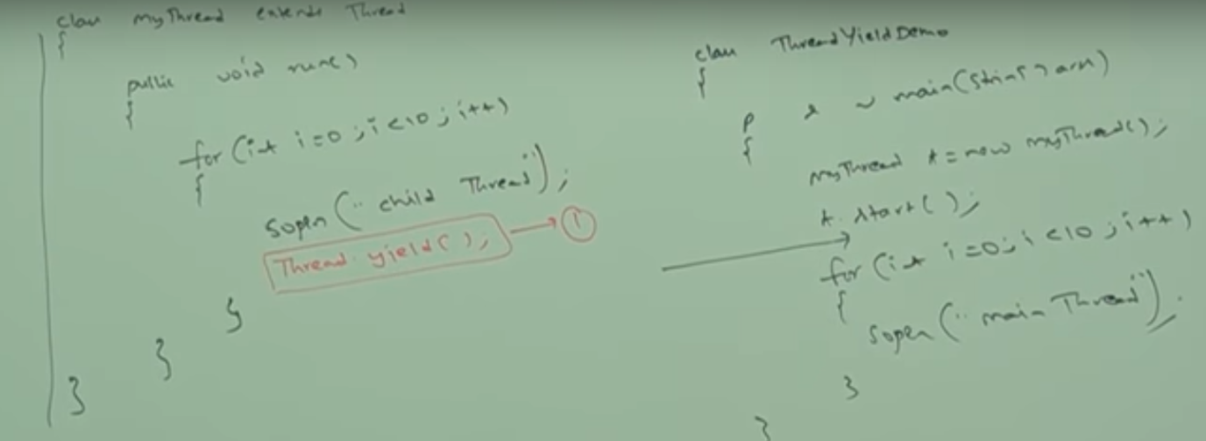

In the above program, if we commenting line 1, then both threads will be executed simultaneously and we can’t expect which thread will complete first.

If we are not commenting line 1, then child thread always call yield(). Because of this main thread will chance more no of times and the chance of completing main thread first is high.

Some platforms would not provide proper support for yield method. It is a native method (Not written in Java), so underlying OS level support should be present.

JOIN METHOD:

If a thread wants to wait until completing some other thread, then we should go for join().

For eX: If a thread t1 wants to wait until completing t2, then t1 has to call **t2.join()**. If t1 executes t2.join, then immediately t1 will be entered into waiting state until t2 is completed. Once t2 completes then t1 can continue its execution. Once t2 is completed t1 can come out of waiting state.

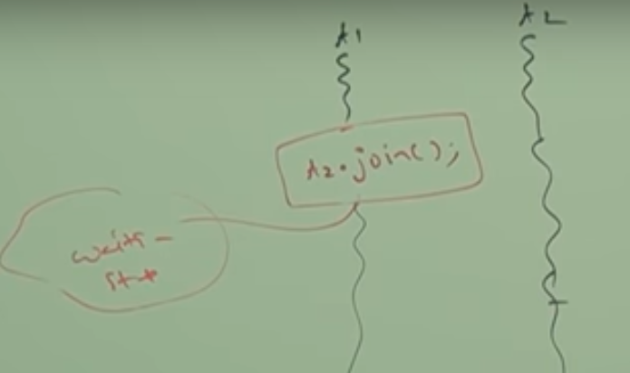

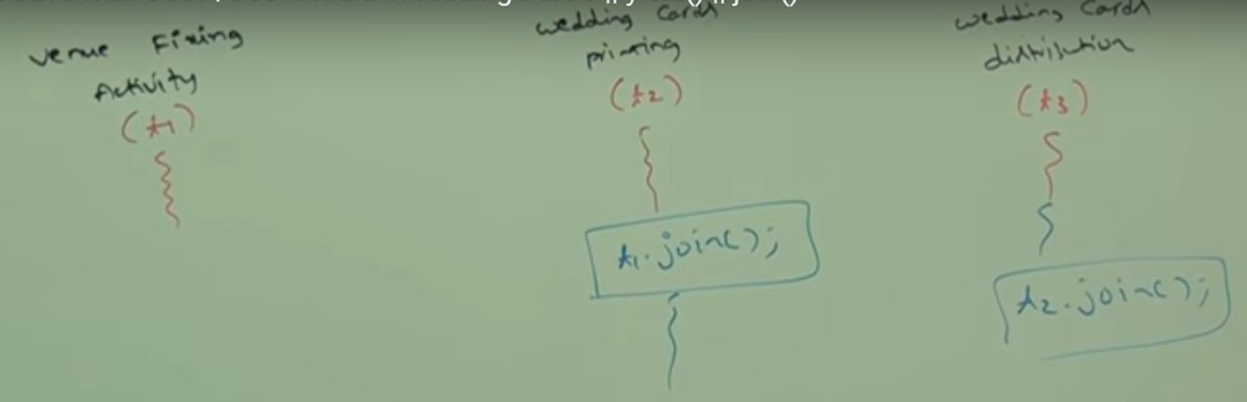

T3 has to wait until t2 is complete and t2 has to wait until t1 is complete.



Long milliseconds, int nanoseconds.

Note: Every join method throws interrupted Exception which is checked exception. Hence compulsorily we have to handle this exception either by using try catch or by using throws keyword otherwise **we will get compile time error**.

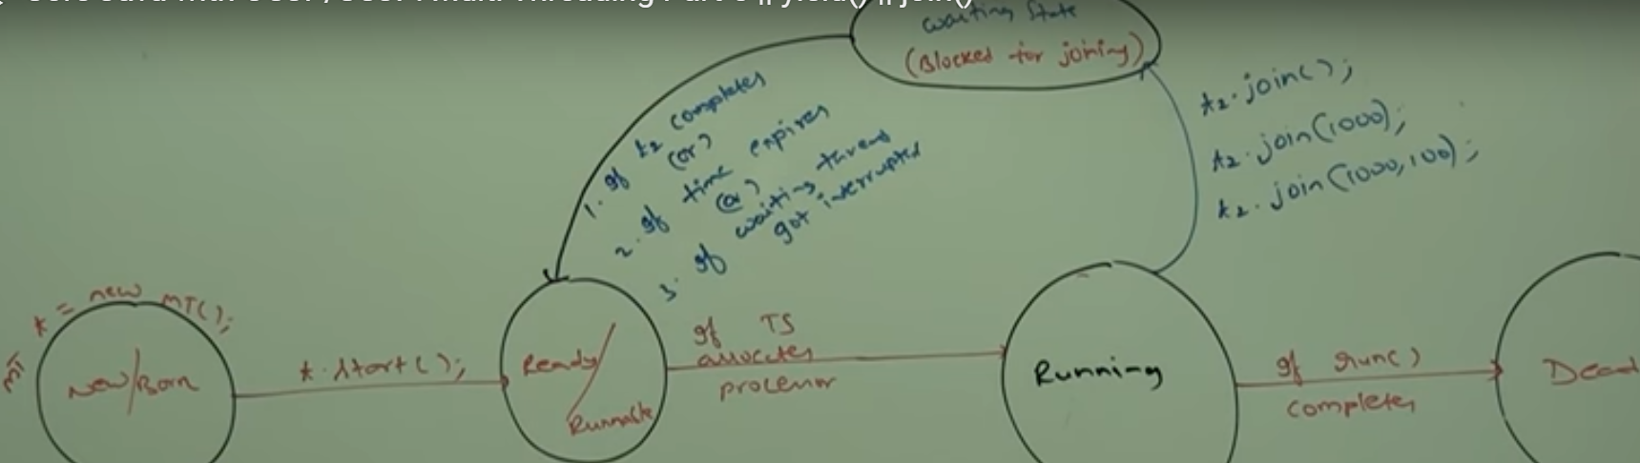

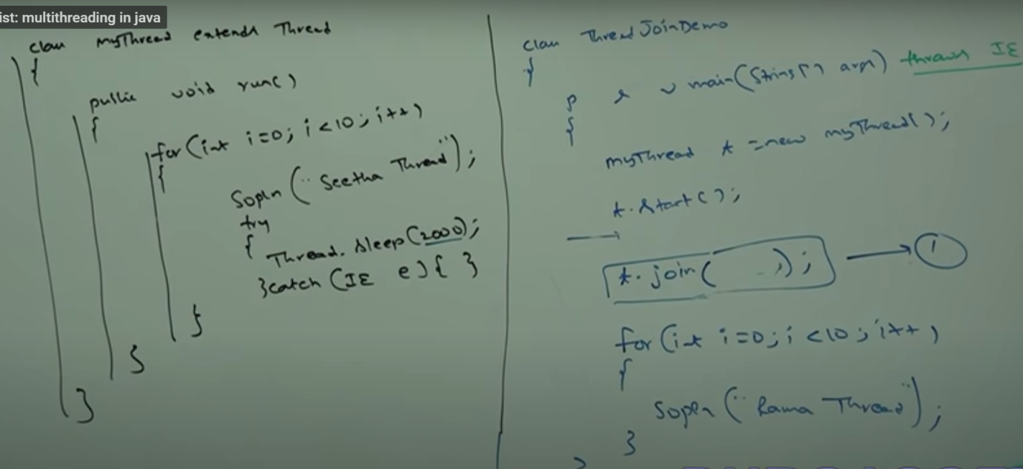

CASE: 1 --- If we comment line 1, then both main and child threads will be executed simultaneously and we can’t expect exact output.

If we are not commenting line 1, then main thread calls join method on child thread object. Hence main thread will wait until completing child thread. In this case output is –

Seetha thread … 10 times followed by Rama thread Rama thread … 10 times.

CASE: 2 --- Waiting of Child thread until completing main thread

So there child thread has to call join on main thread object. It will be requiring the reference of main thread.

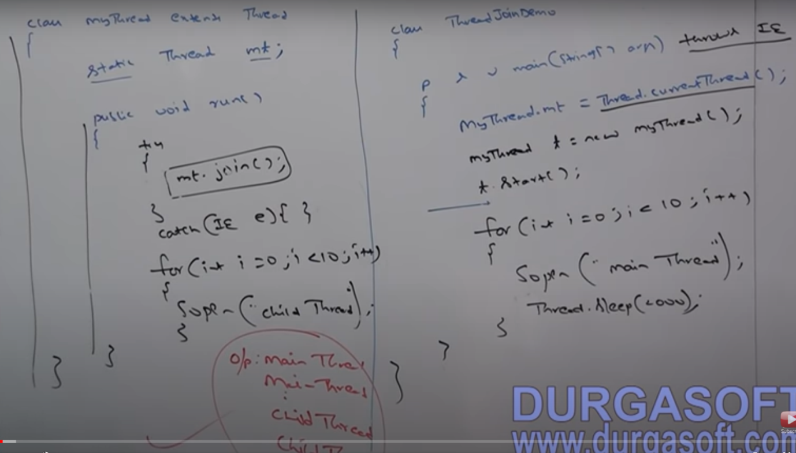

CASE: 3 – If main thread calls join on child thread object an child thread calls join method on main thread object, then both threads will wait forever an the program will be paused/stuck. This is something like deadlock.

CASE: 4 – If a thread calls join method on the same thread itself, then the program will be stuck. This is something like deadlock. The thread has to wait infinite amount of time.

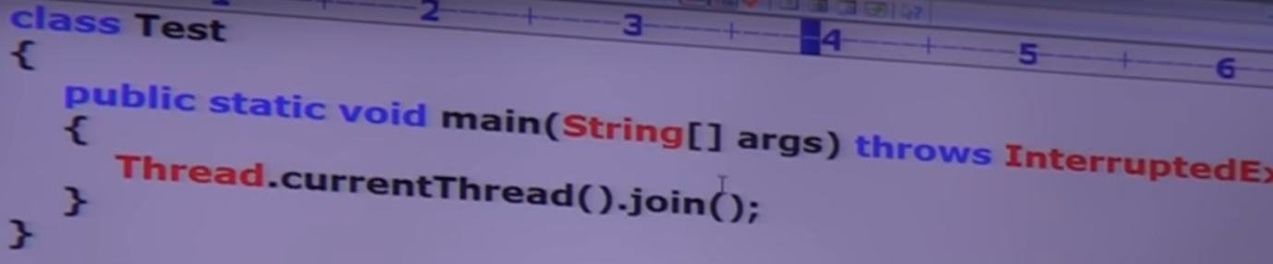

SLEEP METHOD:

If a thread don’t want to perform any operation for a particular amount of time, then we should go for sleep().

Every sleep method throws Interrupted Exception, which is checked Exception Hence, whenever we are using sleep method, compulsory we should handle interrupted Exception either using try-catch or throws keyword ot else the code won’t compile.

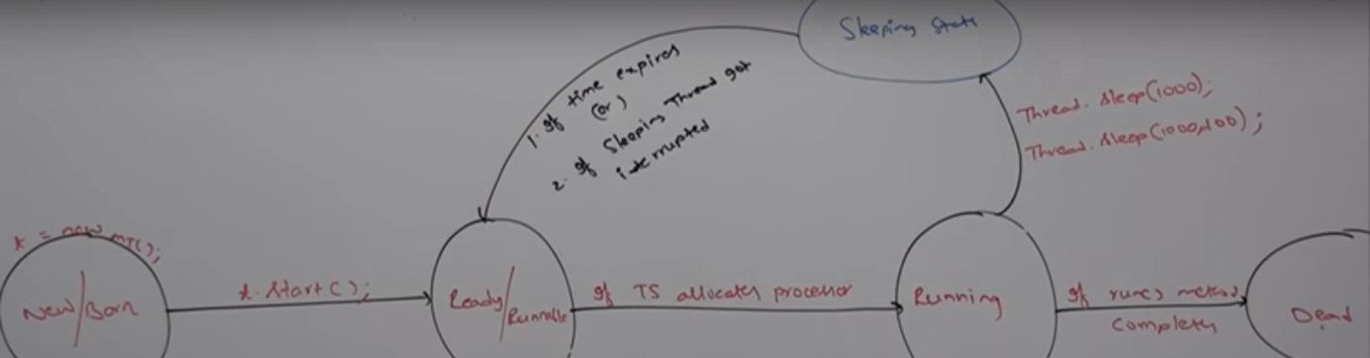

SYNCHRONIZER:

Synchronizer is a modifier applicable only for methods and blocks but not for classes and variables.

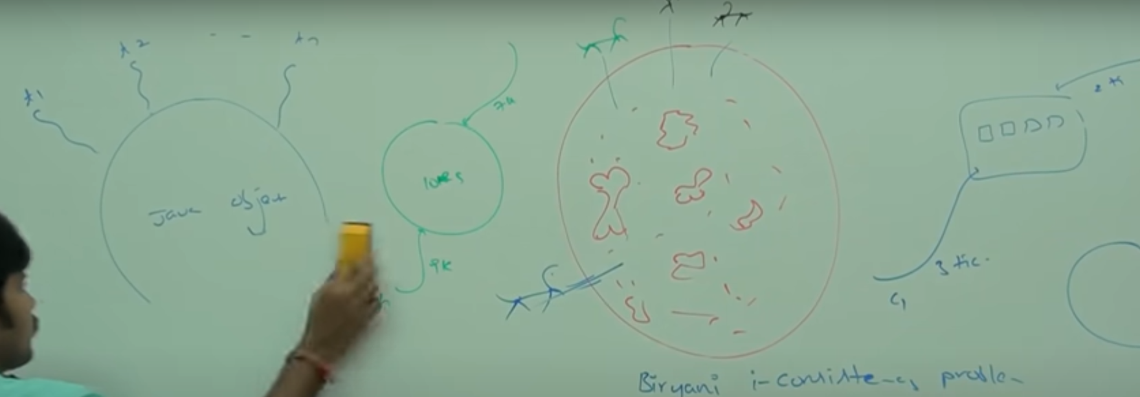

If multiple threads are trying to operate simultaneously on the same java object, then there will be chance of data inconsistency problem. To overcome this problem, we should go for synchronizer keyword. If a method or block declared as synchronizer, then at a time only one thread is allowed to execute that method or block under given object so that data inconsistency problem will be resolved.

Biggest advantage of Synchronizer keyword: Data inconsistency will be resolved

Disadvantage: It increases waiting time of the threads and creates performance problems.

If there is no specific requirement then it is not recommended to use synchronizer keyword.

Internally synchronizer concept is implemented by using lock. Every object in Java has a n unique lock. Whenever we are using synchronizer keyword then only lock concept will come into picture. If a thread wants to execute a synchronized method under given object, first it has to get lock of that object. Once thread got the lock, then it is allowed to execute any synchronizer methods on that object. Once method execution completes, automatically thread releases the lock. Acquiring and releasing lock internally is kten care by JVM. Programmer is not responsible for this activity.

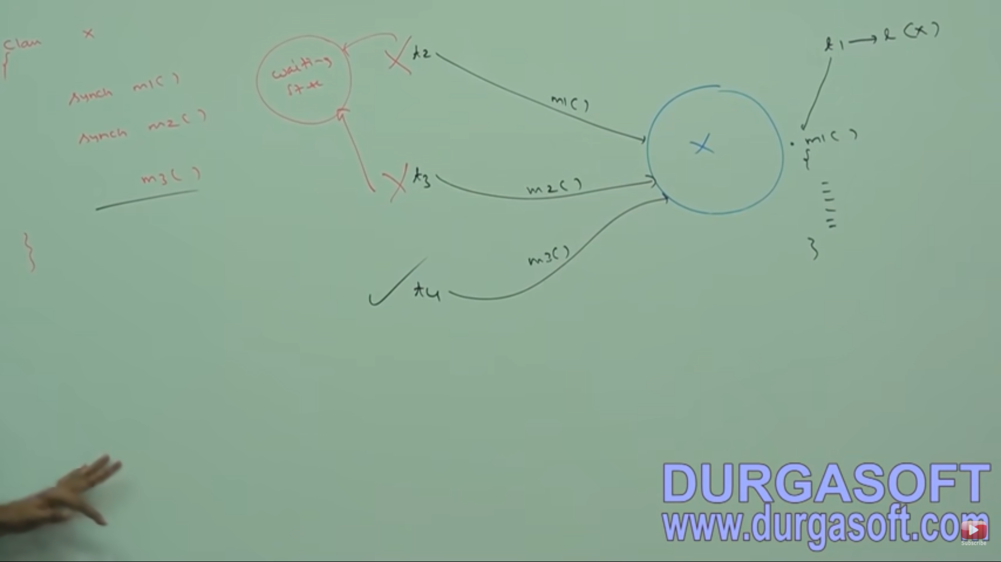

While a thread executing synchronized method on an object, the remaining threads are not allowed to execute any synchronizer method on the object. But remaining threads are allowed to execute non-synchronized methods simultaneously. Lock concept is implemented based on object and not on method.

Now the object is already locked by a thread say t1. How other threads are able to access non synchronized methods using the same object?

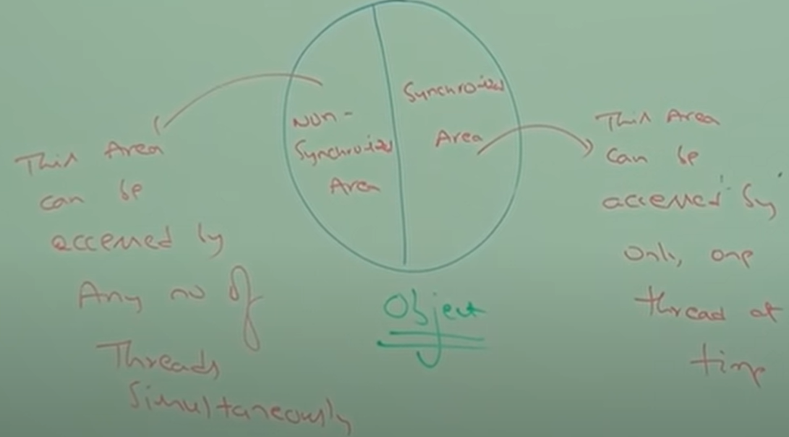

For every object, we have 2 areas – Synchronized area (where update operations are performed – or update operations are performed) and non-Synchronized area (read operations are performed). If update operations are performed in non-synchronized area then it is not a good programming practice.

So, an area (method/block) which does an update operation/insert/remove/replace etc. should be marked as synchronized and it will only be accessed by 1 thread at a time. If you are just doing read operation, this can be read by multiple threads and here state of the object will not change. This method can made as non-synchronous method/area. This is upon us which to make synchronized and which not to.

For ex: Check Availability in Reservation System -- > here read is performed and should be non-sync while booking a seat should be made as synchronized.

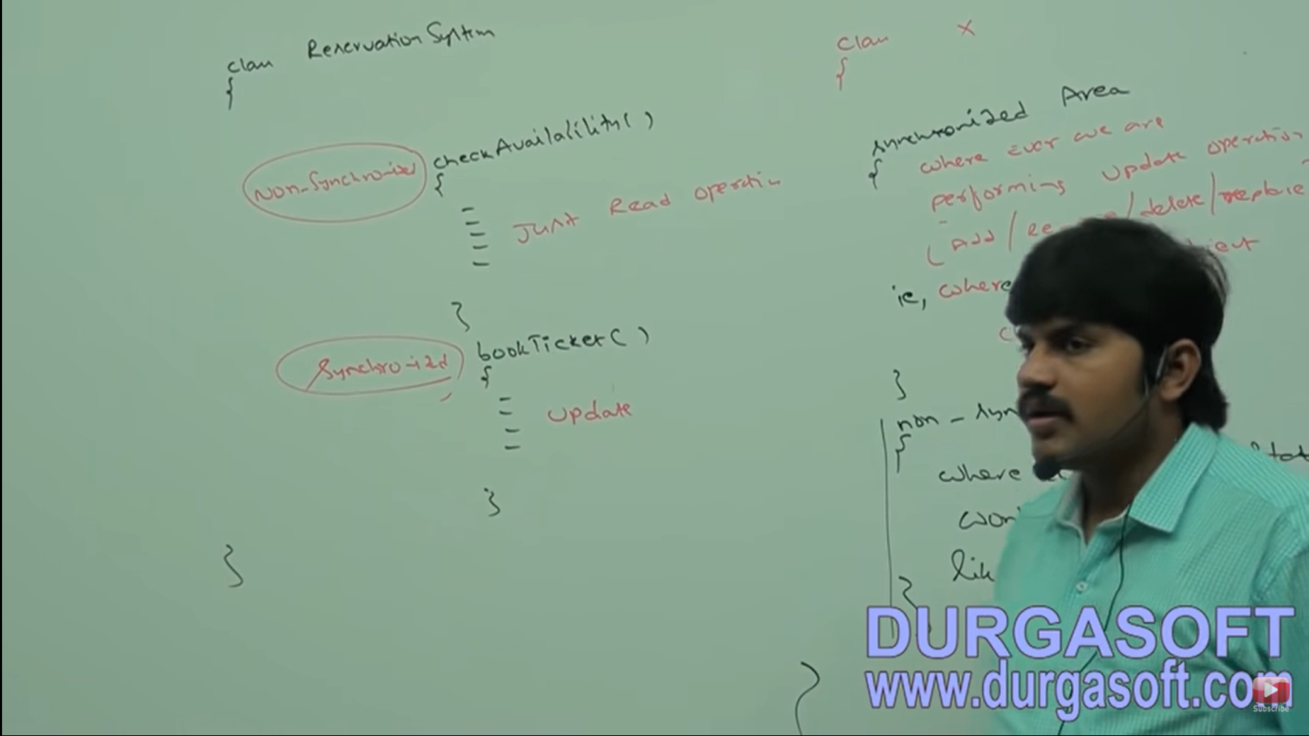

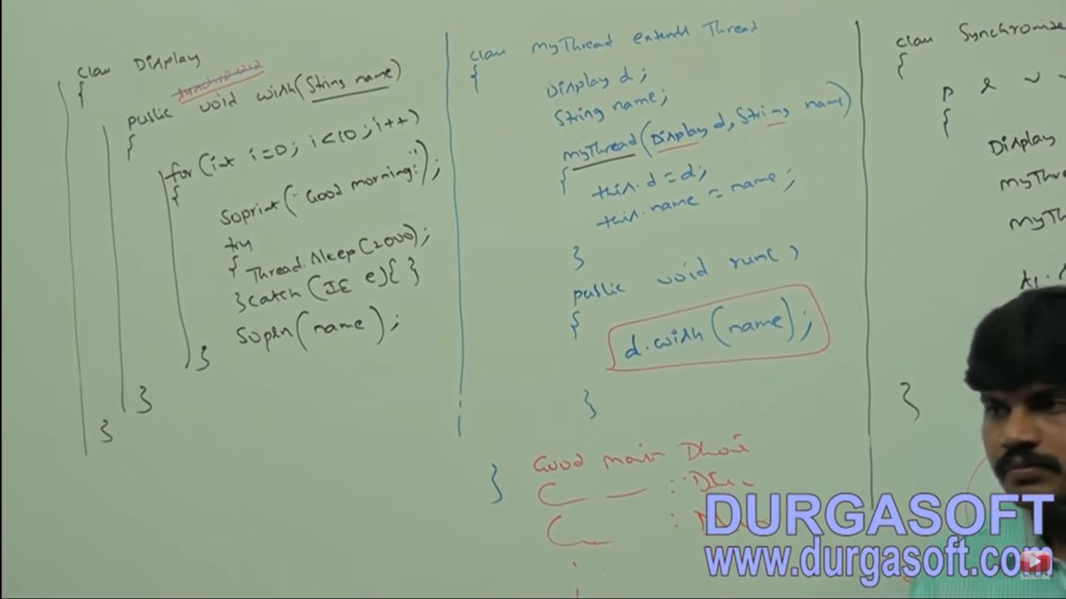

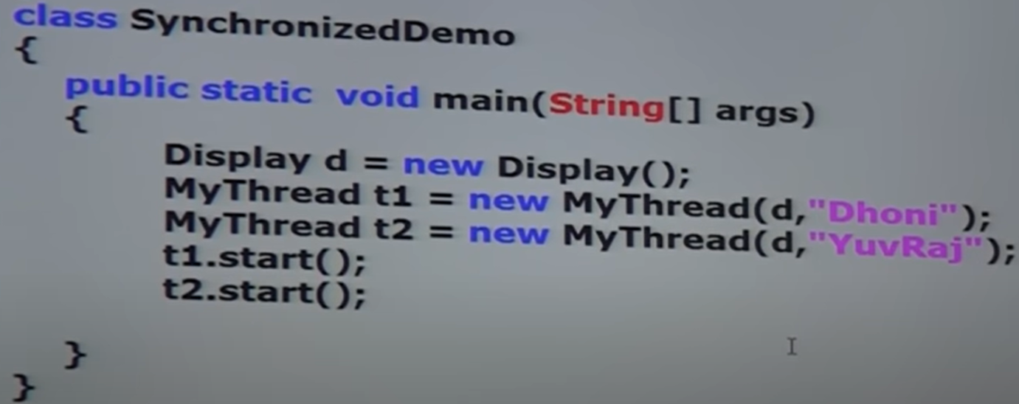

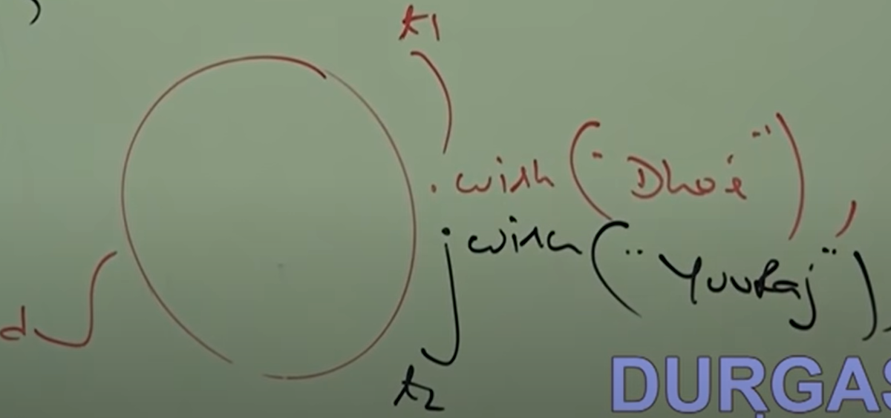

If we are not declaring wish method as synchronized then both threads will be executed simultaneously and hence we will get irregular output (mixed output).

If we declared wish method as synchronized then at a time only one thread is allowed to execute the wish method using the object and we get a regular output.

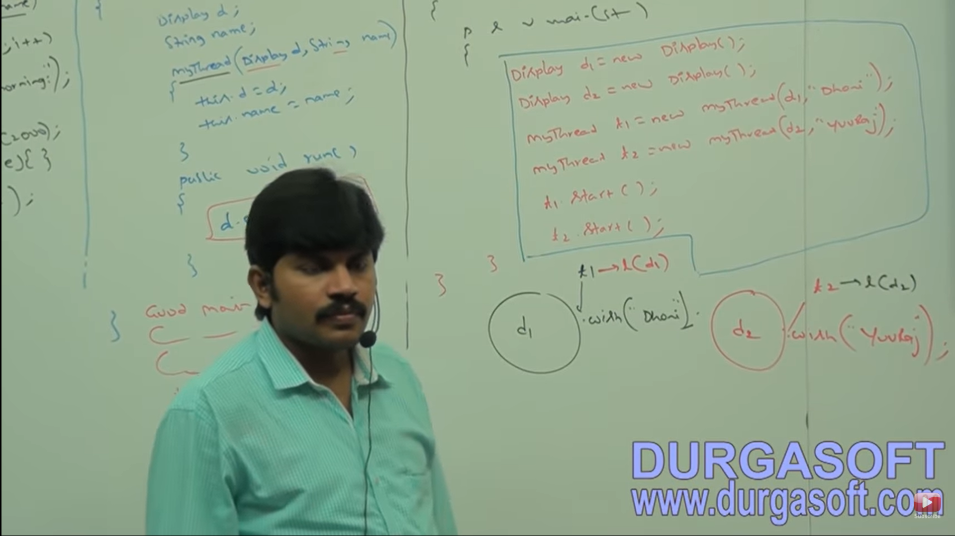

Even though wish method is synchronized, we will get irregular output. This is because threads are operating on different Java Objects.

Conclusion: If multiple threads are operating on same Java Objects then synchronization is required. If multiple threads are operating on multiple Java objects, then synchronization is not required.

CLASS LEVEL LOCK:

Every class in Java has a unique lock which is nothing but Class Level Lock. If a thread wants to execute a static synchronized method, then thread requires class level lock. Once the thread got class level lock, then it is allowed to execute any static synchronized method of that class. Once method execution completes, automatically thread releases the lock.

Ex: In above program, with 2 display objects present and wish method is static synchronized, then we will get regular output since class level lock is attained.

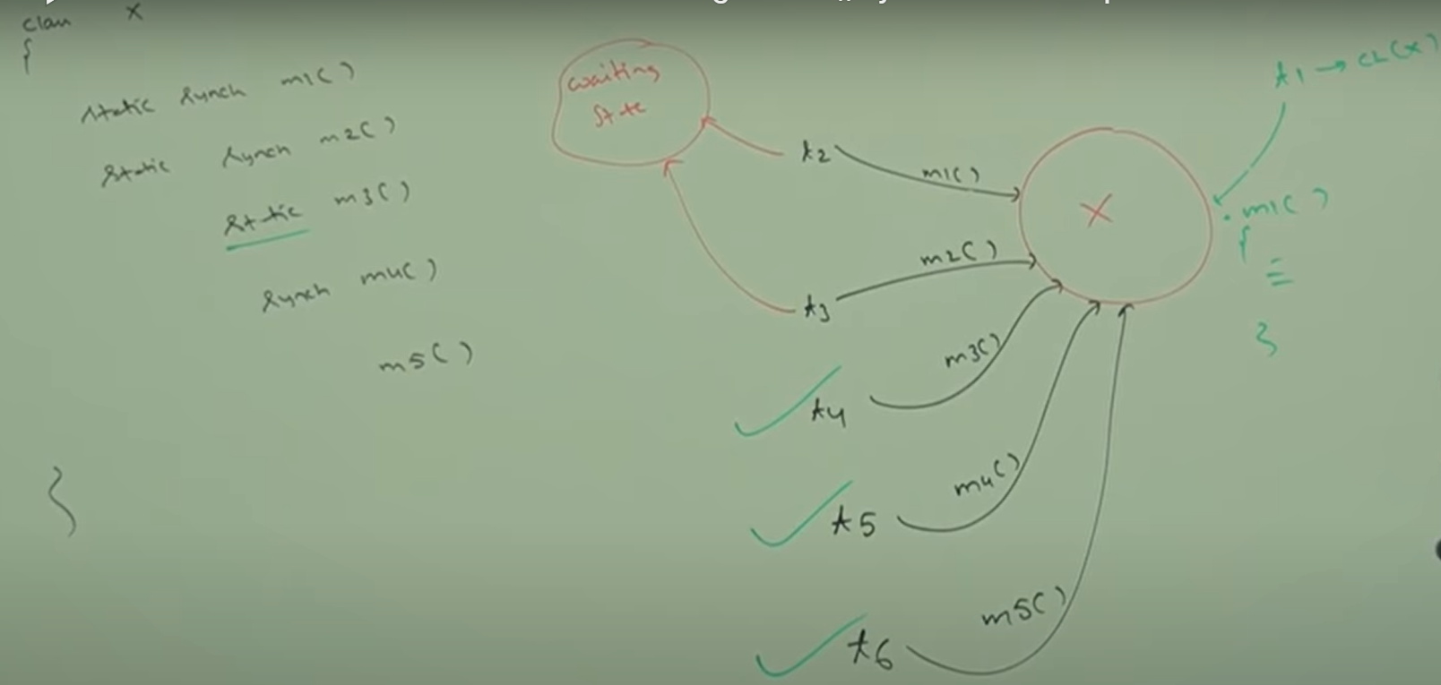

While a thread execution, static synchronized method, the remaining threads are not allowed to execute any static synchronized method of that class simultaneously. But remaining threads are allowed to execute the following methods simultaneously.

1. Normal Static method
2. Synchronized instance methods
3. Normal instance methods

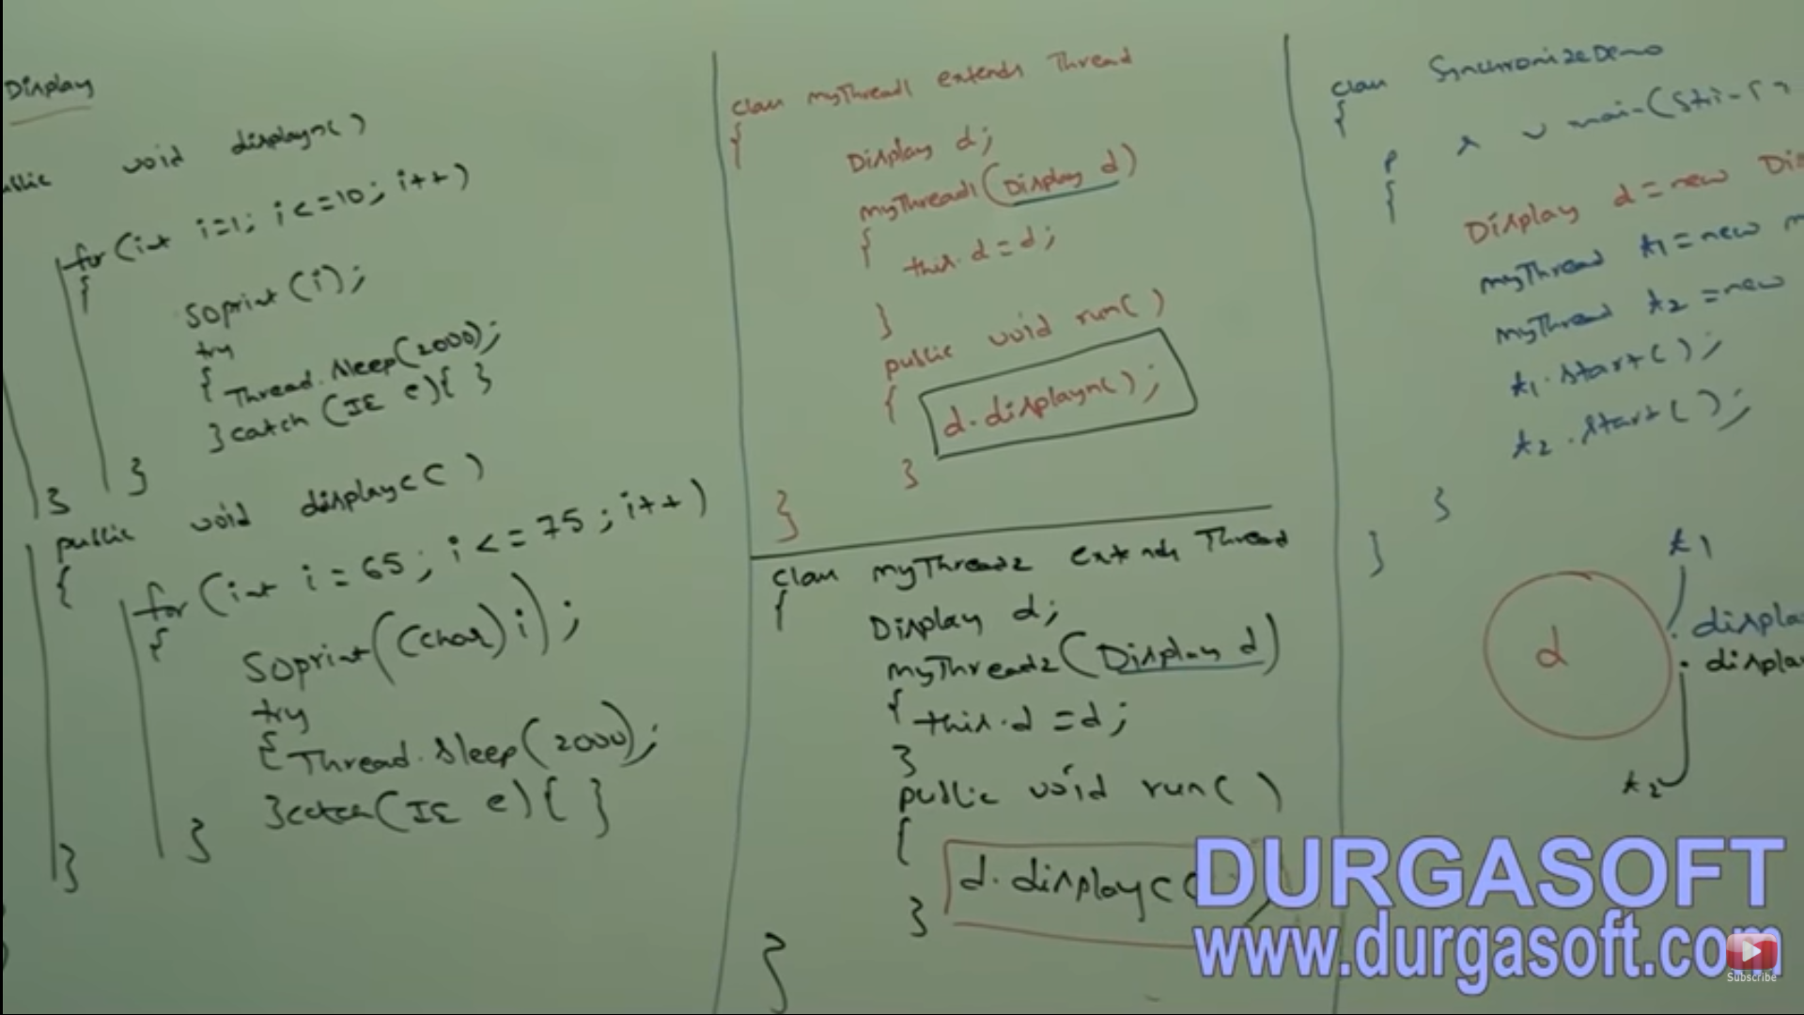

In this when executed, output will be irregular since both threads will be executed simultaneously ,though the threads are of diff classes but they are acting on same Display object. When the methods are made synchronous, then a regular output is observed. Either 123…abcd…. (Or) abcd…..1234

SYNCHRONIZED BLOCK:

If very few lines of code require synchronization, then it is not recommended to declare entire method as synchronizer. We have to enclose those few lines of the code by using synchronized block. The main advantage of synchronize block over synchronized method is it reduces waiting time of threads and improves performance of the system/application.

Ex: If there is 1k lines of code for a method with few lines which require synchronization, it is not a good to make the method as synchronized. Instead we can make the few line synchronised using a block. So this method can be access by multiple threads simultaneously but the block will be executed by just 1 thread at a time.

We can declare synchronized block as follows:

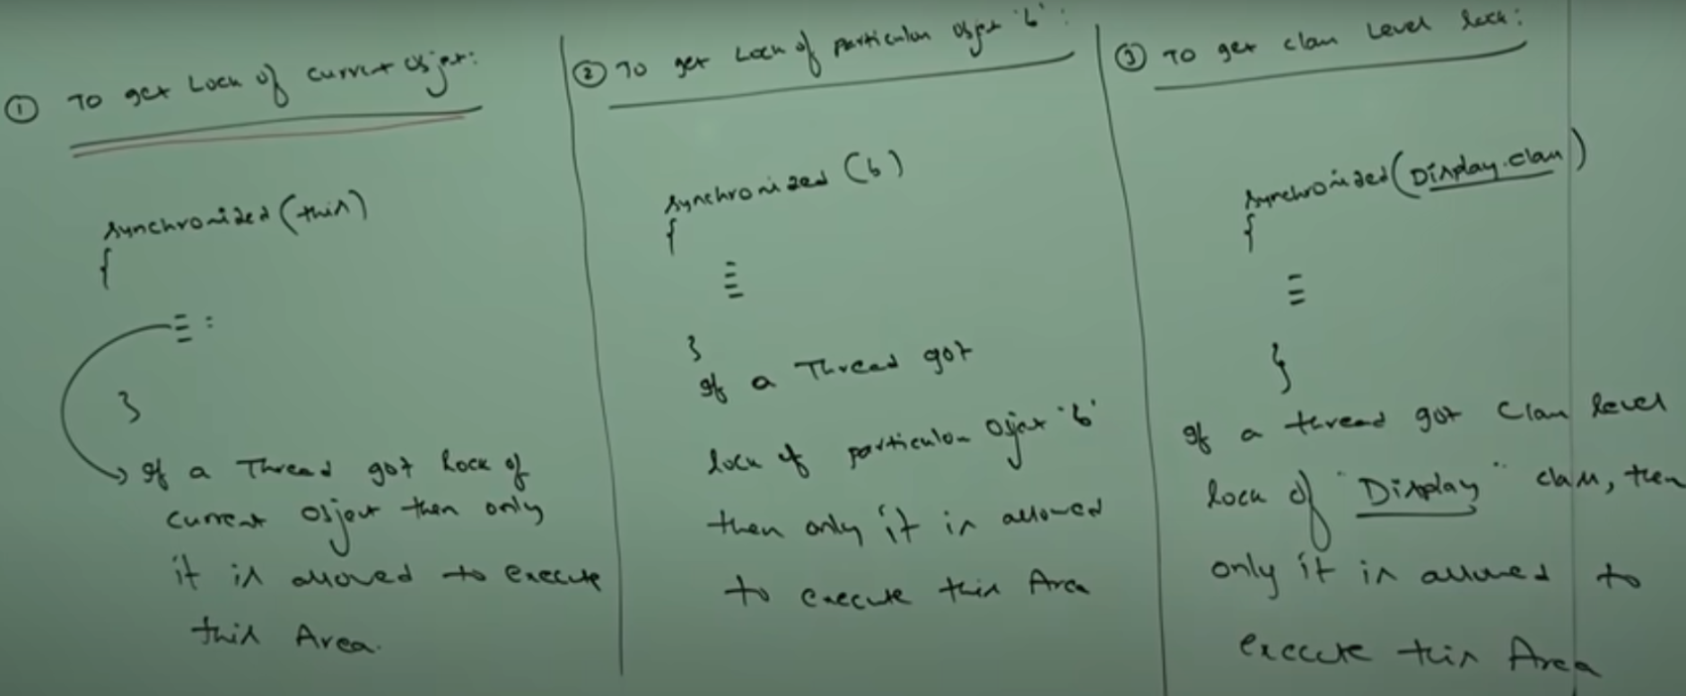

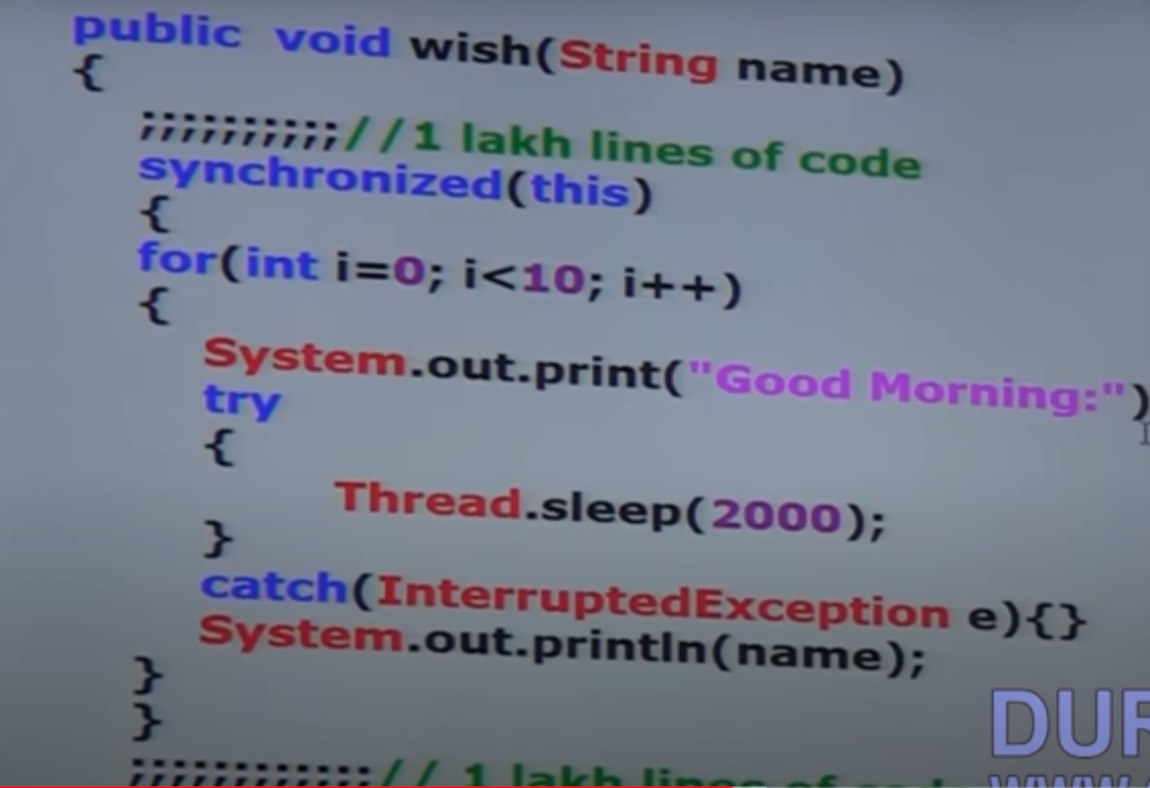

Only two types of locks are present in Java – Object level lock and Class Level Lock. Lock is not applicable for primitive values. So in above code if we pass a primitive type as an argument in synchronized block, it will give a Compile Time Error.

FAQs:

1. What is synchronized keyword? Where we can apply it. (It is a modifier applicable for method,blocks but not for variables, classes).
2. Explain advantage of synchronize keyword. – Resolved Data inconsistency problems
3. Explain disadvantage of synchronize keyword
4. What is RACE condition? When multiple threads are operating simultaneously on same Java Object, then there may be a chance of Data inconsistency problem. This is called RACE condition. We can overcome this problem by using synchronized keyword/modifier.
5. What is **object lock** and when it is required. –> Req. When a thread wants to execute synchronized method
6. What is class level lock and when it is required. –> Req. When a thread wants to execute static synchronized method
7. Diff btw Class and Object Level lock
8. While a thread executing synchronized method under given object, is remaining threads allowed executing any other synchronized method simultaneously under same object. –> No, obj will be locked by 1st thread
9. What is synchronized block and how to declare it to get lock of current object, class level lock
10. What is advantage of synchronized block over synchronized method?
11. Can a thread acquire multiple locks simultaneously? –> Yes, from different objects.

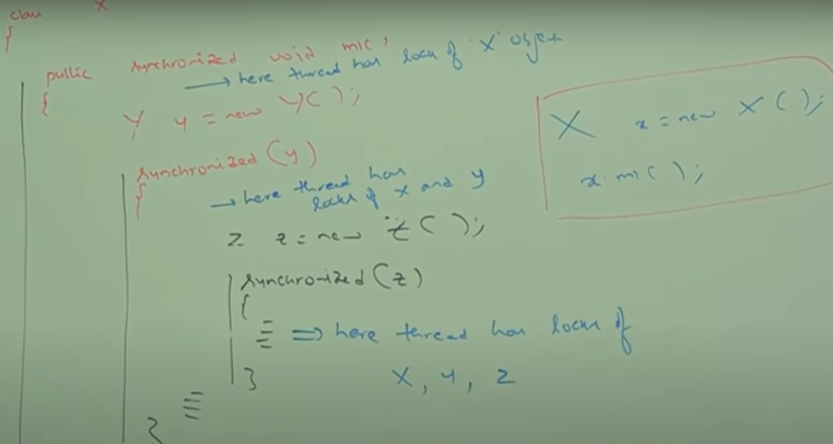

1. What are synchronized statements? 🡪 The statements present in synchronized method and synchronized block are called synchronized statements. (Interview people created this terminology)

**INTERTHREAD COMMUNICATION:**

Need for this:

Two threads can communicate with each other by using wait(), notify() and notifyAll() methods.

The thread which is expecting updation is responsible to call wait(), then immediately the thread will enter into waiting state. The thread which is responsible to perform updation, after performing updation it is responsible to call notify(). Then waiting thread will get that notification and continue its execution with those updated items.

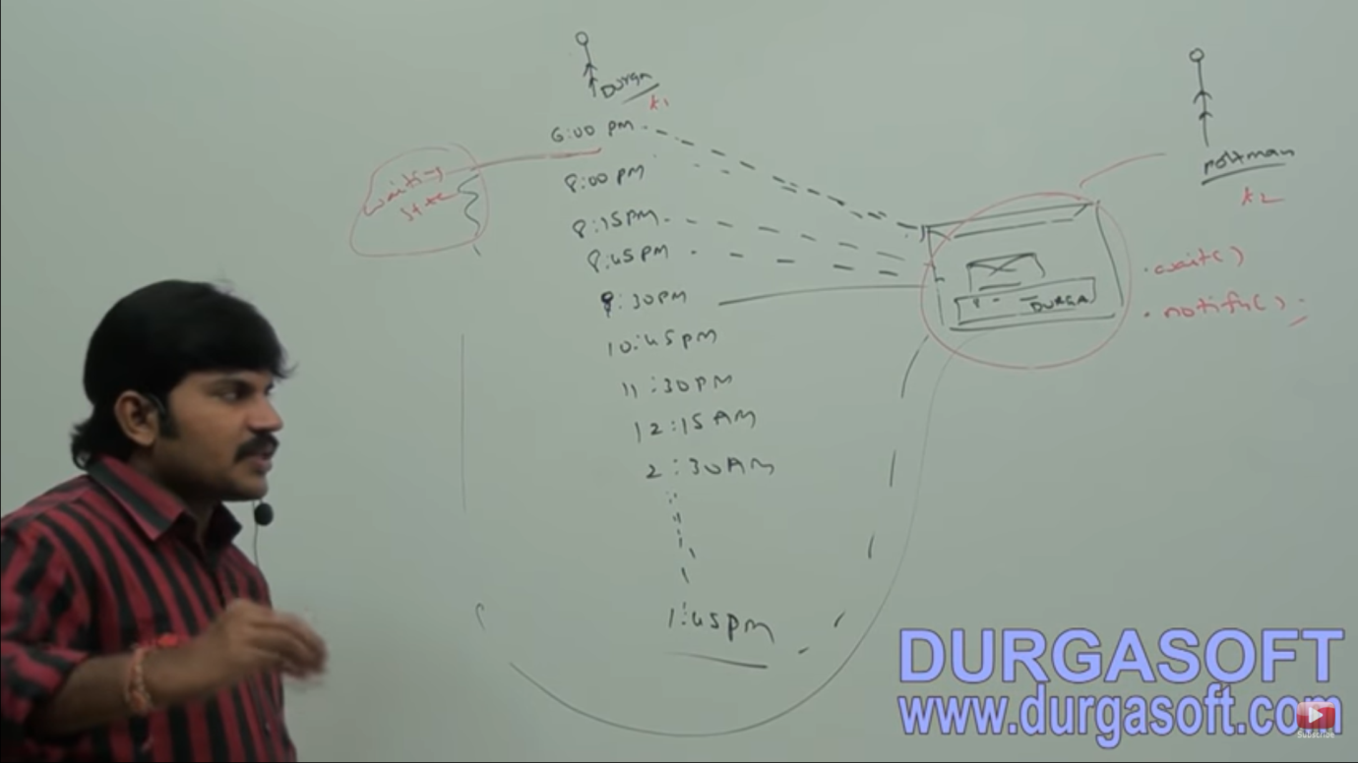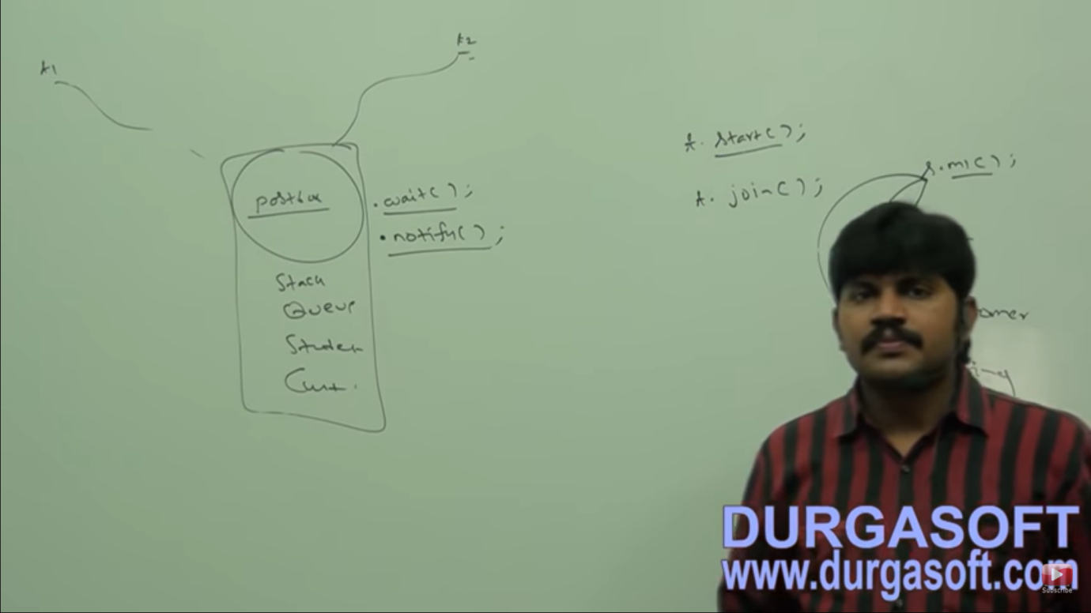

Durga (t1) --- Postbox(object) ----- Postman(t2) Example

These three methods are present in object class and not in thread class. Why so? --> The thread has to call the wait and notify method on any java object (Post-box object here). So, these methods should be present in the object class. It is not called on the thread object. Methods such as start and join which are applicable only for threads are called on thread object and they are present in thread class.

**NOTE: To call wait(), notify() or notifyAll() methods on any object, thread should be owner of that object i.e. the thread should have lock of that object i.e. the thread should be in synchronized area. Hence, we can call all the three methods only from synchronized area (synchronized method or block) otherwise we will get runtime exception saying IllegalMonitorStateException.**

If a thread calls wait() method on any object, it **immediately** releases the lock of **that particular object** and enter into waiting state. (If the thread has lock of other objects too, those will be remained)

If thread calls notify method on any object, it releases the lock of the object but it **may not be immediate**. Except wait(), notify() and notifyAll(), there is no other method where thread releases the lock.

**Why thread has to release the lock**? This is because, the other thread say t2 will have to call notify () method from the synchronized method/block only. For this t2 will require lock of the object.

|  |  |
| --- | --- |
| Method | Is release lock or not |
| wait() | Yes |
| notify() | Yes |
| notifyAll() | Yes |
| yield() | No |
| join() | No |
| sleep() | No |

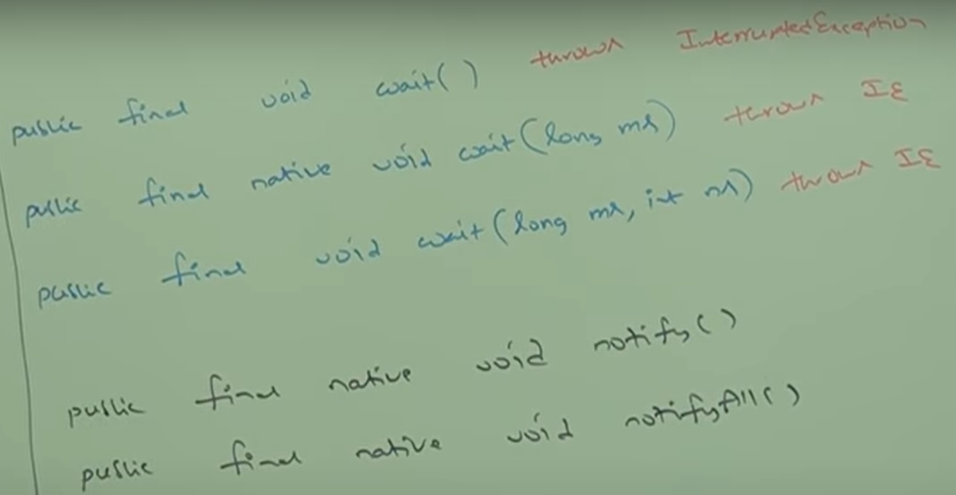

For notify(), notifyAll() thread does not go into waiting state. So, it does not throw Interrupted EXCEPTION. Every wait() method throws Interrupted Exception which is a checked exception. So, whenever we are using wait() method compulsorily we should handle this exception with using try-catch or by using throws keyword otherwise we will get Compile time Error. When the thread is in waiting state and is interrupted by another thread, it will throw Interrupted Exception.

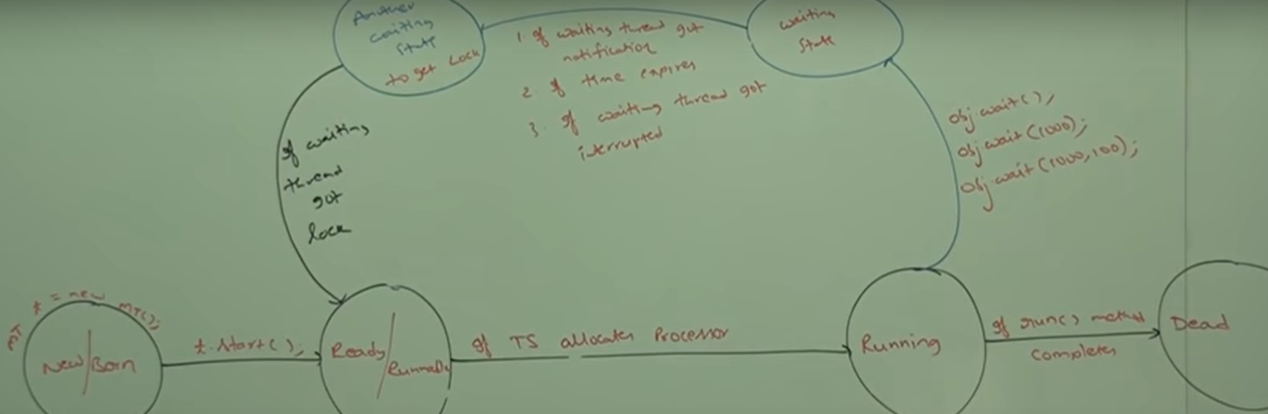

So, after wait state, the thread does not go into ready/Runnable state directly. It first goes to another waiting state to acquire the lock.

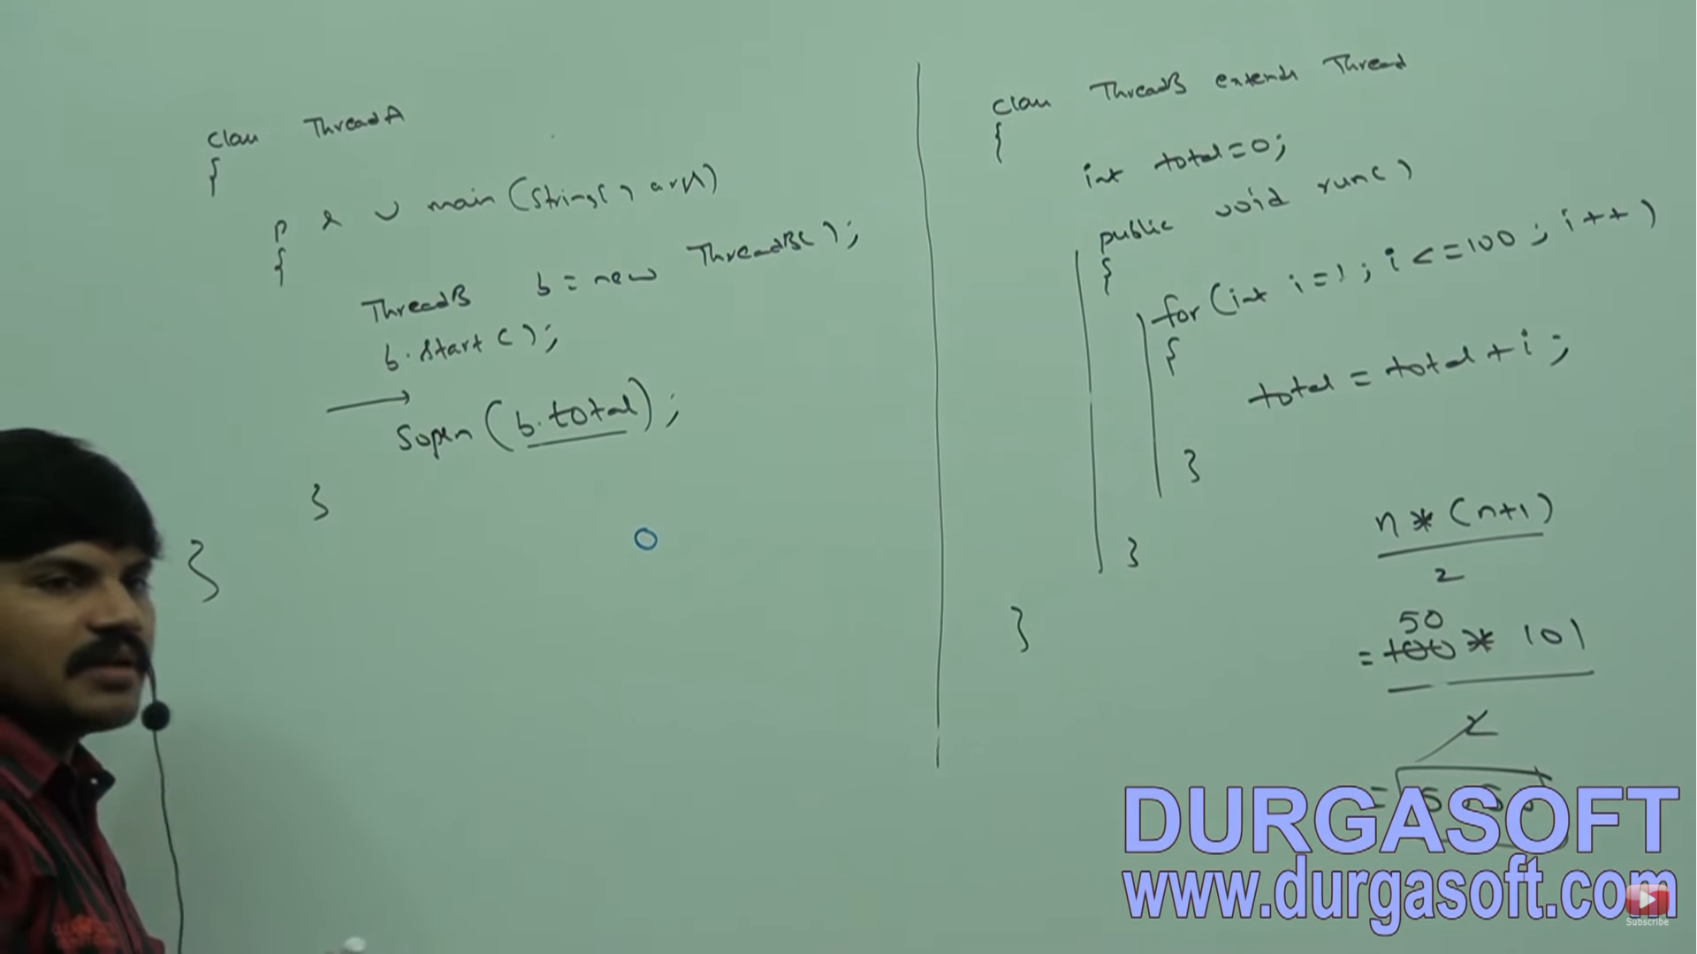

The above code can print value as 0, 5050 or any intermediate value depending on which thread got executed first. The main thread is expecting some updation here i.e. the value of total.

We can use multiple threads here after line b.start()

1. If we use Thread.sleep(10000); or Thread.sleep(0,1); --- > This will give us 5050 since main thread has to sleep for a while and in that time child thread performs the operation. Calling sleep method is not recommended here for 2 reasons
2. The operation is done in nano secs and if 10000ms is provided the main thread will be unnecessarily sleeping rest of the time. Overall performance will be down.
3. If the calculation is big and within 10 secs it is not going to complete, then intermediate value will be printed. So, sleep method is not recommended.
4. If we use b.join(); ---> We are expecting an updation. Join method is not recommended though it works. If there is a large code written after for loop in the run method, then main thread has to wait until the run method is complete. So, using join method is not a correct implementation here. Performance will get down.
5. We can use wait() and notify() here. These needs to be added in synchronized blocks here.

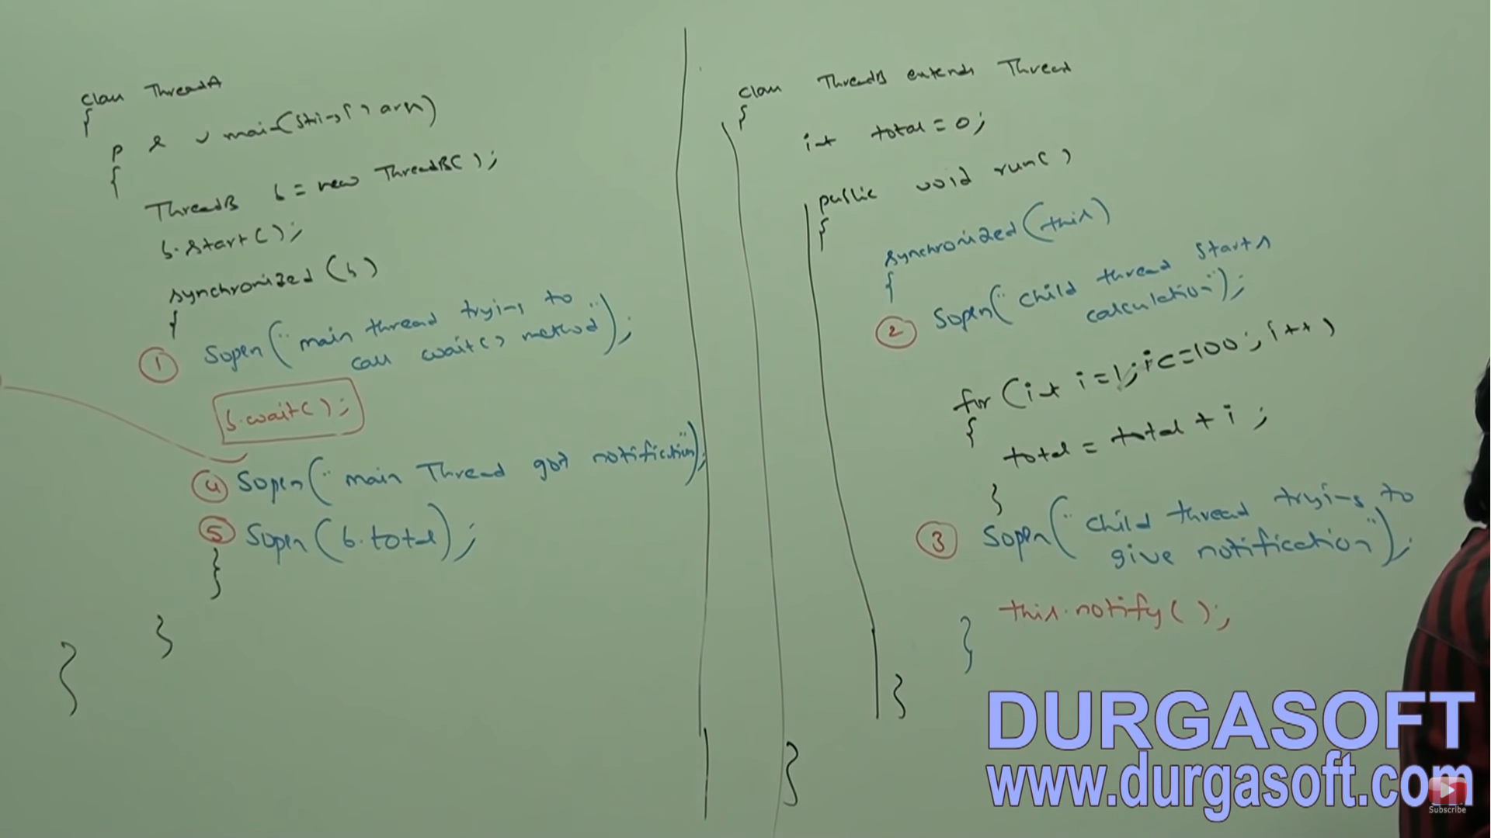

If thread.sleep(1000); is added after b.start(); --> Child thread gives notification first only since it gets competed while main thread is still sleeping. Now the main thread executes wait() method. Since the child has already notified, the main thread will be in waiting state for the rest of the life. This situation can be handled by giving a time even in main() method.

PRODUCER- CONSUMER Problem:

Producer thread is responsible to produce items to the queue and consumer thread is responsible to consume items from the queue. If a queue is empty, then consumer thread will call wait method and enter into waiting state. After producing items to the queue, producer thread is responsible to call notify method, then waiting consumer will get the notification and continue its execution with updated items.

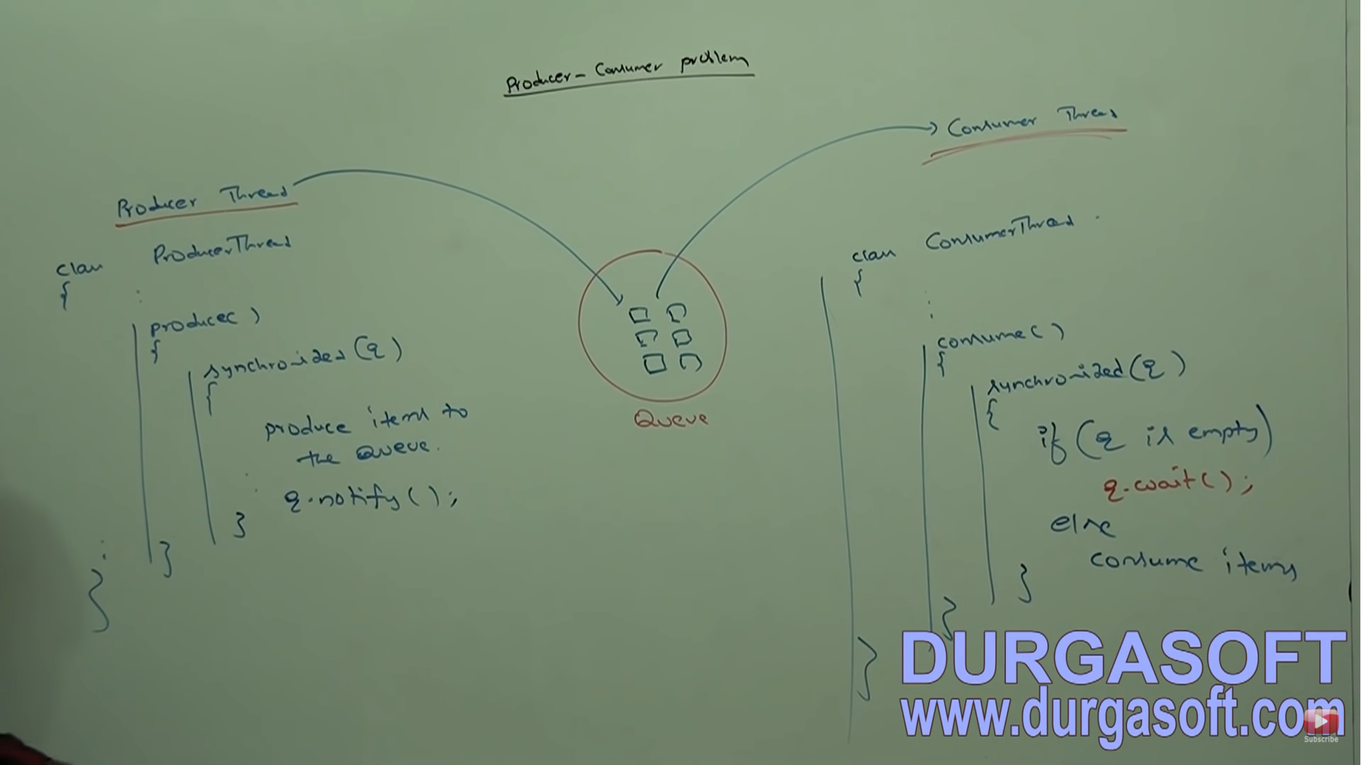

DIFFERENCE between notify() and notifyAll():

We can use notify method to give the notification to only one waiting thread. If multiple threads are waiting, then only one thread will be notified and the remaining threads have to wait for further notifications. We can’t expect which thread will be notified. It depends on JVM.

We can use notifyAll method to give notification for all waiting threads of a particular object. Even though multiple threads are notified but execution will be performed one by one because threads require lock and only one lock is available per object.

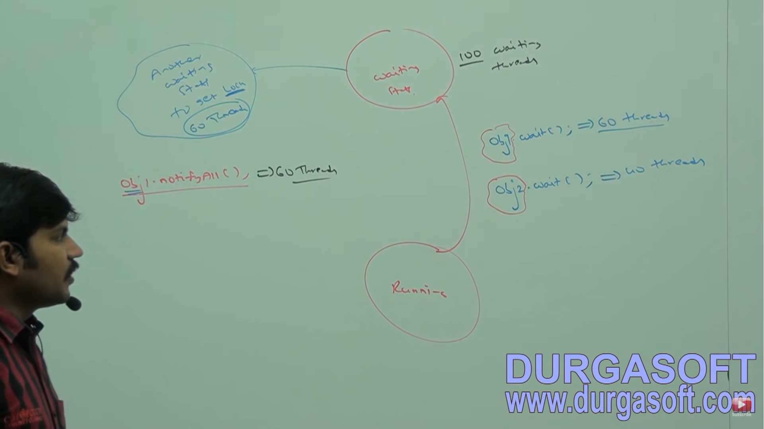

On which object we are calling wait method, thread require lock (**lock done using synchronized(s1)** in below example) of that particular object. For ex, if we are calling wait method on s1, then we have to get lock of s1 but not on s2. ( Ex below – 1st is invalid and 2nd is valid)

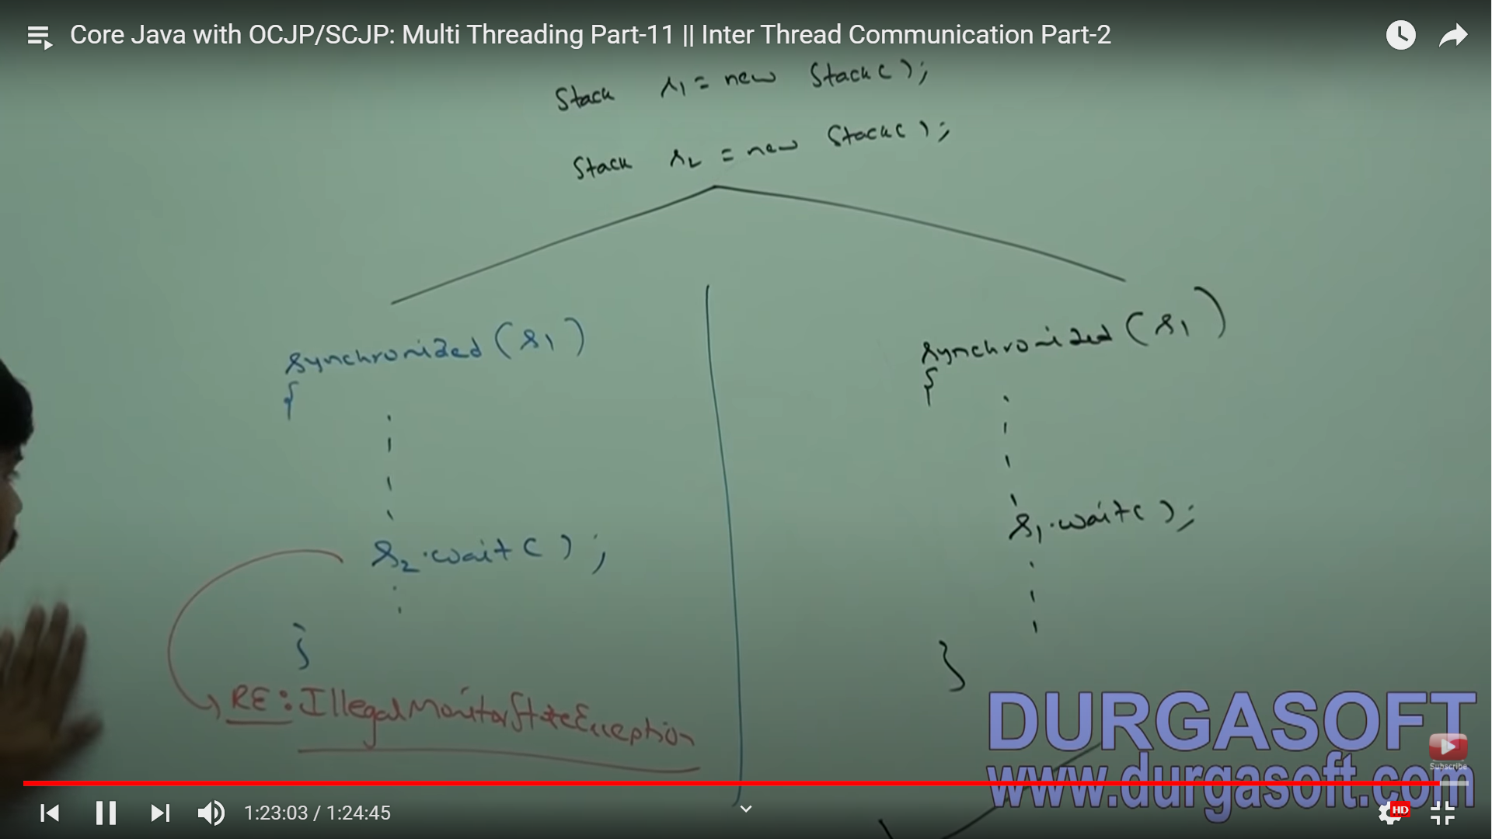

**DEADLOCK and STARVATION:**

If two threads are waiting for each other forever, such type of infinite waiting is called Deadlock.

Synchronized keyword is the only reason for Deadlock situation. Hence, while using synchronized keyword we have to take special care. There are no resolution techniques for Deadlocks but several prevention techniques are available.

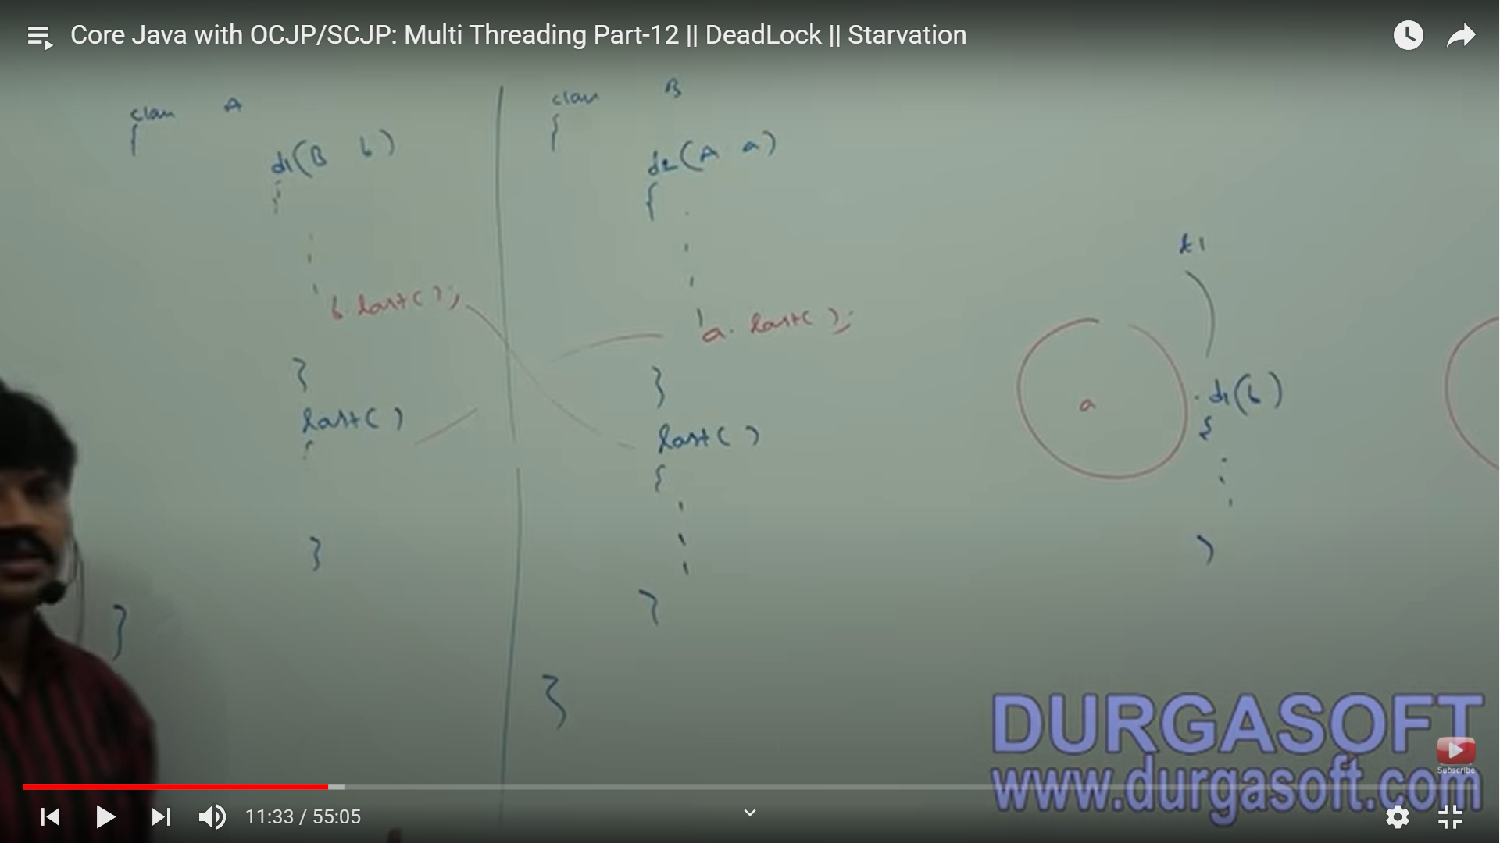

Consider above snip. Here the code will run properly when 2 threads are created (thread t1 acting on object ‘a’ and thread t2 on object ’b’).

Now if we make d1 and 2 methods synchronized --> t1 will acquire lock of ‘a’ to call d1 and t2 will acquire lock of ‘b’ to call d2. Since both the last methods are not made synchronized, the code works fine in this case as well.

If all the 4 methods are made synchronized --> t1 will acquire lock of ‘a’ to call d1 and t2 will acquire lock of ‘b’ to call d2. Now, t1 cannot call last using ‘b’ since it requires a lock to call a synchronized method while ‘b’ is already locked by thread t2 and similar for t2, it cannot call last() on object a.

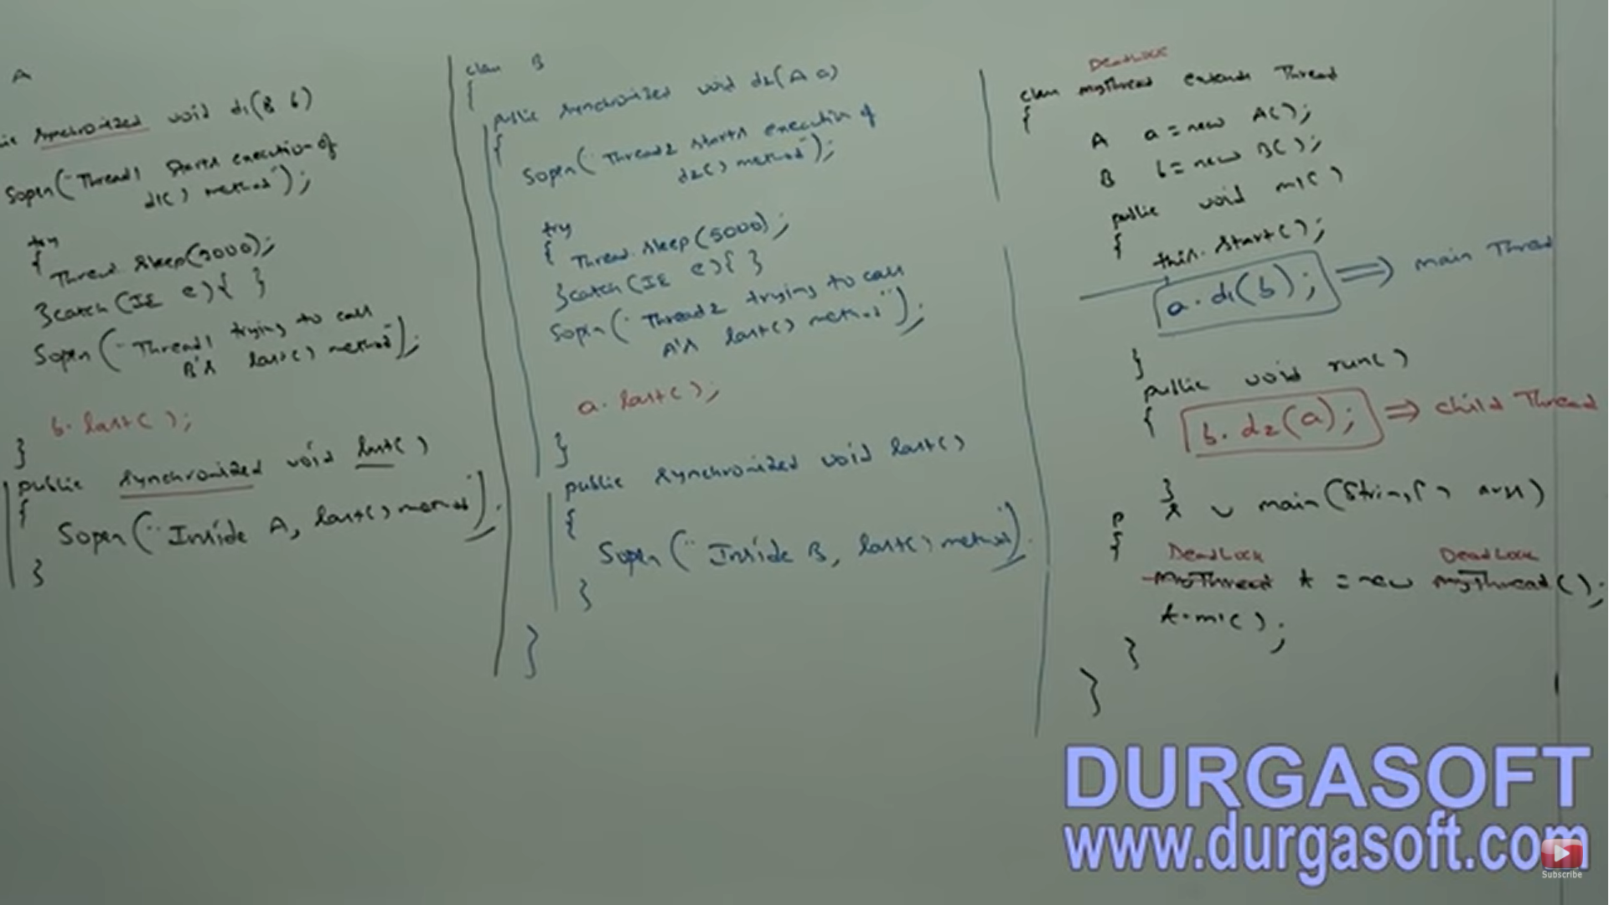

In above program, sleep() is added so that if a thread is not started, it will be able to lock an object. Main thread calls m1(). Main thread calls d1(b) while the child thread will execute the code only present in run(). After this.start(), two threads will be present. This is executed by main thread by this refers to object ‘t’ here.

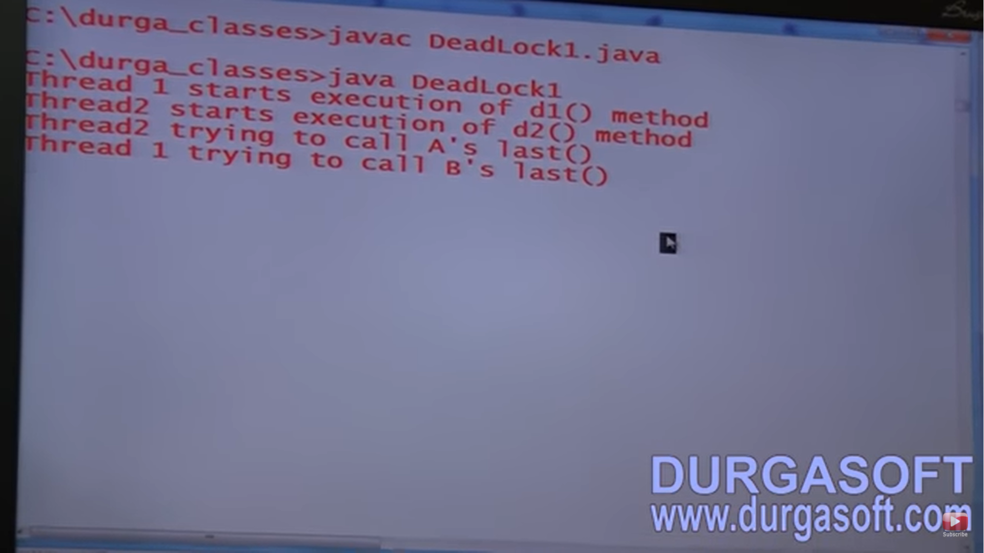

In the above program, if we remove at least one synchronized keyword, then the program won’t enter into deadlock. Hence, synchronized keyword is the only reason for deadlock situation.

DEADLOCK vs STARVATION:

Long waiting of a thread where waiting never ends is called Deadlock whereas long waiting of a thread where waiting ends at a certain point is called starvation. For ex: low priority thread has to wait until completing all high priority threads. It may be long waiting but ends at a certain point, which is nothing but starvation.

DAEMON THREADS:

The threads which are executing in the background are called Daemon threads. Ex: Garbage collector, Signal Dispatcher, Attach Listener etc.

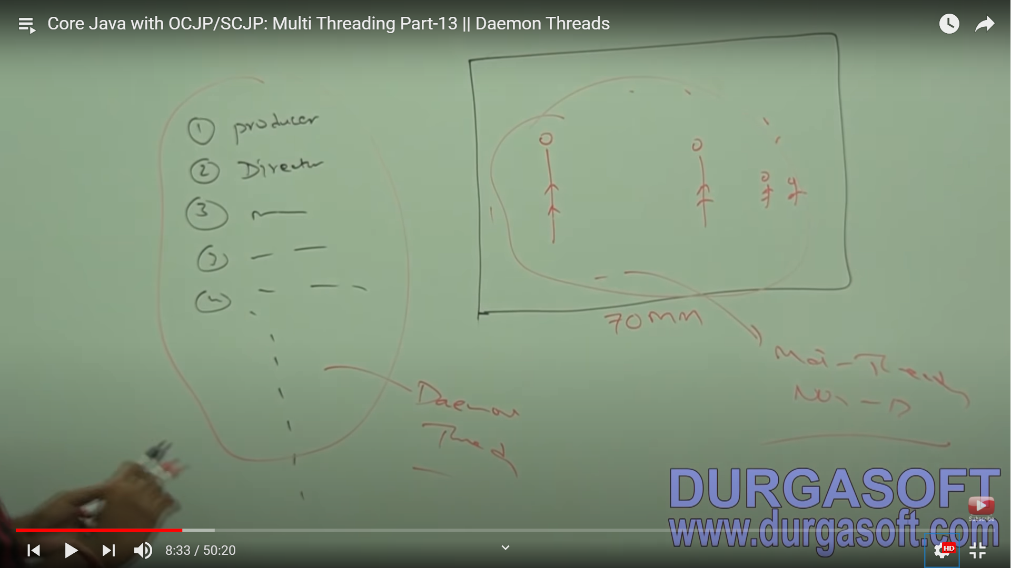

The main objective of Daemon threads is t provide support for non- daemon thread (main thread). For ex: if main thread runs with low memory, then JVM runs Garbage collector to destroy useless object so that number of bytes of free memory will be improved. With this free memory, main thread can continue its execution.

Usually, daemon threads have low priority but based on our requirement Daemon threads can run with high priority also. For ex: main thread has Priority 5 and GC has 1. When main thread is stuck, JVM increases the priority of GC to 10 and once GC has done its task, its priority is decreased and main thread continues its execution.

We can check Daemon nature of a thread by using isDaemon() method of thread class. We can change Daemon nature of a thread by using setDaemon method.

|  |  |
| --- | --- |
| public Boolean isDaemon() |  |
| public void SetDaemon(Boolean b) | Change Daemon nature is possible before starting of a thread only. If done after starting of thread, it will give Runtime Exception saying IllegalThreadStateException. |

Default nature of a thread:

By default, main thread is always non-daemon and for all remaining threads, daemon nature will be inherited from parent to child i.e. if the parent thread is Daemon, then automatically child thread is also Daemon. If the parent thread is non-daemon then automatically child thread is also non-daemon.

NOTE: It is impossible to change the Daemon nature of main thread because, it is already started by JVM at beginning.

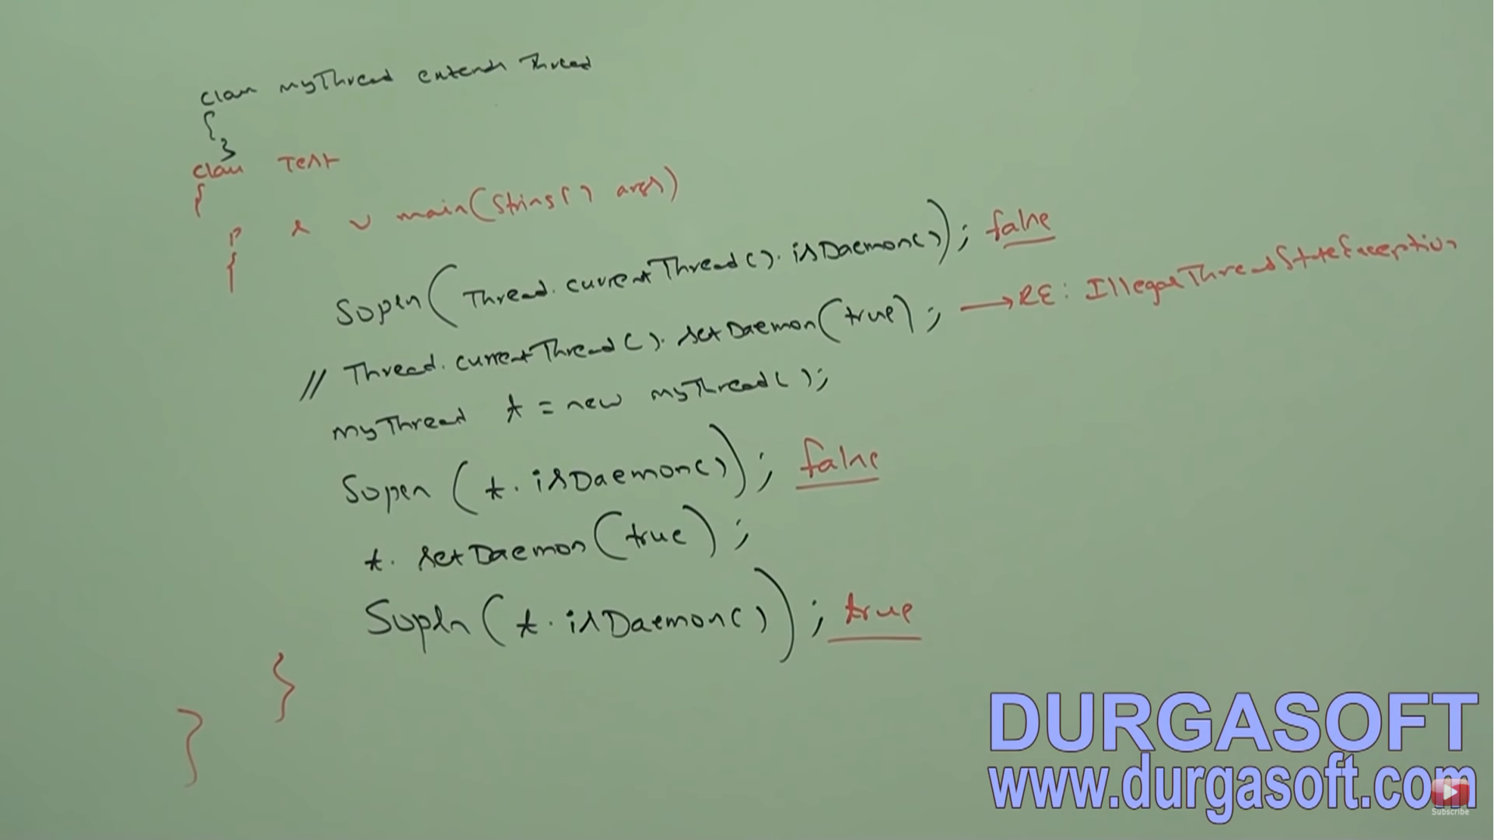

Whenever last non-daemon thread terminates, automatically all daemon threads will be terminated irrespective of their position.

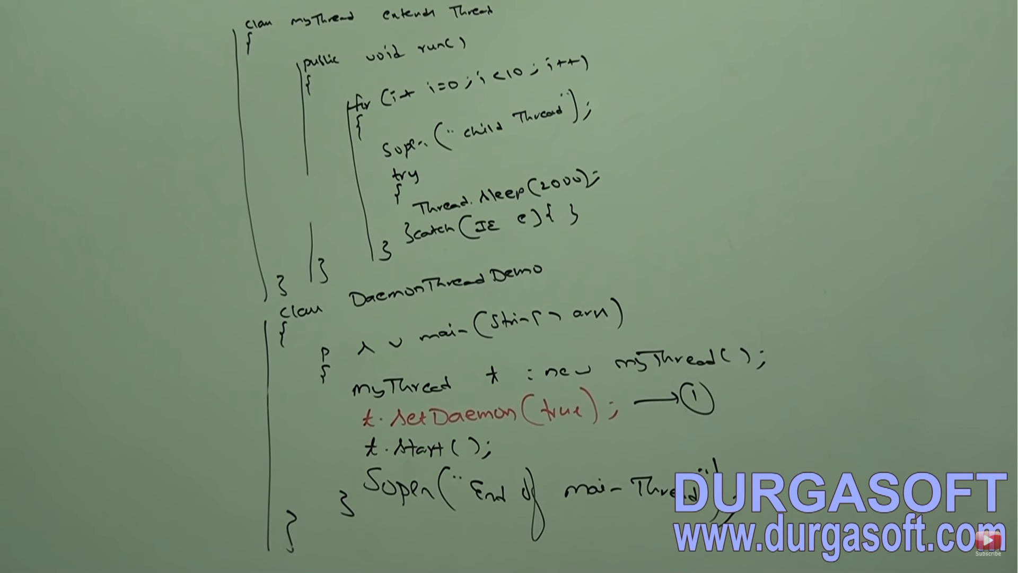

Here, if we comment line 1, both child and main threads are non-daemon threads and hence both threads will be executed until their completion. If we are not commenting line 1, then main thread is non-daemon and child thread is daemon. Hence whenever main thread terminates, automatically child thread will terminate. In this case the child thread will not execute 10 times. (Either 1 time or 0 time).

GREEN THREAD:

Java Multithreading concept is implemented using the following two models

1. Green thread Model -- > The thread which is managed completely by JVM without taking underlying OS support is called Green thread. Very few operating systems like Sun Solaris provide support for Green thread model. Anyways, this model is deprecated and not recommended to use.
2. Native OS Model --> The thread which is managed by JVM with the help of underlying OS is called native OS model. All windows based OS provide support for native OS model.

How to stop a thread? -- > We can stop a thread execution by using a stop() method of thread class [**public void stop()**]. If we call stop() method, then immediately the thread will enter into dead state. Anyway, stop method is deprecated and not recommended to use.

How to suspend and resume a thread? -- > We can suspend a thread using suspend method of thread class. Then immediately the thread will enter into suspended state. We can resume a suspended thread by using resume method of thread class, and then suspended thread can continue its execution.

Methods: public void suspend() and public void resume()

Anyway, these methods are deprecated and not recommended to use.

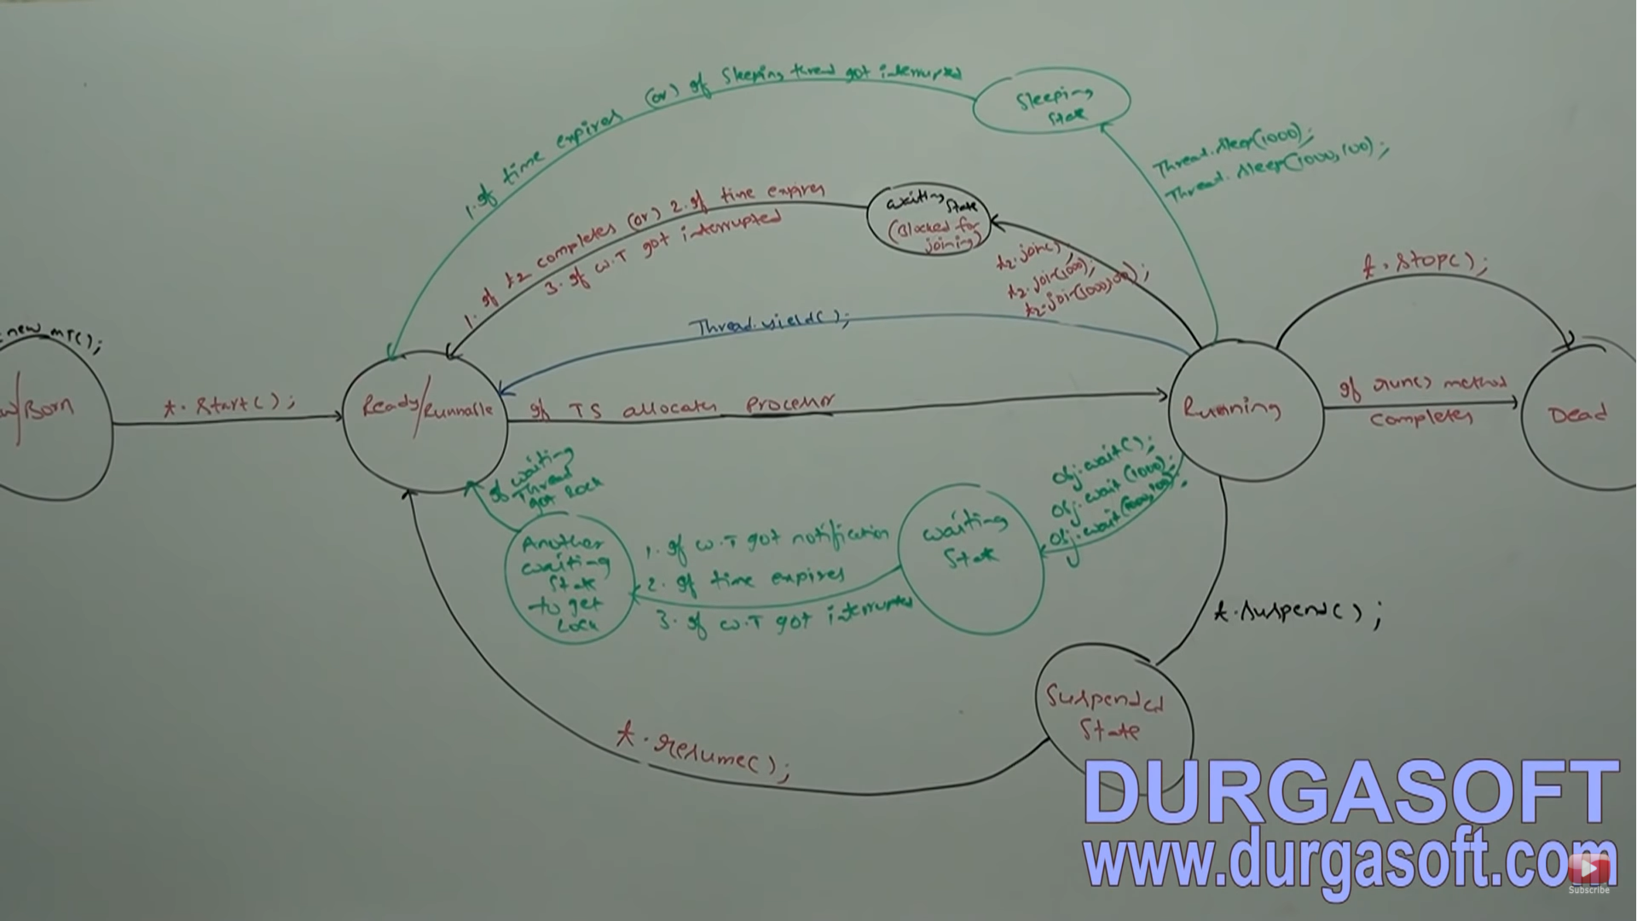

THREAD GROUP:

Based on functionality, we can group threads into a single unit which is nothing but thread group i.e. thread group contains a group of threads. In addition to threads, thread group can also contain sub thread groups. The main advantage of maintaining threads in form of thread group is we can perform common operations (minPriority, maxPriority to all similar threads) very easily.

 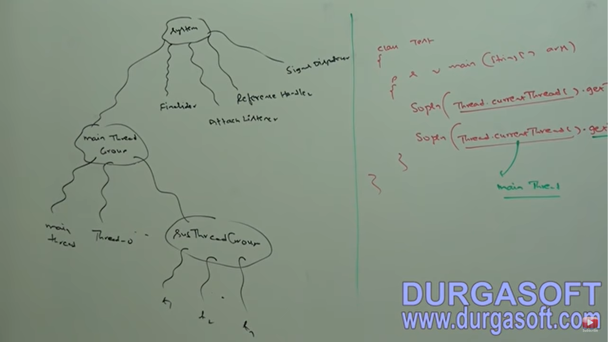

Every thread in Java belongs to some group. Main thread belongs to MAIN group. Every thread group in Java is a child group of System group, either directly or indirectly. Hence, System group acts as a root for all thread groups in Java. System group contains several system level threads like GC (Finalizer), Reference handler, Signal Dispatcher, Attach Listener etc. Main thread group is the direct child group of System group.

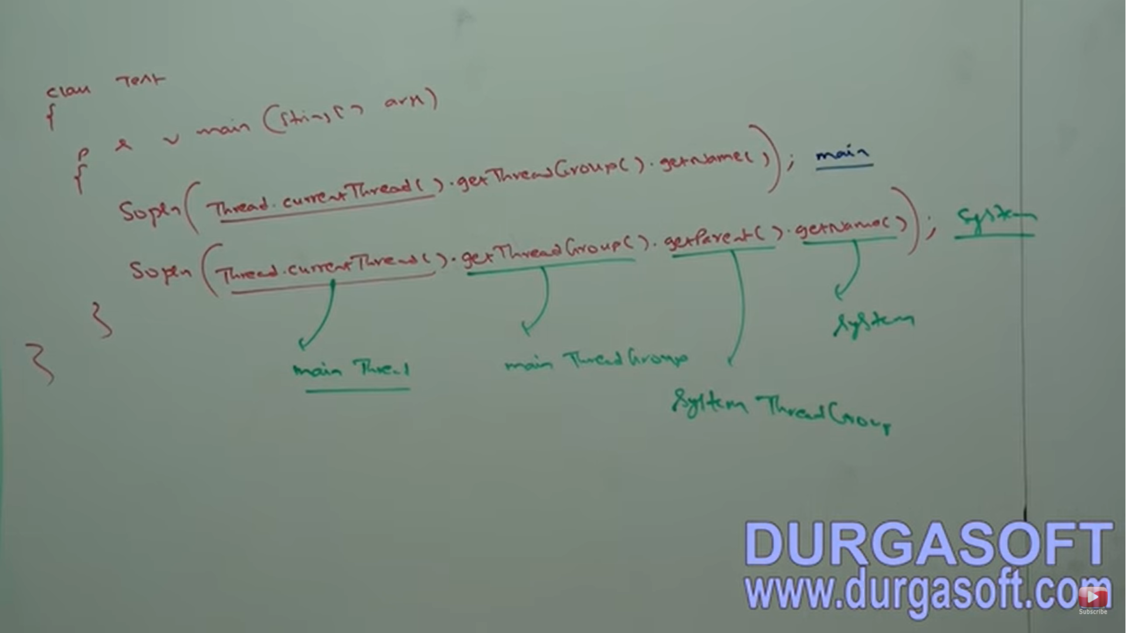

ThreadGroup is a Java Class present in java.lang package and it is direct child class of Object.

CONSTRUCTORS:

1. ThreadGroup g = new ThreadGroup(String name);
   1. Creates a group with the specified Group name.
   2. The parent of this new group is the thread group of currently executing thread.
2. ThreadGroup g = new ThreadGroup(ThreadGroup m, String name);
   1. Creates a new ThreadGroup with the specified group name.
   2. The parent of this new thread group is the specified parent group.
   3. 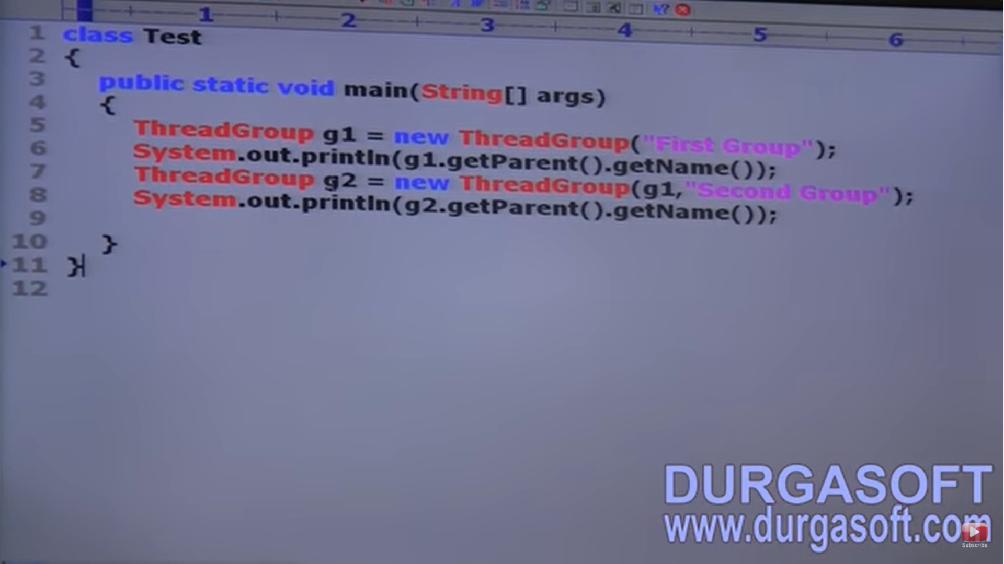

IMPORTANT METHODS of THREADGROUP CLASS:

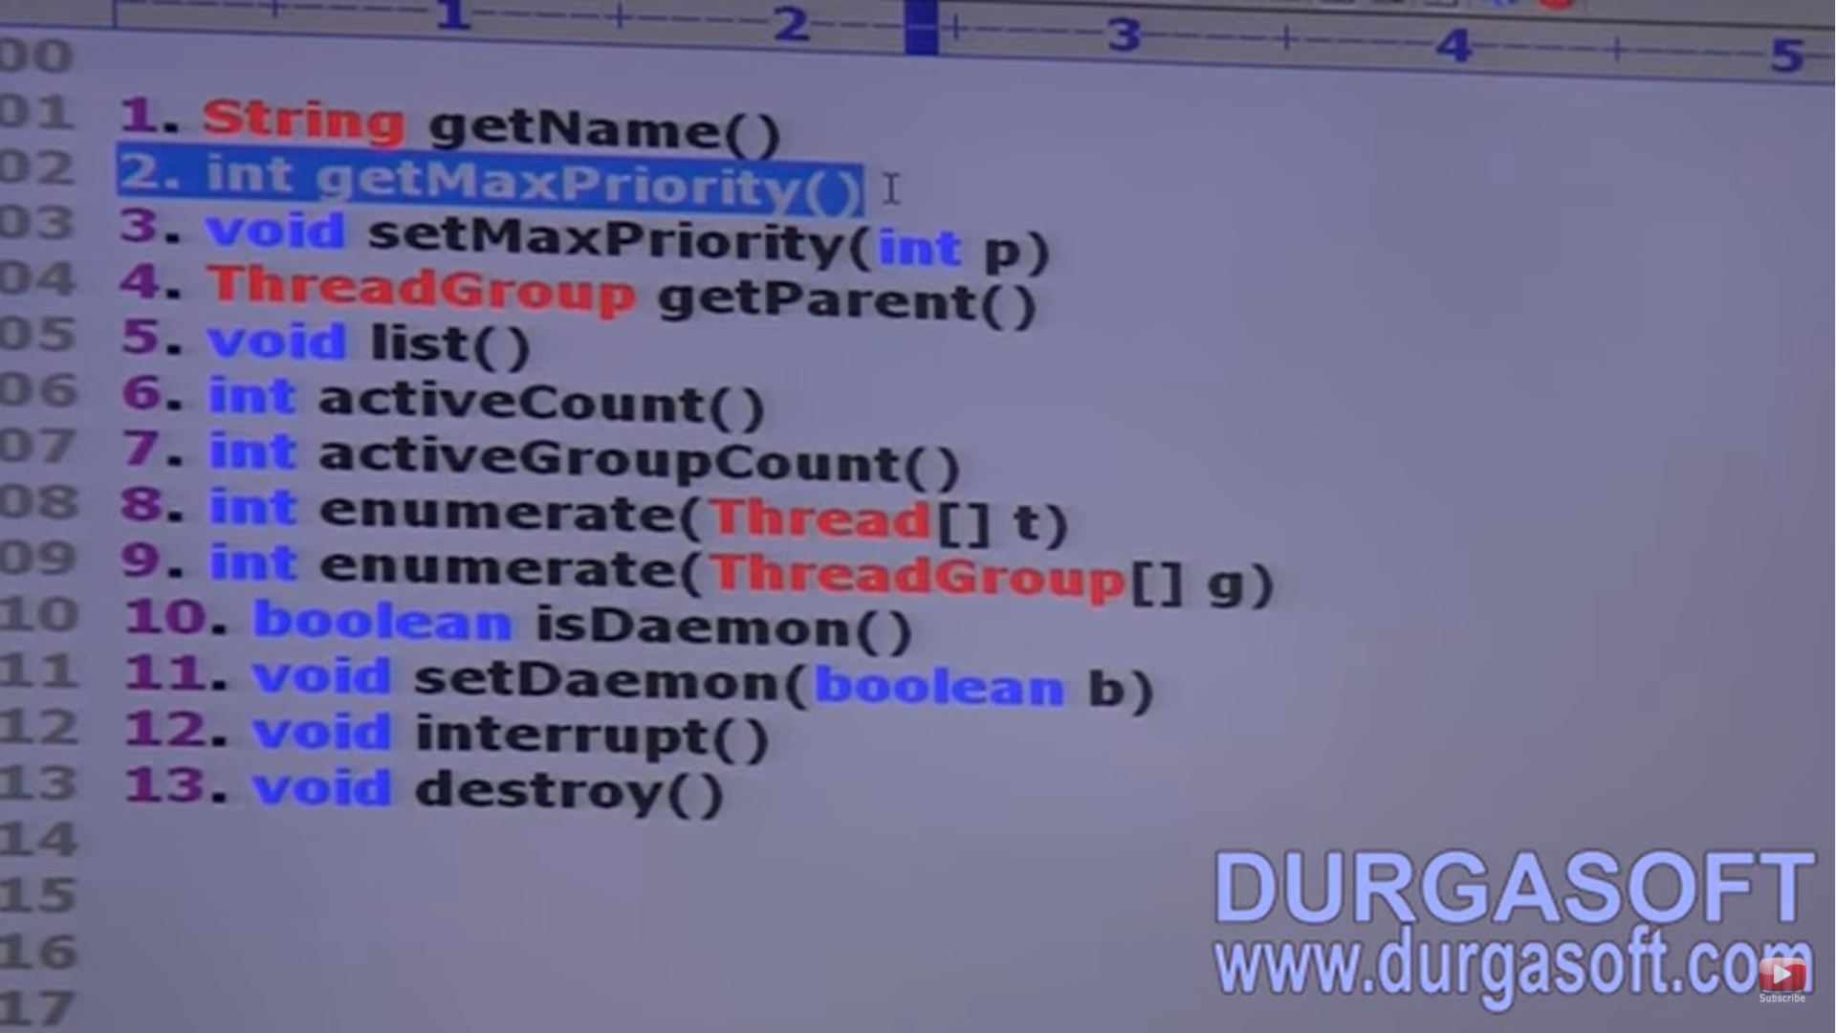

The default maxPriority for a ThreadGroup is also 10.

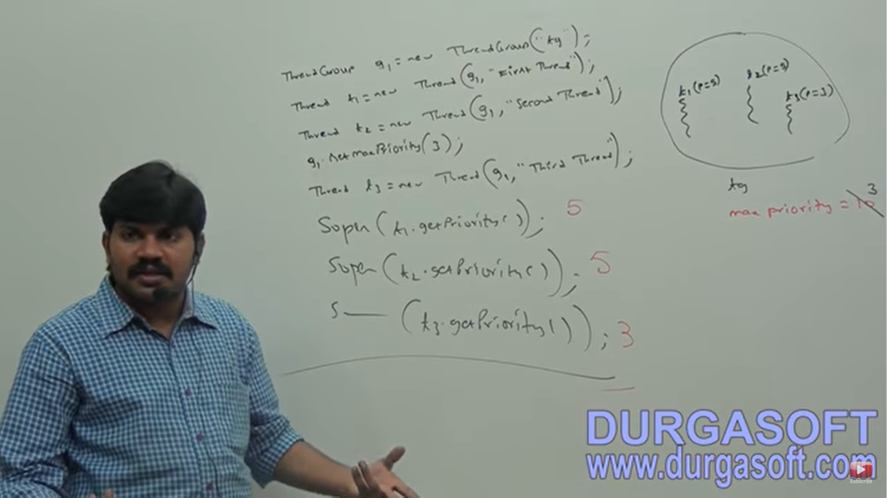

Threads in the ThreadGroup that already have higher priority won’t be affected. But for newly added threads, this maxPriority is applicable. While adding t1 and t2, the maxPriority was default one i.e. 10 and the default priority set was 5.

list() -- > It prints information about ThreadGroup to the console.

activeCount() -- > Returns no of active thread present in ThreadGroup

activeGroupCount() -- > It returns no of active groups present in current ThreadGroup.

enumerate(Thread[] t) -- > To copy all active threads of this ThreadGroup into provided thread array. In this case, sub thread groups will also be considered.

enumerate(ThreadGroup[] t) -- > To copy all active sub Thread Groups into ThreadGroup array.

Interrupt() -- > To interrupt all waiting/ sleeping threads present in the ThreadGroup

destroy() -- > To destroy ThreadGroup and it sub thread groups.

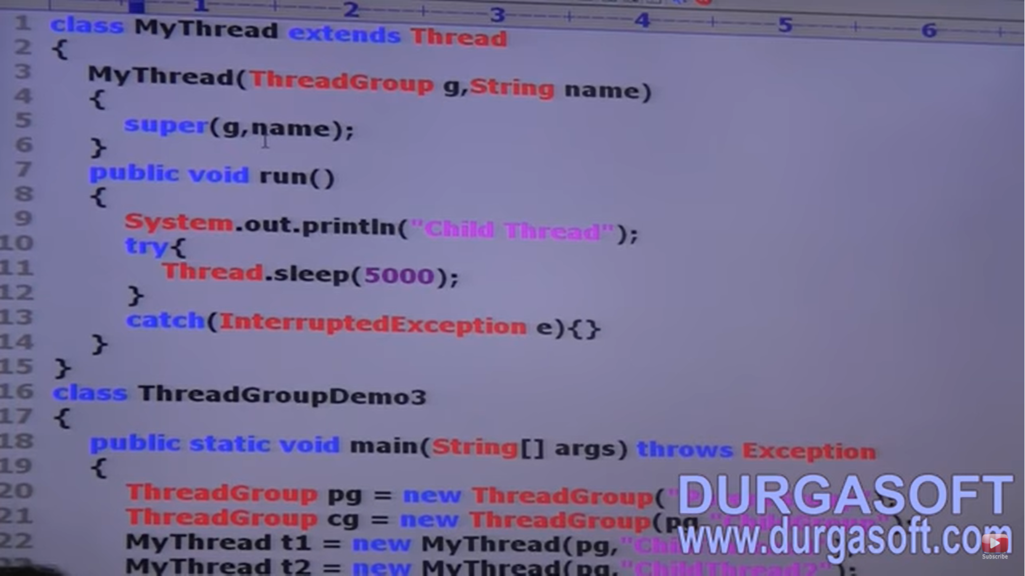

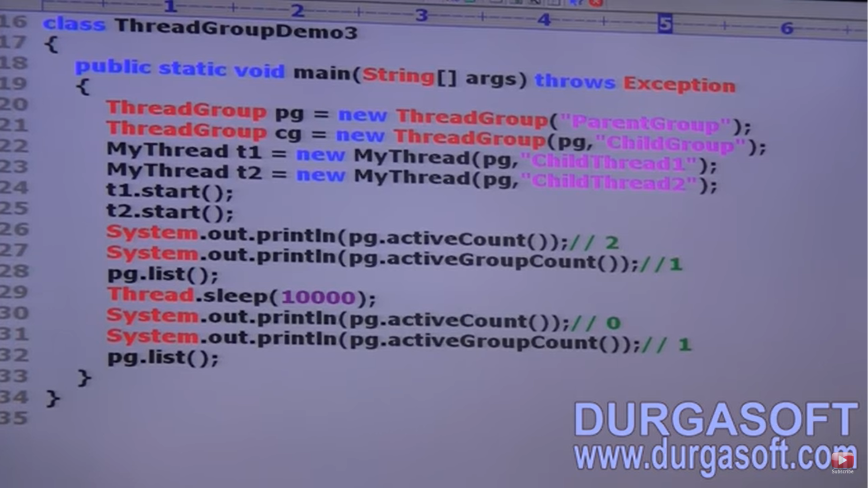

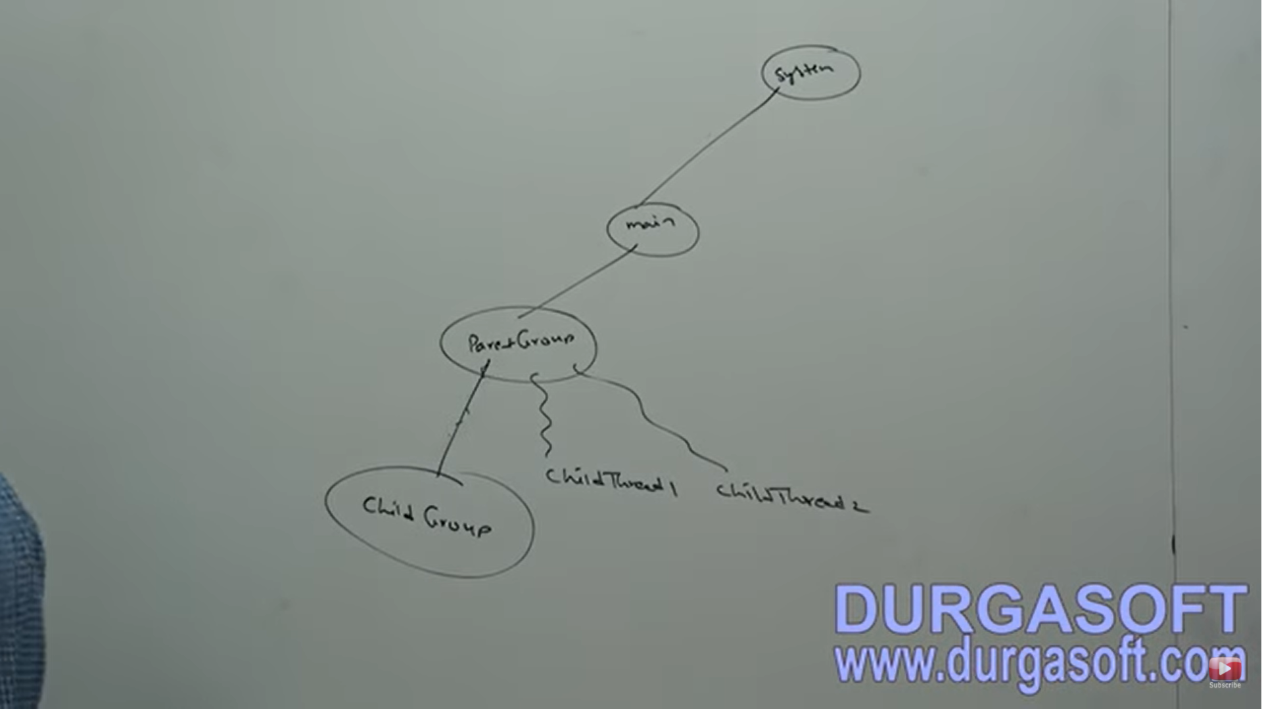

WAP to display all active threads in System group an its child groups.

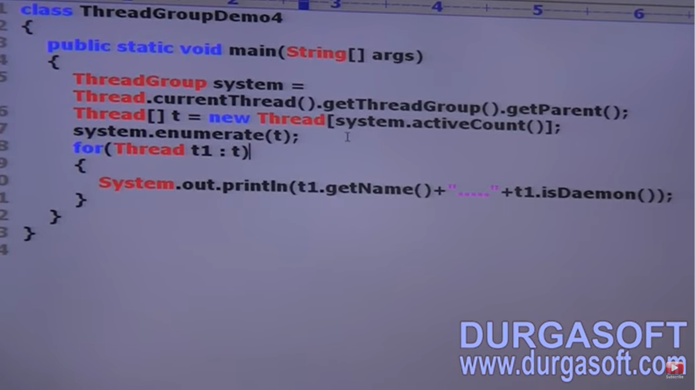

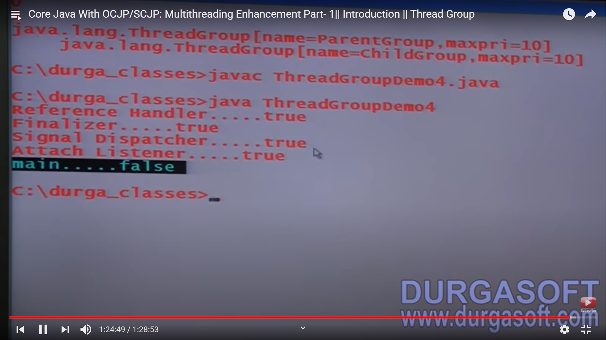

**java.util.concurrent package**:

Problems with traditional **synchronize** keyword:

1. We are not having any flexibility to try for a lock without waiting (if lock is occupied by someone, other threads need to wait).
2. There is no way to specify maximum waiting time for a thread to get a lock so that thread will wait until getting the lock which may create performance problem and may cause deadlock.
3. If a thread releases lock, then which waiting thread will get that lock, we are not having any control on this.
4. There is no API to list out all waiting thread for a lock.
5. In synchronize keyword approach, compulsory we have to use it either at method level or at block level and it is not possible to use across multiple methods (see below snip) i.e. only some part of code of method 1 and some part of method 2 to be synchronized.

To overcome these problems, Sun people introduced java.util.concurrent.locks package in 1.5 version. It also provides several enhancements to the programmers to provide more control on concurrency.

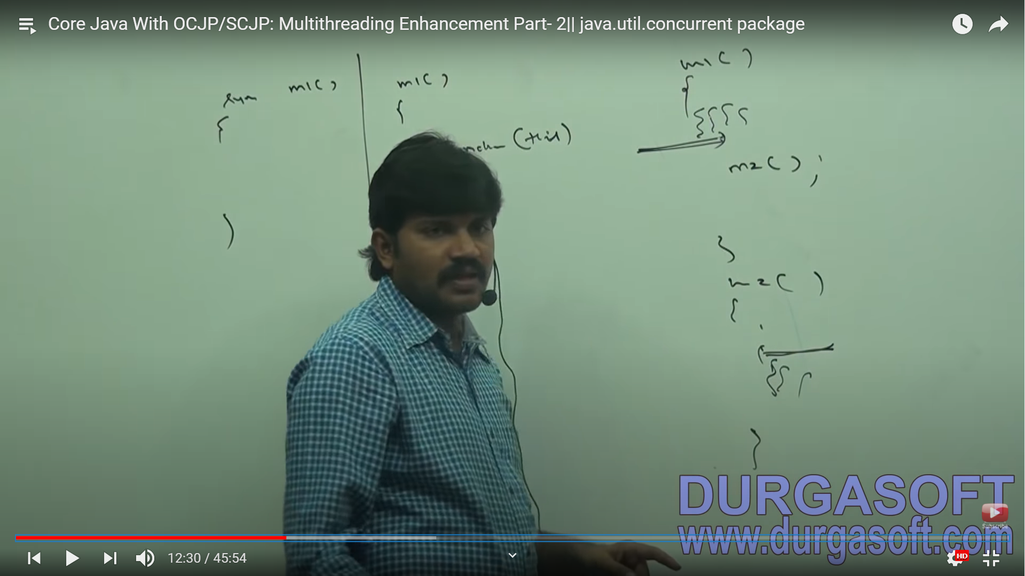 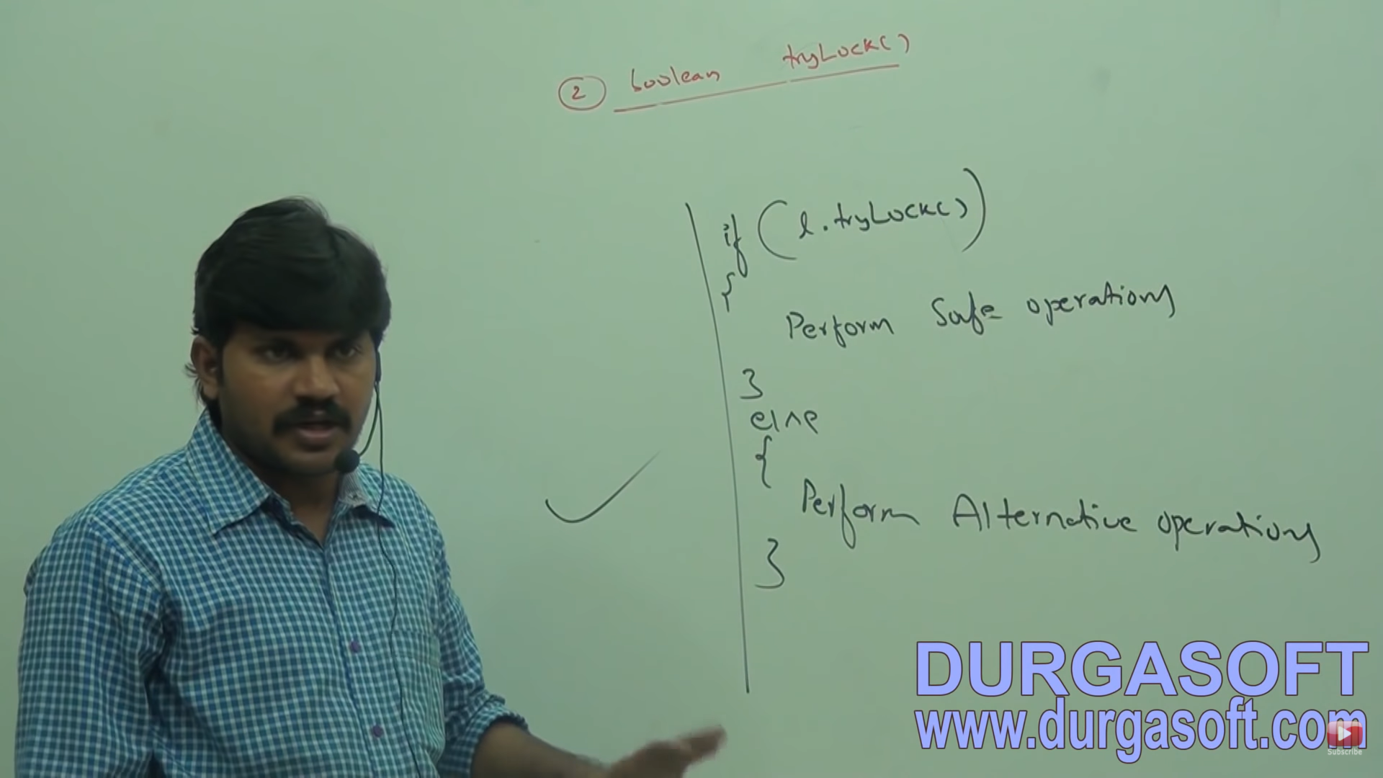

LOCK INTERFACE: (5 methods)

Lock object is similar to implicit lock acquired by a thread to execute synchronized method r synchronized block. Lock Implementation provides more extensive operations than those traditional implicit locks.

IMPORTTANT METHODS OF LOCK INTERFACE:

**void lock()** -- > this is used to acquire a lock. If lock is already available, then immediately current thread will get the lock. If lock is not already available, then it will wait until getting the lock. If has the same behaviour as traditional synchronized keyword.

**Boolean tryLock():** To acquire the lock without waiting. If the lock is available, then the thread acquires the lock and returns true. If the lock is not available, then this method returns false and can continue its execution without waiting. In this case, thread does not enter into waiting state.

**Alternative operations:**

If lock is available, then thread will get the lock and continue its execution. Of lock is not available then, thread will wait until specified amount of time. Still if the lock is not available, then thread can continue its execution.

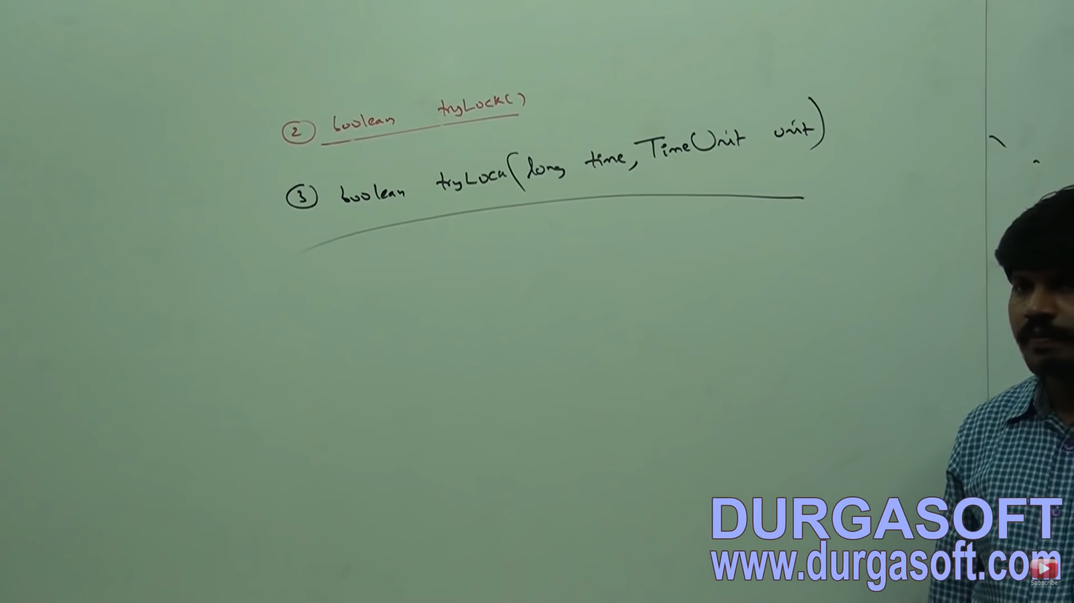

TIME UNIT:

It is an ENUM present in **java.util.concurrent** package.

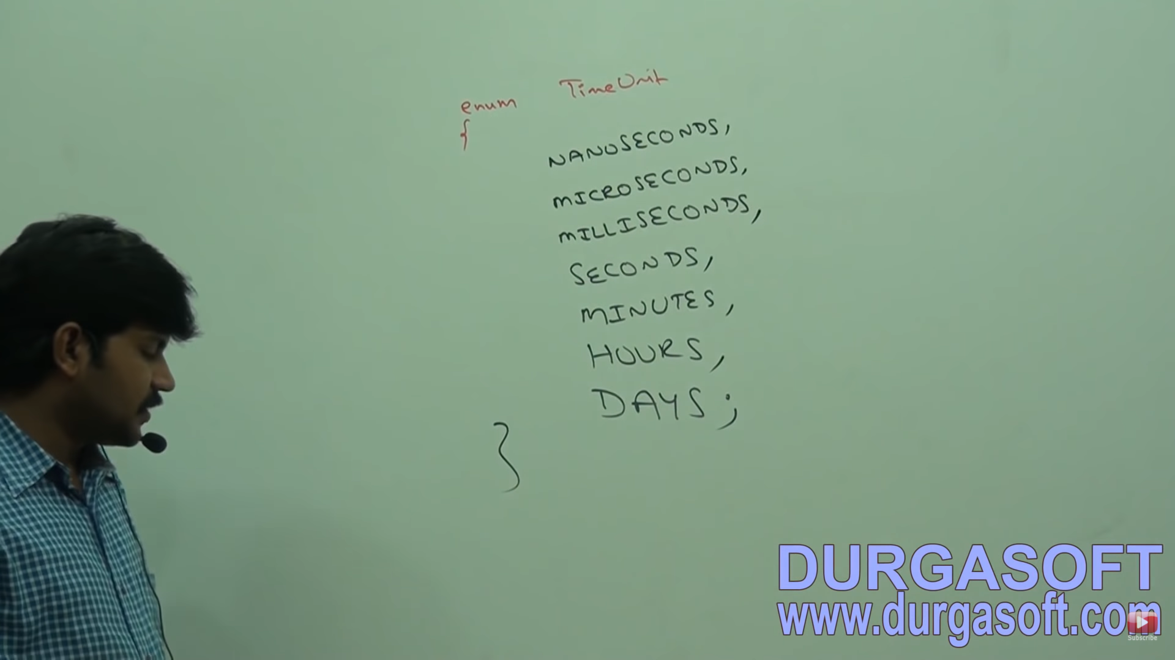

**void lockInterruptibly():**

Acquires the lock if it is available and returns immediately. If the lock is not available then it will wait. While waiting if the thread is interrupted then thread will not get the lock.

**void unlock()** -- > To release the lock. To call this method, compulsory current thread should be owner (Should acquire the lock) of the lock else we will get Runtime exception saying IllegalMonitorState Exception.

**Reentrant Lock (Implementation Class)**

It is the implementation class of Lock Interface and direct child class of Object. Reentrant means a thread can acquire same lock multiple times without any issue. Internally, re-entrant lock increments threads personal count whenever we call lock method and decrements count value whenever thread calls unlock method. Lock will be released whenever count reaches 0.

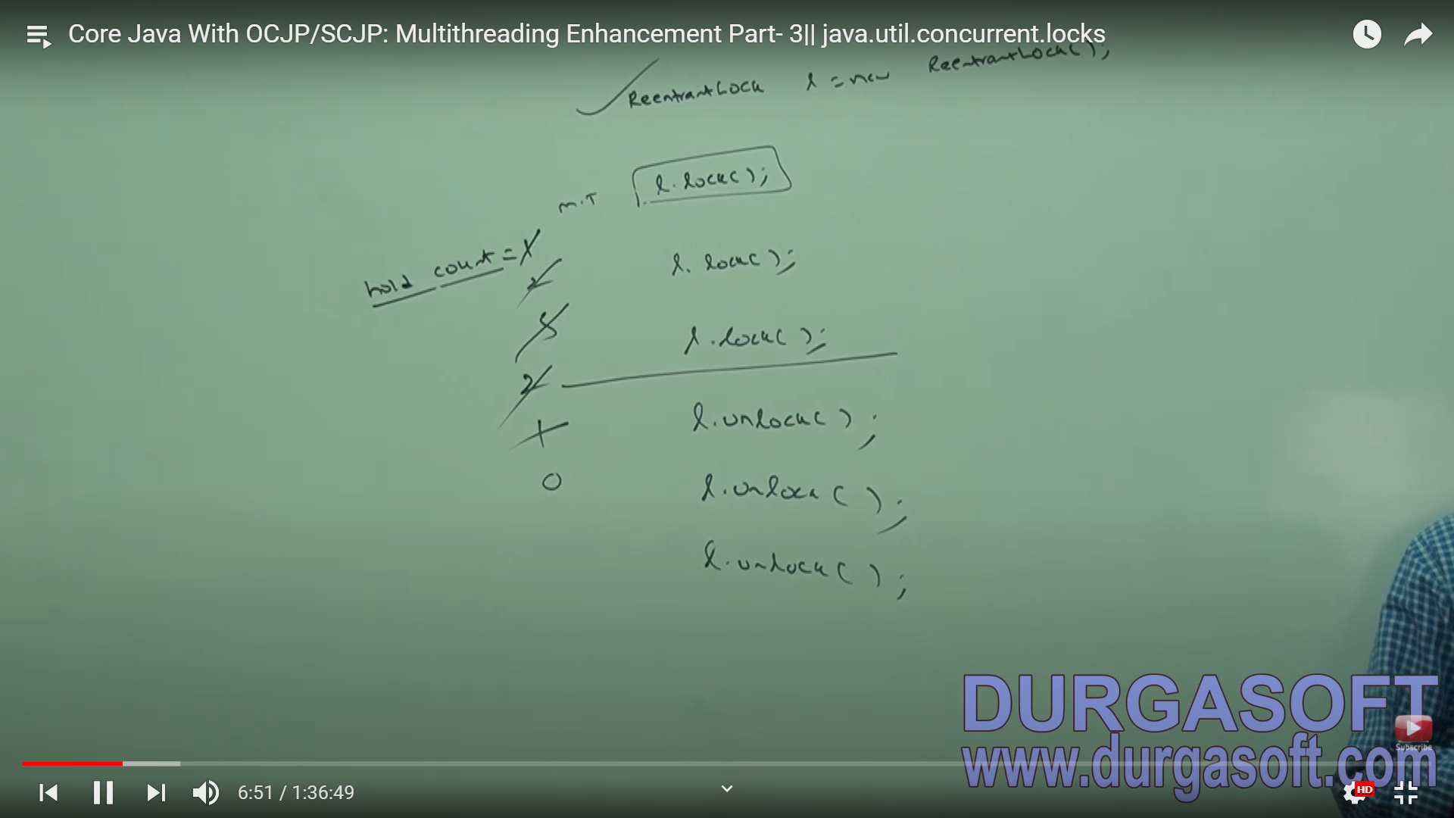

CONSTRUCTORS:

ReentrantLock lock = new ReentrantLock (); -- > Creates a new lock

ReentrantLock lock = new ReentrantLock (Boolean fairness) -- > Creates a ReentrantLock with the given fairness policy. If the fairness is true, the longest waiting thread will be getting the lock if it is available. It follows FCFS policy. If fairness is false, then we can’t expect which waiting thread will get a chance. The default value for fairness is false.

IMPORTANT METHODS OF ReentrantLock:

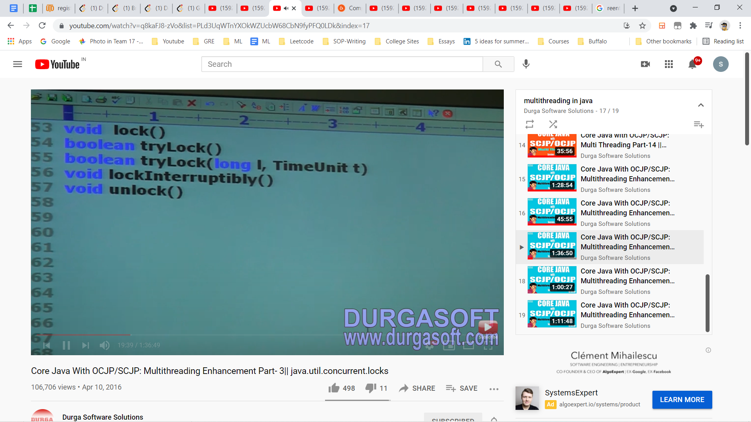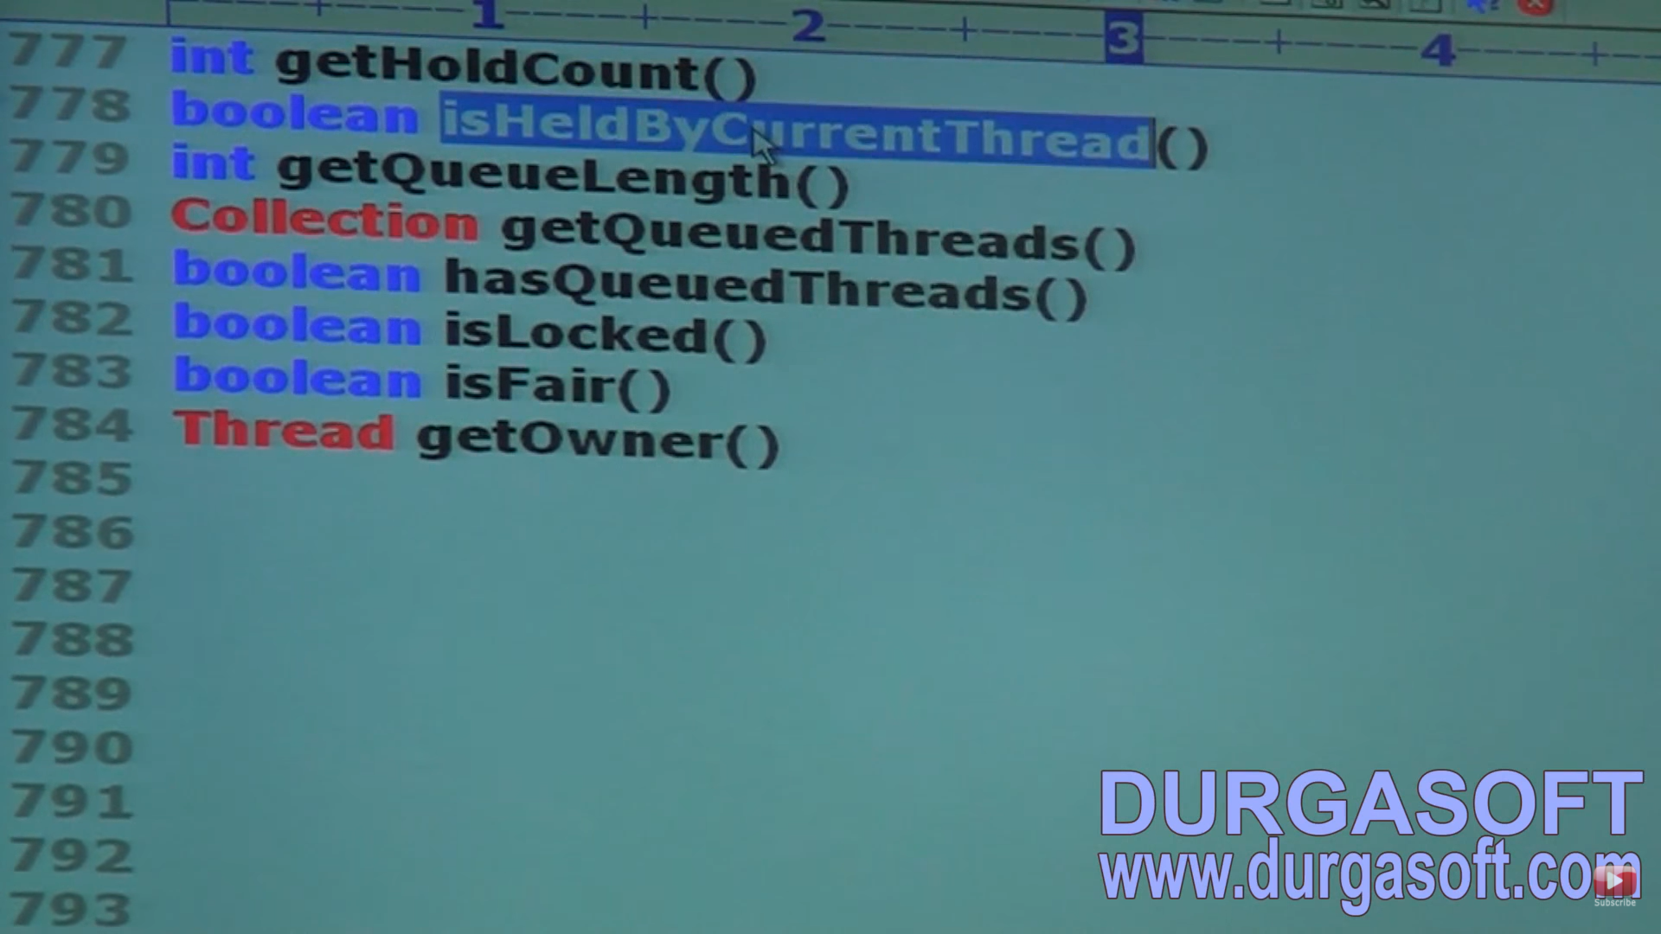

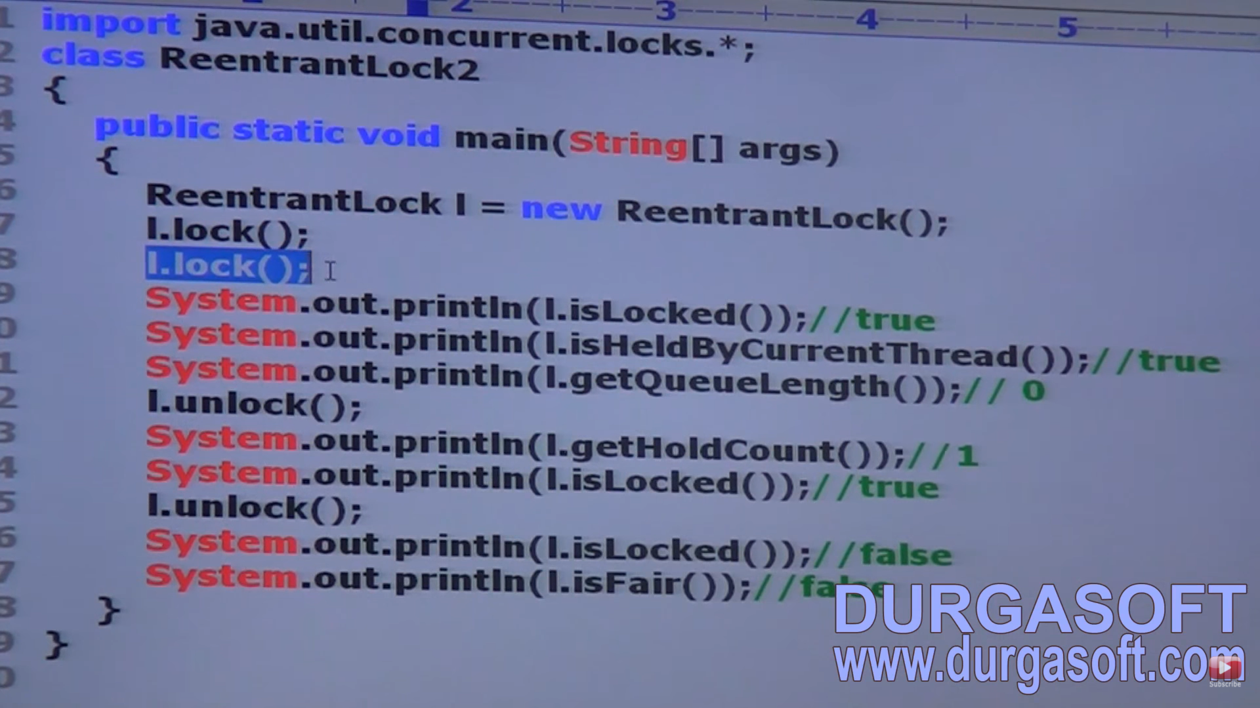

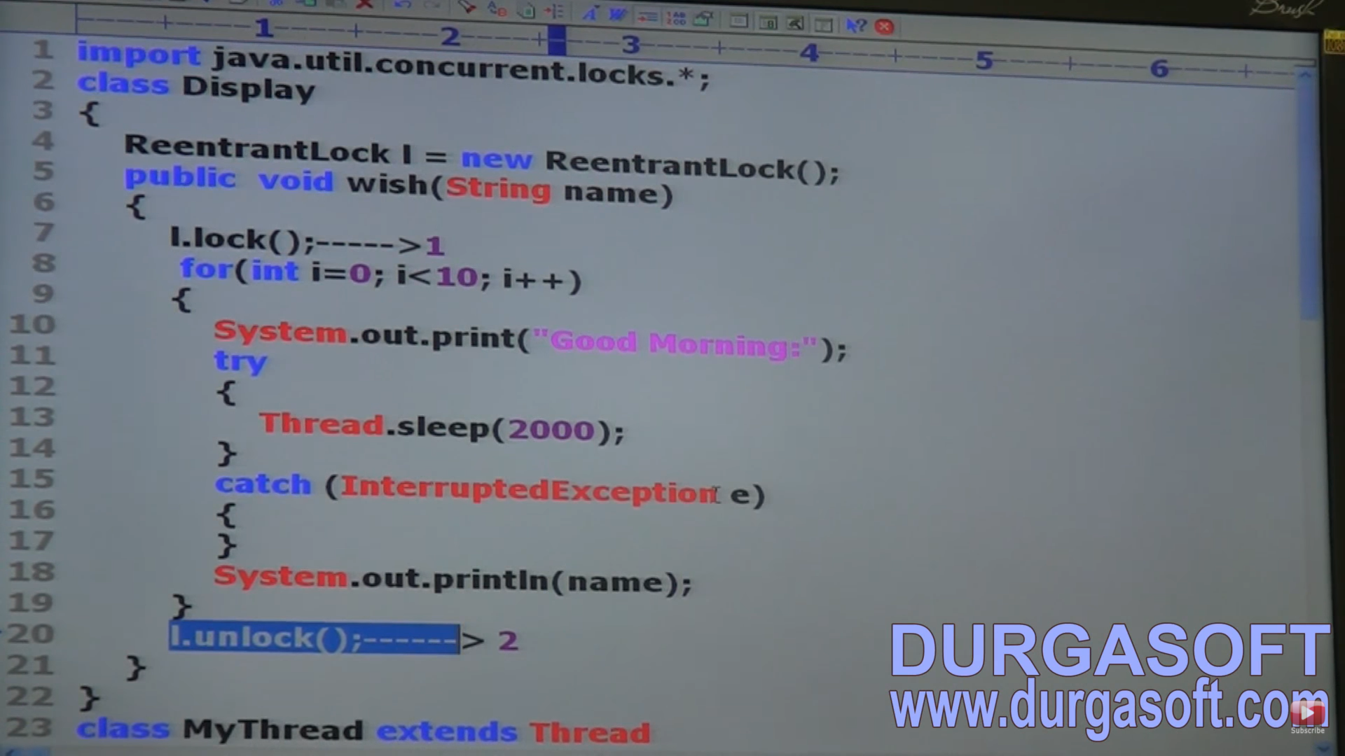

Initially, we were using synchronize keyword to execute the wish method. Above is an example using locks.

DEMO PROGRAM for tryLock():

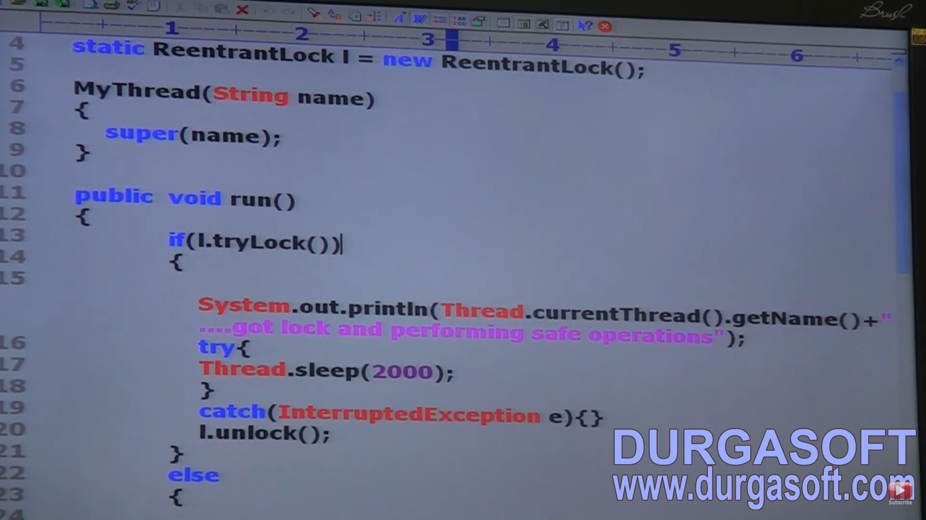

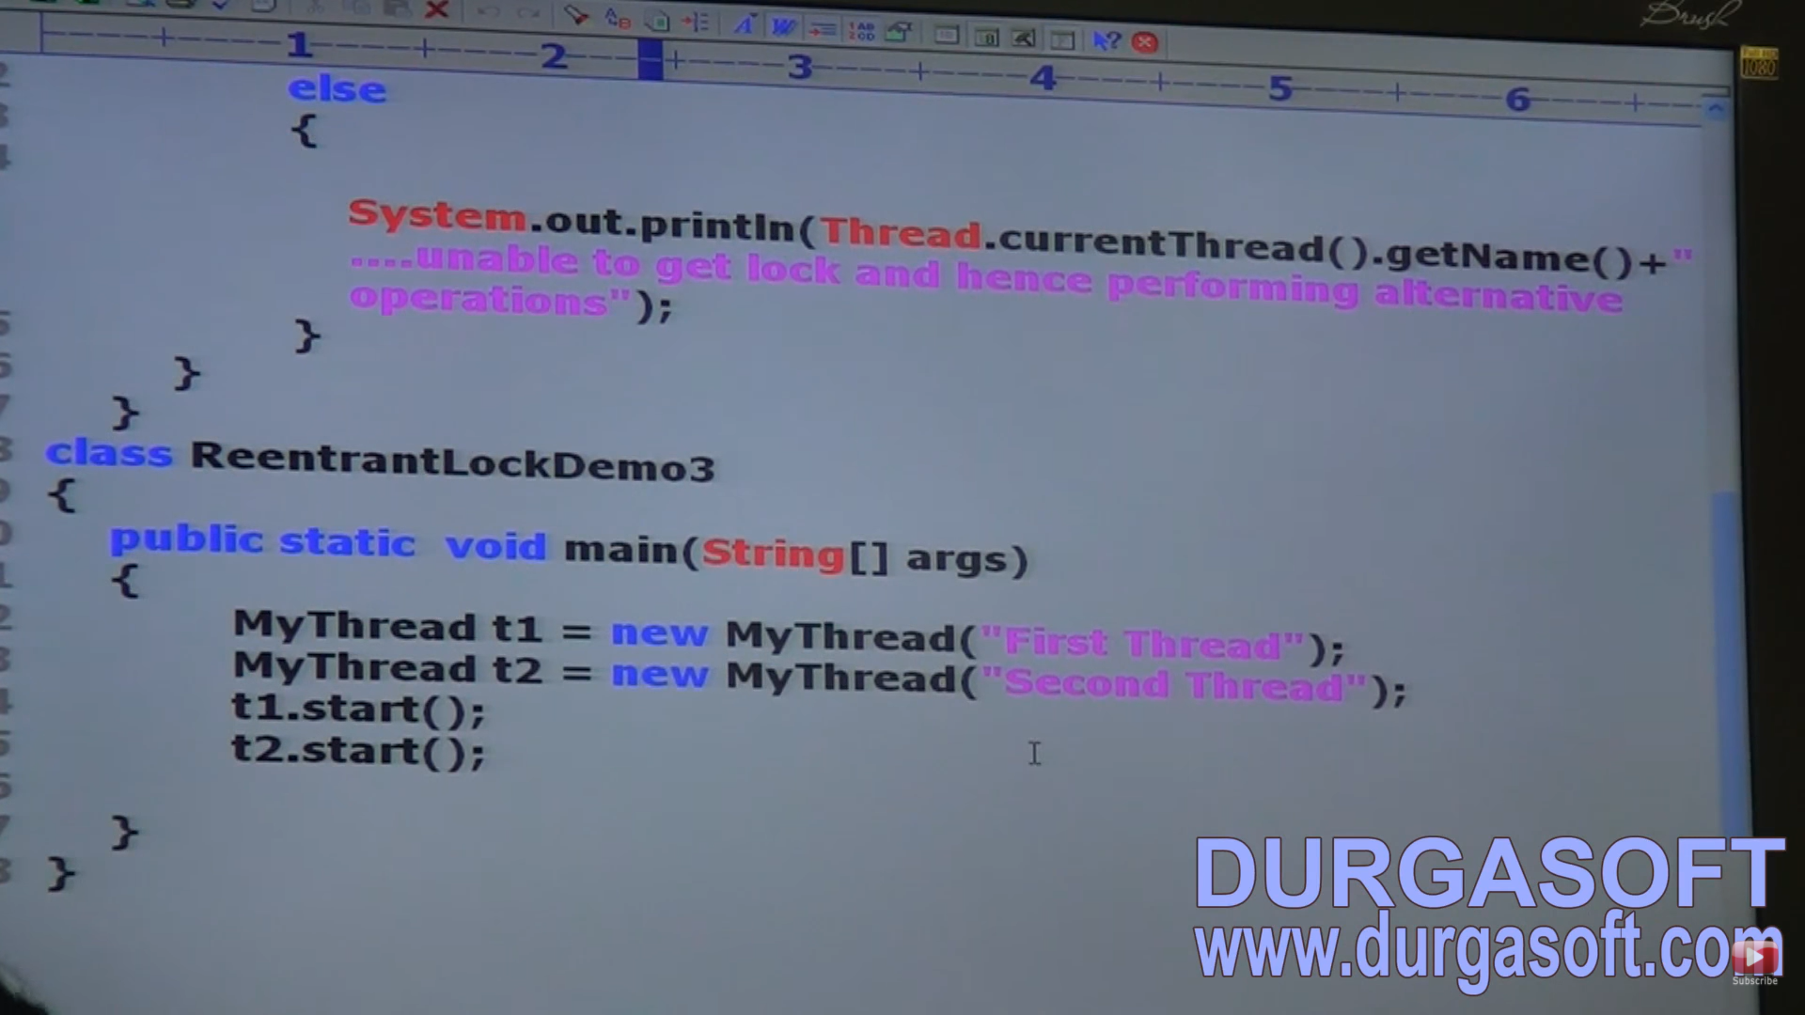

Usin time on tryLock

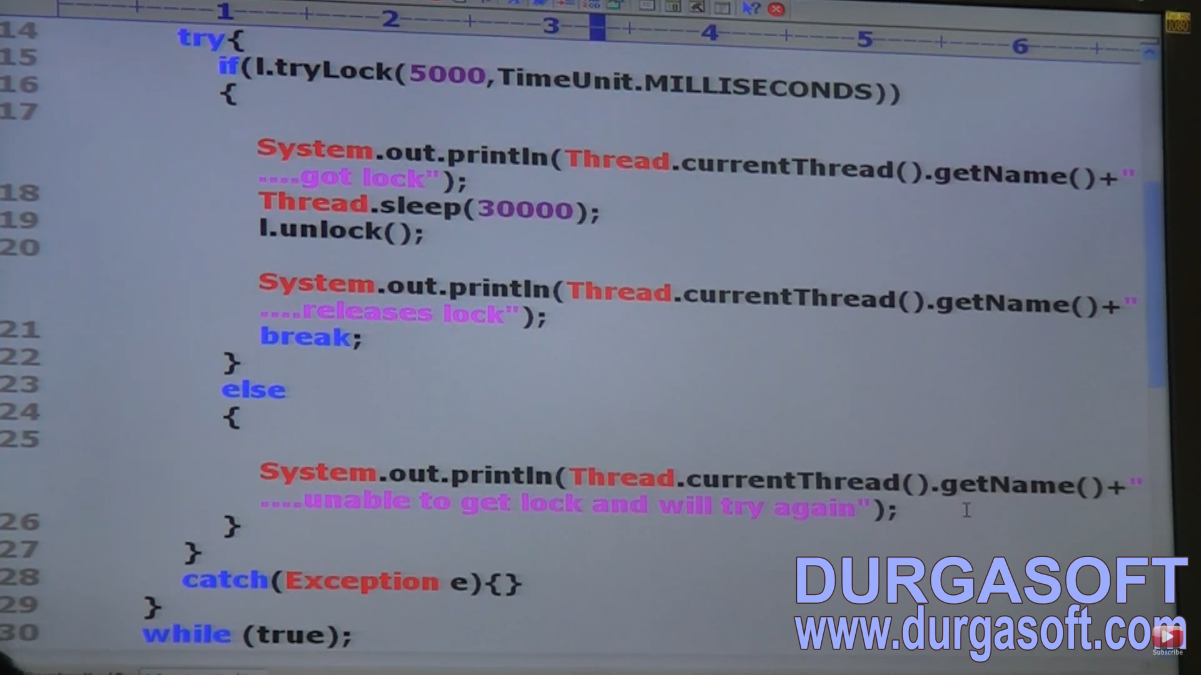

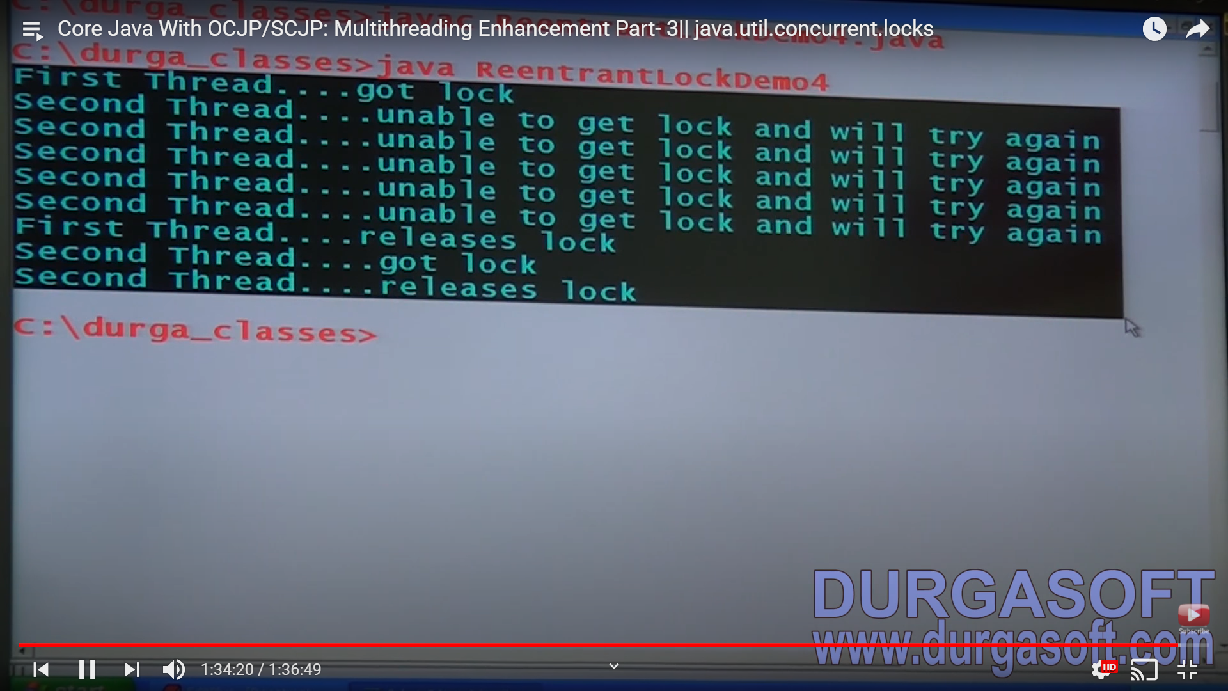

So, deadlock is not seen in the locks implementation.

THREAD POOLS:

Creating a new thread for every job may create performance and memory problems. To overcome this, we should go for thread pool. Thread pool is a pool of already created threads ready to do our job. Java 1.5v introduces thread pool framework to implement thread pools. Thread pool framework is also known as Executor Framework.

If there are 10 independent jobs that need to be done, instead of creating a new thread always and closing them, we can create a thread pool. Here 5 threads will take 5 tasks and after completion, the same 5 threads will be reused to perform next 5 tasks.

We can create a thread pool as follows:

**ExecutorService service = Executors.newFixedThreadPool(3);** -- > Creates a pool of 3 threads

**service.submit(job);** -- > We can submit a runnable job by using submit method.

**service.shutdown();** -- > We can shut down ExecutorService by using shutdown method.

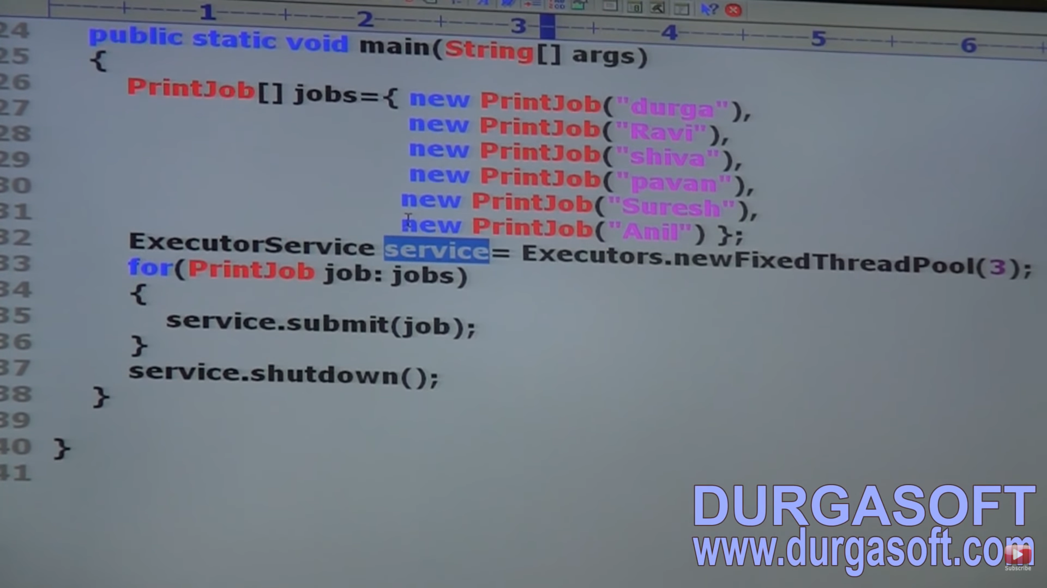

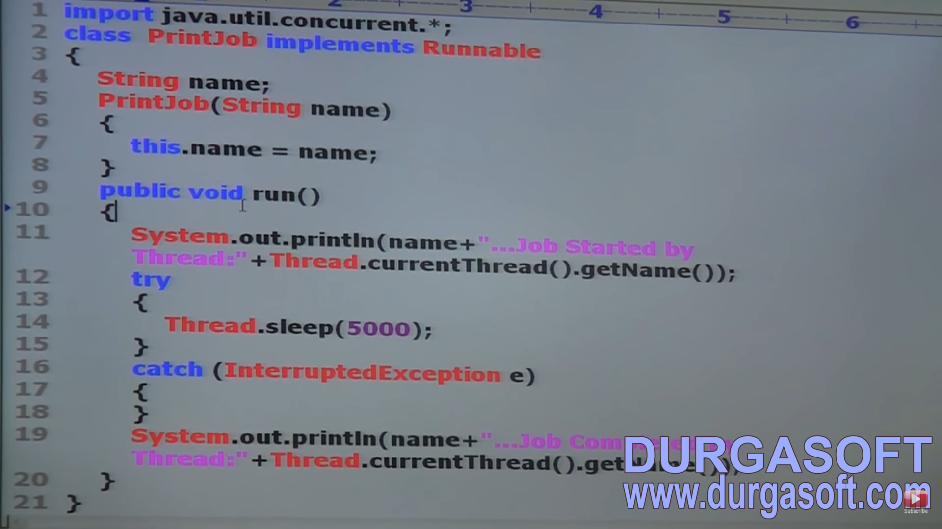

Output:

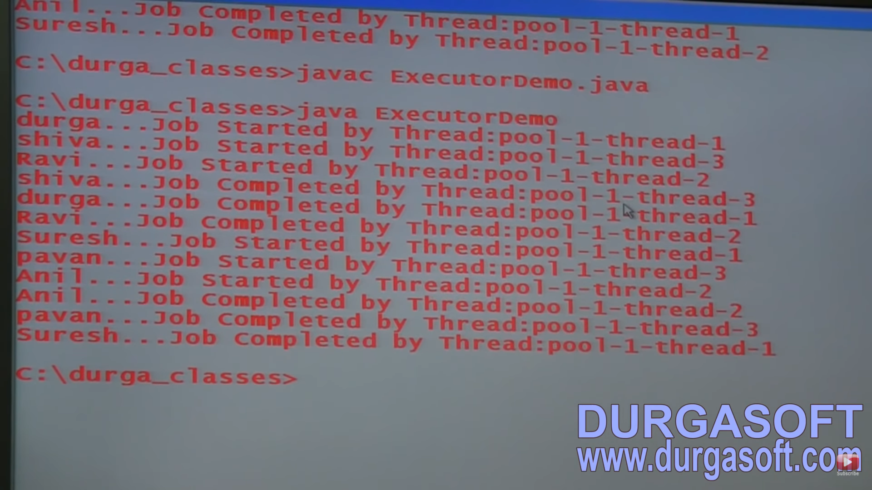

In the above example. 3 threads are responsible to execute 6 jobs so that a single thread can be reused for multiple jobs.

While designing Web Servers and application servers, we can use thread pool concept. Ex: There is a web application which will receive multiple requests. For every request, a new thread will be allocated which will be responsible to process the request. So, in every web/application server, a pool of threads will be there from where a thread will b allocated for a request and sent back to pool once the task is done.

CALLABLE and FUTURE:

In case of runnable job, thread won’t return anything after completing the job i.e. once the run method is completed, it will not be notified. If a thread is required to return some result after execution, then we should go for callable. Callable interface contains only one method -- > call().

**public object call() throws Exception**

If we submit a callable object to Executor, then after completing the job, thread returns an object of the type Future i.e. Future object can be used to retrieve the result from callable job.

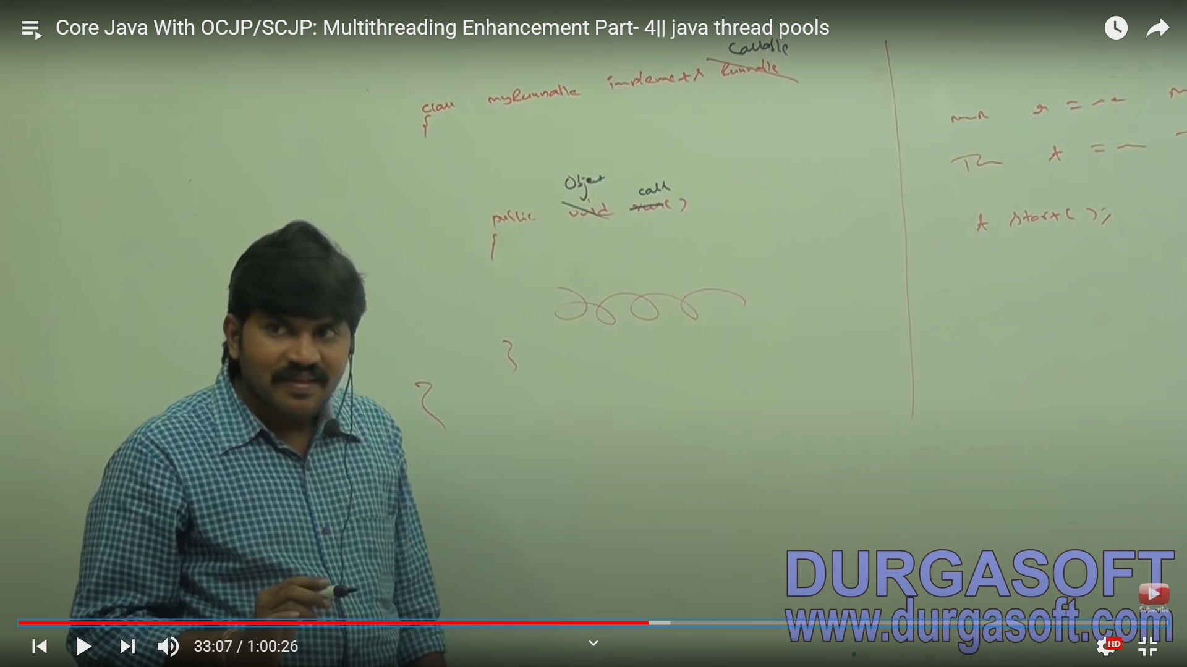

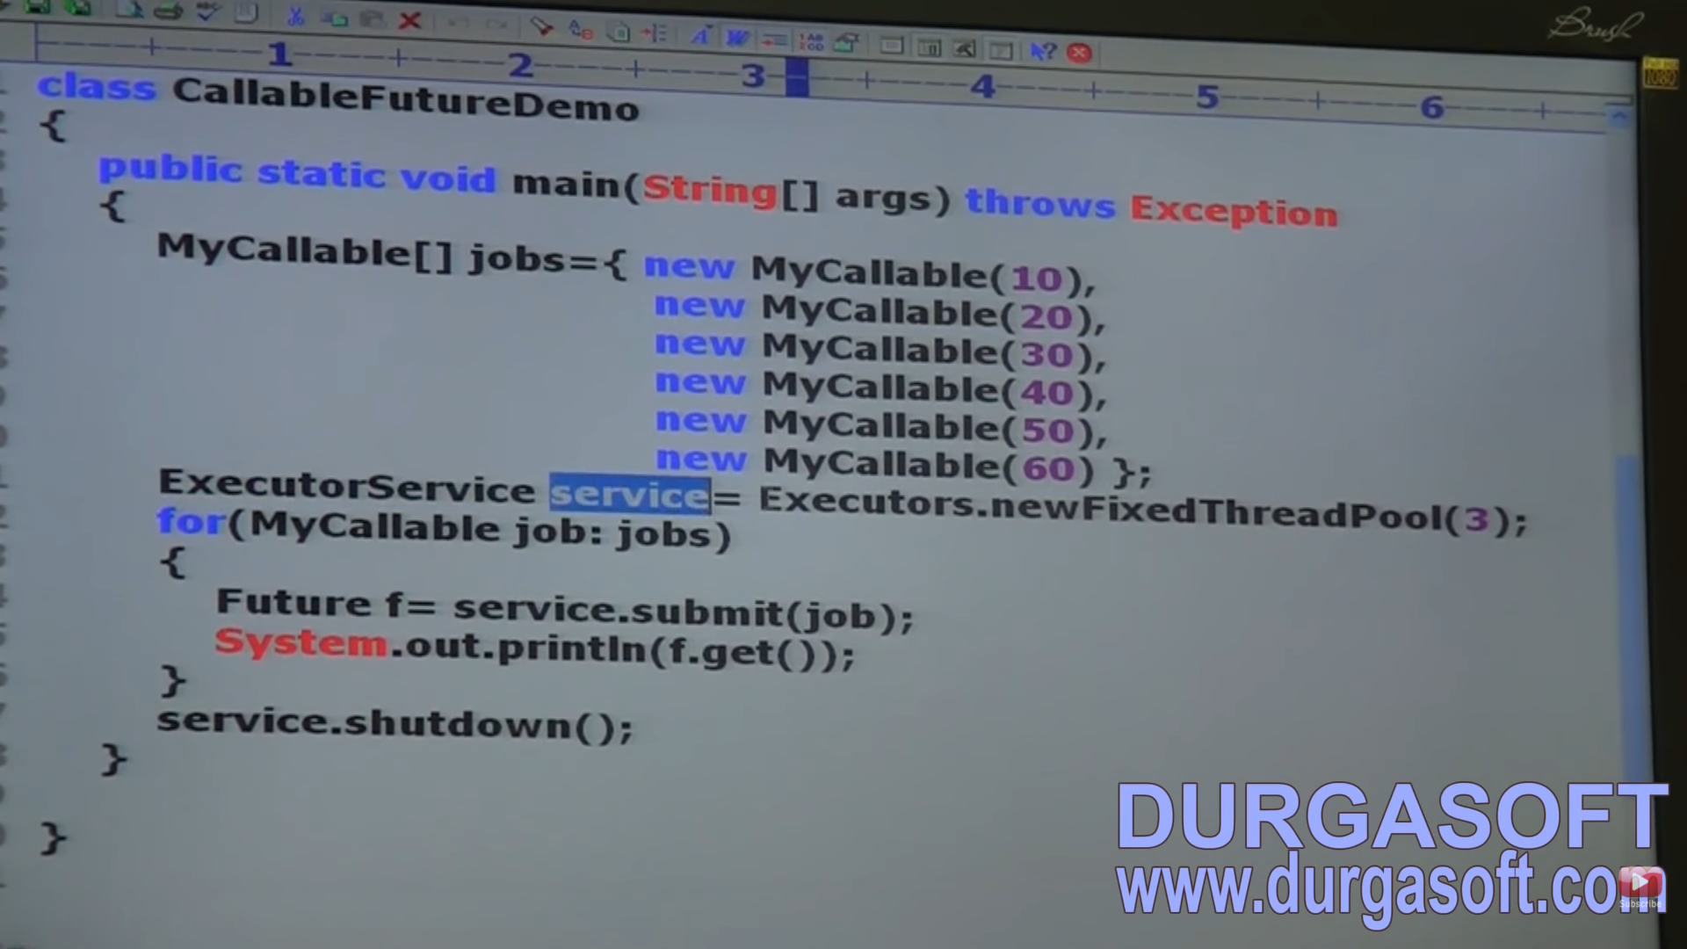

|  |  |
| --- | --- |
| Runnable | Callable |
| If a thread is not required to return anything after completing the job, then we should go for Runnable | If a thread requied to return some thing after completion of job, go for Callable |
| Contains only 1 method -- > run() | Contains 1 method --> call() |
| Return type is void | Return type of call() is Object |
| Within the run(), if there is any chance of rising Checked Exception, **compulsorily we should handle only using try-catch** because we cannot use throws keyword for run method since the run() in parent class also do not throw an Exception. If child uses throws keyword, compulsorily parent also needs to throw the Exception. | Inside call method if there is any chance of rising Checked Exception, we are not required to handle using try-catch because call() (One present in parent class) already throws exception. |
| Present in java.lang package | Present in java.util.concurrent package |
| Introduced in 1.0 version | Introduced in 1.5 version. |

THREAD LOCAL:

Thread Local class provides thread local variables. This class maintain values per thread basis. Each thread local object maintains a separate value like user Id, transaction id for each thread that accesses the object.

Thread can access its local value, can manipulate its value and even can remove its value. In every part of the code which is executed by the thread, we can access its local variable. For example: Consider a servlet which invokes some business methods. We have a requirement to generate a unique transaction Id for each and every request and we have to pass this transaction Id to the Business methods. For this requirement, we can use thread local to maintain a separate transaction Id for every request i.e. for every thread.

NOTE: 1) Thread Local Class was introduced in 1.2v and enhanced in 1.5 version.

2) Thread Local can be associated with thread scope.

3) Total code which is executed by the thread has access to the corresponding thread local variable.

4) A thread can access its own local variable and can’t access other thread’s local variable.

5) Once a thread enters into dead state, all its local variables are by default eligible for Garbage Collection.

CONSTRUCTOR:

ThreadLocal tl = new ThreadLocal (); -- > Creates a new thread local variable.

1. Object get() -- > Returns the value of thread local variable associated with current thread.
2. Object initialValue() 🡪 Returns initial value of thread local variable associated with current thread. The default implementation of this method returns null. To customise our own initial value, we have to override this method.
3. Void set(Object newValue) -- > To set a new value
4. Void remove() -- > To remove the value of thread local associated with current thread. It I newly added method in 1.5v. After removal if we trying to access, it will be reinitialize once again by involing its initial value method.

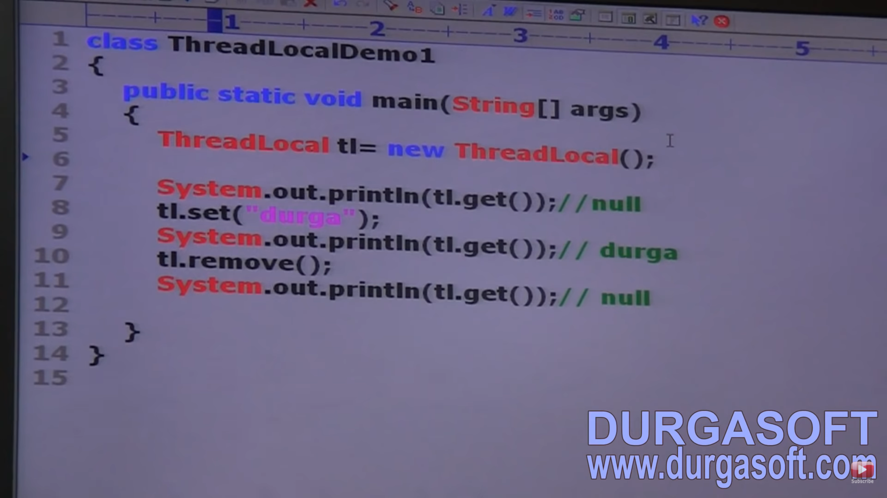

Overriding on initial value method: Anonymous inner class created here in example

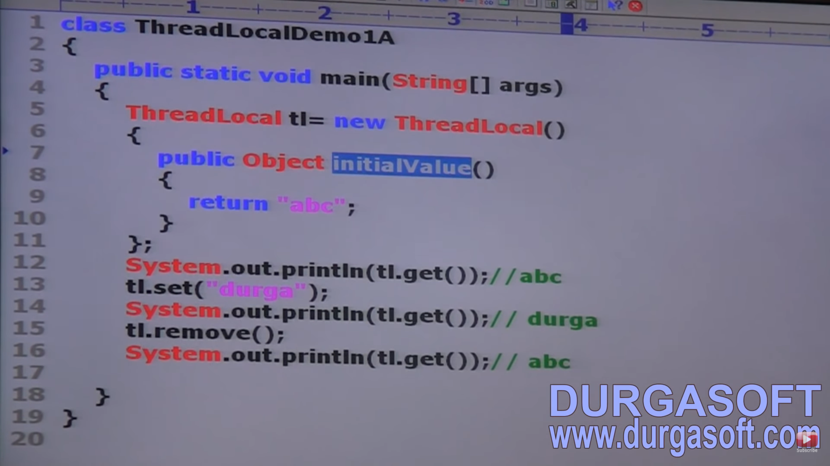

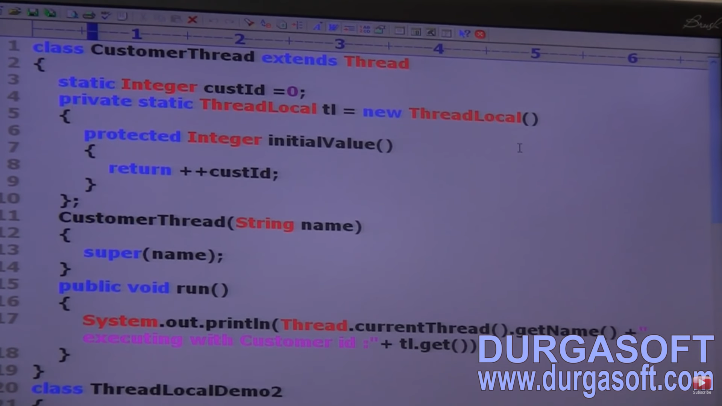

In the above program, for every customer thread a separate customer id will be maintained by thread local object. So, here Ids will be present for every thread but a single object of thread local is maintained.

THREAD LOCAL with respect to INHERITANCE:

Parent threads ThreadLocal variable by default not available to the child thread. If we want to make parent’s thread ThreadLocal variable value available to child thread, then we should go for InheritableThreadLocal class.

By default, child thread value is exactly the same as parent’s thread’s value but we can provide customized value for child thread by overriding child value method.

CONSTRUCTOR:

InheritableThreadLocal itl = new InheritableThreadLocal ();

METHODS:

InheritableThreadLocal is the child class of thread local and hence all methods present in thread local by default available to InheritableThreadLocal. In addition to these methods, it contains only 1 method -- >

**public Object childValue (Object parentValue);**

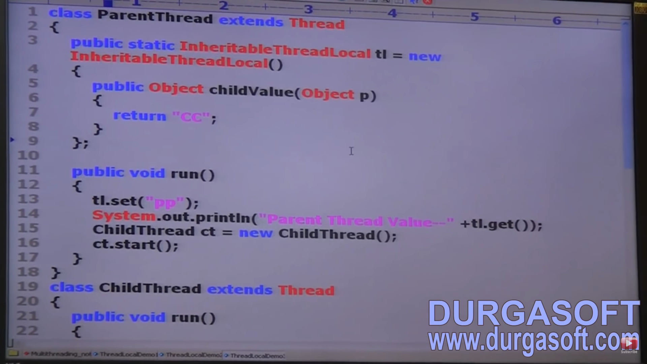

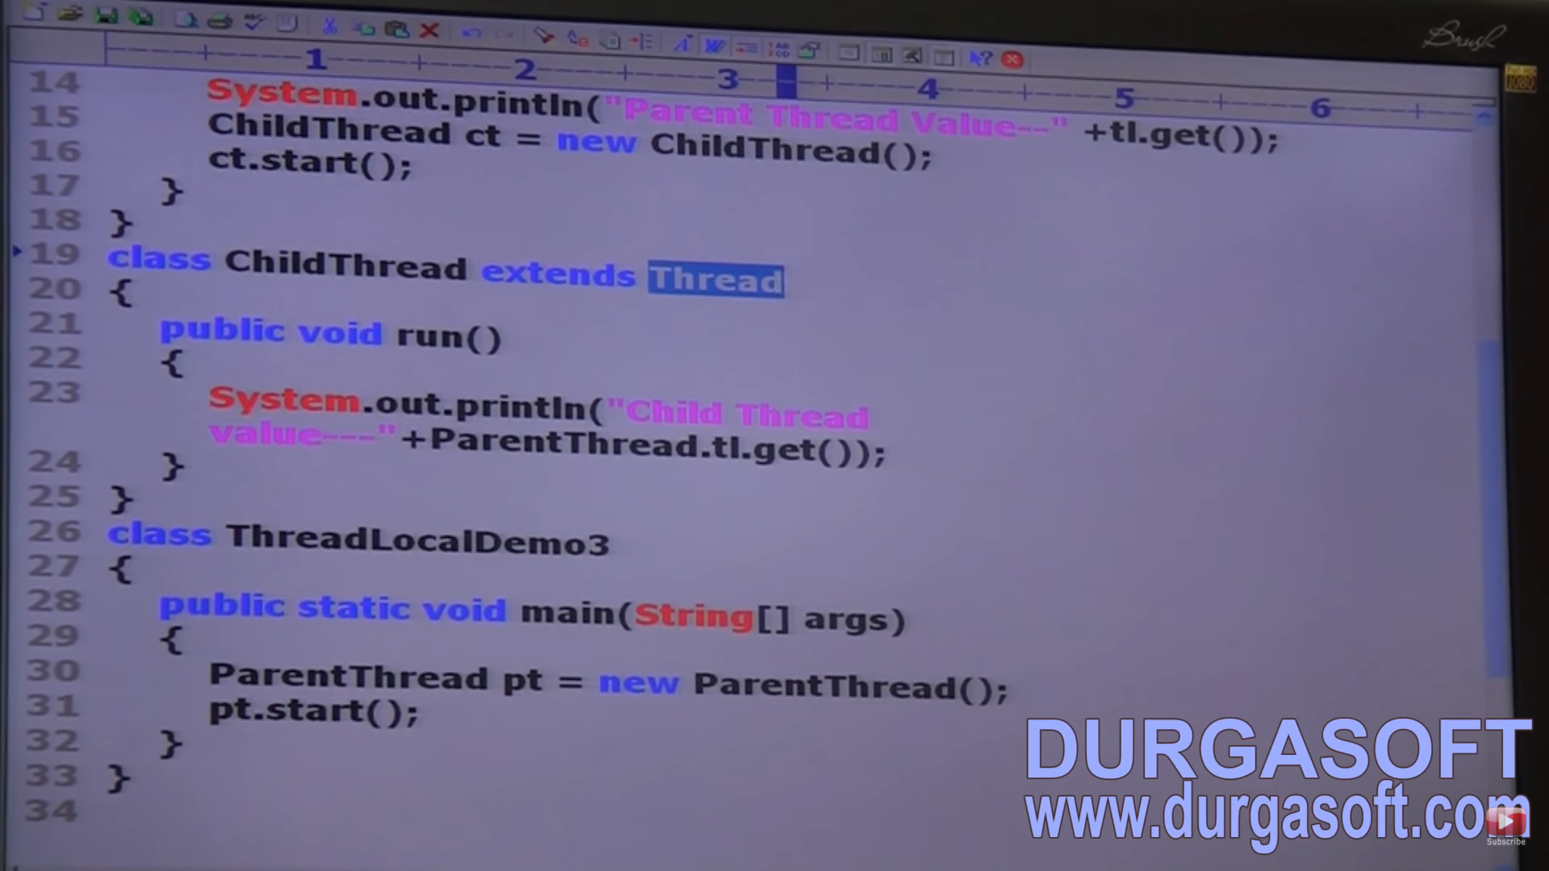

Child thread will get the value as ‘PP’ until we implement the childValue in the Parent class. In the above program, if we replace InheritableThreadLocal with ThreadLocal and if we are not overriding child value method, then we get child thread value as null while parent thread value as ‘PP’

In the above program, if we are maintaining InheritableThreadLocal and if we are not overriding childValue method, then we get child thread value as ‘PP’ and parent thread value also as ‘PP’.